|  |  |  |  |  |
| --- | --- | --- | --- | --- |
| Fond-Rec_e | | **International Telecommunication Union** | | |
|  | |  | | |
| **ITU-T** | **P.570** | |
| TELECOMMUNICATION STANDARDIZATION SECTOR OF ITU | | (06/2018) |
|  | SERIES P: TELEPHONE TRANSMISSION QUALITY, TELEPHONE INSTALLATIONS, LOCAL LINE NETWORKS  Objective measuring apparatus | | | |
|  | **Artificial noise fields under laboratory conditions** | | | |
|  | Recommendation ITU‑T P.570 | | | |



ITU-T P-SERIES RECOMMENDATIONS

**TELEPHONE TRANSMISSION QUALITY, TELEPHONE INSTALLATIONS, LOCAL LINE NETWORKS**

|  |  |
| --- | --- |
|  |  |
| Vocabulary and effects of transmission parameters on customer opinion of transmission quality | Series P.10 |
| Voice terminal characteristics | Series P.30 |
|  | P.300 |
| Reference systems | Series P.40 |
| **Objective measuring apparatus** | **Series P.50** |
|  | **P.500** |
| Objective electro-acoustical measurements | Series P.60 |
| Measurements related to speech loudness | Series P.70 |
| Methods for objective and subjective assessment of speech quality | Series P.80 |
| Methods for objective and subjective assessment of speech and video quality | Series P.800 |
| Audiovisual quality in multimedia services | Series P.900 |
| Transmission performance and QoS aspects of IP end-points | Series P.1000 |
| Communications involving vehicles | Series P.1100 |
| Models and tools for quality assessment of streamed media | Series P.1200 |
| Telemeeting assessment | Series P.1300 |
| Statistical analysis, evaluation and reporting guidelines of quality measurements | Series P.1400 |
| Methods for objective and subjective assessment of quality of services other than speech and video | Series P.1500 |
|  |  |

*For further details, please refer to the list of ITU-T Recommendations.*

|  |
| --- |
| Recommendation ITU-T P.570  Artificial noise fields under laboratory conditions |

|  |
| --- |
| Summary  Recommendation ITU-T P.570 specifies various artificial noise field configurations that can be used in connection with objective as well as subjective evaluation of communication equipment.  Furthermore, Recommendation ITU-T P.570 provides guidance on capturing real-world noise environments and preprocessing of signals for reproduction of such environments. Recommendation ITU-T P.570 also describes calibration procedures and assessment methods for artificial noise field configurations. |

|  |  |  |  |  |  |  |  |  |  |  |
| --- | --- | --- | --- | --- | --- | --- | --- | --- | --- | --- |
| History   |  |  |  |  |  | | --- | --- | --- | --- | --- | | Edition | Recommendation | Approval | Study Group | Unique ID[[1]](#footnote-1)\* | | 1.0 | ITU-T P.570 | 2018-06-13 | 12 | [11.1002/1000/13624](http://handle.itu.int/11.1002/1000/13624) | |

|  |
| --- |
| Keywords  Ambient noise, artificial noise fields, capturing environment noise, loudspeaker equalization, loudspeaker set-up. |

FOREWORD

The International Telecommunication Union (ITU) is the United Nations specialized agency in the field of tele­com­mu­ni­ca­tions, information and communication technologies (ICTs). The ITU Telecommunication Standardization Sector (ITU-T) is a permanent organ of ITU. ITU-T is responsible for studying technical, operating and tariff questions and issuing Recommendations on them with a view to standardizing telecommunications on a worldwide basis.

The World Telecommunication Standardization Assembly (WTSA), which meets every four years, establishes the topics for study by the ITU‑T study groups which, in turn, produce Recommendations on these topics.

The approval of ITU-T Recommendations is covered by the procedure laid down in WTSA Resolution 1.

In some areas of information technology which fall within ITU-T's purview, the necessary standards are prepared on a collaborative basis with ISO and IEC.

NOTE

In this Recommendation, the expression "Administration" is used for conciseness to indicate both a telecommunication administration and a recognized operating agency.

Compliance with this Recommendation is voluntary. However, the Recommendation may contain certain mandatory provisions (to ensure, e.g., interoperability or applicability) and compliance with the Recommendation is achieved when all of these mandatory provisions are met. The words "shall" or some other obligatory language such as "must" and the negative equivalents are used to express requirements. The use of such words does not suggest that compliance with the Recommendation is required of any party.

INTELLECTUAL PROPERTY RIGHTS

ITU draws attention to the possibility that the practice or implementation of this Recommendation may involve the use of a claimed Intellectual Property Right. ITU takes no position concerning the evidence, validity or applicability of claimed Intellectual Property Rights, whether asserted by ITU members or others outside of the Recommendation development process.

As of the date of approval of this Recommendation, ITU had not received notice of intellectual property, protected by patents, which may be required to implement this Recommendation. However, implementers are cautioned that this may not represent the latest information and are therefore strongly urged to consult the TSB patent database at <http://www.itu.int/ITU-T/ipr/>.

© ITU 2018

All rights reserved. No part of this publication may be reproduced, by any means whatsoever, without the prior written permission of ITU.

**Table of Contents**

Page

1 Scope 1

2 References 1

3 Definitions 2

3.1 Terms defined elsewhere 2

3.2 Terms defined in this Recommendation 2

4 Abbreviations and acronyms 4

5 Conventions 4

6 How to use this Recommendation 5

7 Techniques for capturing real-world noise environments 6

7.1 Monaural recording 6

7.2 Stereo recording 6

7.3 Binaural recording 6

7.4 Sound field recording 8

7.5 Multi-point sound field recording 9

7.6 Recording format 12

7.7 Calibration of recording instrumentation 13

8 Environments for reproducing artificial noise fields 13

8.1 Loudspeaker configurations 13

8.2 Loudspeaker calibration and equalization 14

8.3 Reproducing artificial noise fields in a simulation set-up 40

9 Techniques for synthetizing noise fields 40

9.1 Equalization procedure 41

9.2 Recommended set-ups 41

10 Techniques for assessing artificial noise fields 41

10.1 Assessment based on spectral content 41

10.2 Assessment based on spatial coherence 41

10.3 Assessment of uniformity 41

11 Documentation of measurements in artificial noise fields 41

Annex A – Loudspeaker performance 42

Appendix I – Requirements for test environments 43

Appendix II – Loudspeaker configurations and decoding of loudspeaker signals 45

Appendix III – Spatial sound field stability 51

III.1 Reproduction of monophonic signals in anechoic conditions 51

III.2 Reproduction of monophonic signals in treated rooms 63

III.3 Reproduction of stereophonic signals in anechoic conditions 63

III.4 Reproduction of stereophonic signals in treated rooms 63

III.5 Reproduction of binaural signals in anechoic conditions 63

Page

III.6 Reproduction of binaural signals in treated rooms 63

III.7 Reproduction of sound field signals in anechoic conditions 63

III.8 Reproduction of sound field signals in treated rooms 63

III.9 Reproduction of multi-point signals in anechoic conditions and treated rooms 63

Appendix IV – Spatial reproduction stability 87

IV.1 Spatial reproduction accuracy of monophonic signals under anechoic conditions 87

IV.2 Spatial reproduction accuracy of monophonic signals in treated rooms 87

IV.3 Spatial Reproduction Accuracy of stereophonic signals in anechoic conditions 102

IV.4 Spatial Reproduction Accuracy of stereophonic signals in treated rooms 102

IV.5 Spatial Reproduction Accuracy of binaural signals in anechoic conditions 102

IV.6 Spatial Reproduction Accuracy of binaural signals in treated rooms 102

IV.7 Spatial reproduction accuracy sound field signals in anechoic conditions 109

IV.8 Spatial reproduction accuracy of sound field signals in treated rooms 109

IV.9 Spatial reproduction accuracy of multi-point reproduction 109

Appendix V – Detailed description of the overall equalization procedure for a HATS 111

Bibliography 112

Introduction

This Recommendation covers various loudspeaker set-ups that can be used for reproduction of typical environment noise scenarios. The scope of this Recommendation is limited to artificial noise fields under laboratory conditions, whereas actual performance testing of handset, headset or hands-free terminals when placed in an environment with background noise are covered by other relevant ITU Recommendations.

Recommendation ITU-T P.570

Artificial noise fields under laboratory conditions

# 1 Scope

The quality of ambient noise transmission is an important factor, which significantly contributes to the perceived overall quality of speech. Existing and even more the new generation of terminals, networks and system configurations including broadband services can be greatly improved with a proper design of terminals and systems in the presence of ambient noise.

This Recommendation:

– provides information about techniques needed for capturing real-world noise environments;

– outlines methods for preprocessing of signals for artificial noise fields (ANFs);

– specifies loudspeaker set-ups and a loudspeaker calibration procedure;

– describes the requirements for laboratory conditions;

– specifies techniques for assessing ANFs.

The ANF established when applying this Recommendation can be used for the evaluation and optimization of terminals and of complex configurations including terminals, networks and other configurations.

The ANF described in this Recommendation is applicable to:

– objective performance evaluation of terminals in different ambient noise environments;

– speech-processing evaluation by using the preprocessed speech signal in the presence of ambient noise, recorded by a terminal;

– subjective evaluation of terminals by performing conversational tests, specific double talk tests or talking and listening tests in the presence of ambient noise;

– subjective evaluation in third party listening tests by recording the speech samples of terminals in the presence of ambient noise.

# 2 References

The following ITU-T Recommendations and other references contain provisions which, through reference in this text, constitute provisions of this Recommendation. At the time of publication, the editions indicated were valid. All Recommendations and other references are subject to revision; users of this Recommendation are therefore encouraged to investigate the possibility of applying the most recent edition of the Recommendations and other references listed below. A list of the currently valid ITU-T Recommendations is regularly published. The reference to a document within this Recommendation does not give it, as a stand-alone document, the status of a Recommendation.

[ITU-T P.58] Recommendation ITU-T P.58 (2013), *Head and torso simulator for telephonometry.*

[ITU-T P.581] Recommendation ITU-T P.581 (2014), *Use of head and torso simulator for hands-free and handset terminal testing.*

[ITU-T P.1100] Recommendation ITU-T P.1100 (2017), *Narrowband hands-free communication in motor vehicles.*

[ITU-T P.1110] Recommendation ITU-T P.1110 (2017), *Wideband hands-free communication in motor vehicles.*

[ITU-T P.1120] Recommendation ITU-T P.1120 (2017), *Super-wideband and fullband hands-free communication in motor vehicles.*

[ITU-T P.1140] Recommendation ITU-T P.1140 (2017), *Speech communication requirements for emergency calls originating from vehicles.*

[ITU-R BS.1116-3] Recommendation ITU-R BS.1116-3 (2015): *Methods for the subjective assessment of small impairments in audio systems.*

[ETSI EG 202 396-1] ETSI EG 202 396-1, V1.2.2 (2008), *Speech processing, transmission and quality aspects (STQ); Speech quality performance in the presence of background noise; Part 1: Background noise simulation technique and background noise database*.

[IEC 61260-1] IEC 61260-1:2014, *Electroacoustics – Octave-band and fractional-octave-band filters – Part 1: Specifications*.

[IEC TR 60268-13] IEC TR 60268-13:1998, *Sound system equipment – Part 13: Listening tests on loudspeakers*.

[IEC 61094-4] IEC 61094-4:1995, *Measurement microphones – Part 4: Specifications for working standard microphones*.

[ISO 11904-1] ISO 11904-1:2002, *Acoustics – Determination of sound immission from sound sources placed close to the ear – Part 1: Technique using a microphone in a real ear (MIRE technique)*.

# 3 Definitions

Headset: device which includes telephone receiver and transmitter which is typically secured to the head or the ear of the wearer.

## 3.1 Terms defined elsewhere

This Recommendation uses the following term defined elsewhere:

**3.1.1 hands-free terminal** [b-ITU-T P.10]: A telephone set that does not require the use of hands during the communications session; examples are headset, speakerphone and group-audio terminal.

## 3.2 Terms defined in this Recommendation

This Recommendation defines the following terms:

**3.2.1 A-format**: A signal format used within a sound field microphone that is not normally accessible to the outside world. It consists of the four signals from an array of microphone capsules that are placed at the vertices of a regular tetrahedron. These signals are processed electronically to produce B-format.

NOTE – See [b-Rumsey] for more information.

**3.2.2 ambisonics**: A series of recording and replay techniques using multichannel mixing technology that can be used live or in the studio. By encoding and decoding sound information on a number of channels, a 2-dimensional or 3-dimensional sound field can be presented.

NOTE – See [b-Rumsey] for more information.

**3.2.3 artificial ear**: Device incorporating an acoustic coupler and a calibrated microphone for the measurement of the sound pressure and having an overall acoustic impedance similar to that of the median adult human ear over a given frequency band.

NOTE – Based on [b-ITU-T P.10].

**3.2.4 B-format**: In the basic version, known as first-order ambisonics, a format in which sound information is encoded into four channels: *W*, *X*, *Y* and *Z*. The *W* channel is the non-directional mono component of the signal, corresponding to the output of an omni-directional microphone. The *X*, *Y* and *Z* channels are the directional components in three dimensions. They correspond to the outputs of three figure-of-eight microphones, facing forward, to the left, and upward respectively.

NOTE – See [b-Rumsey] for more information.

**3.2.5 C-format; UHJ**: A format that is a matrixed version of B-format for transmission over a reduced number of channels with associated decreases in decoding accuracy.

NOTE – See [b-Rumsey] for more information.

**3.2.6 D-format**: The format of the decoded signals to be applied to the loudspeakers in the ambisonic system.

NOTE – See [b-Rumsey] for more information.

**3.2.7 diffuse-field equalization**: Equalization of the head and torso simulator (HATS) sound pick-up, equalization of the difference, in decibels, between the spectrum level of the acoustic pressure at the eardrum reference point (DRP) and the spectrum level of the acoustic pressure at the HATS reference point (HRP) in a diffuse sound field with the HATS absent using the reverse nominal curve given in Table 3 of [ITU-T P.58].

NOTE – Based on [ITU-T P.1100].

**3.2.8 diffuse-field test point (DFTP)**: The physical position of the measurement microphone during the loudspeaker equalization procedure. The centre of the head of the head and torso simulator (HATS) will be located at the DFTP when the actual measurements are performed.

**3.2.9 eardrum reference point (DRP)**: A point located at the end of the ear canal, corresponding to the eardrum position.

NOTE – Based on [b-ITU-T P.10].

**3.2.10 free-field equalization**: The transfer characteristics of the artificial head are equalized in such a way that, for a frontal sound incidence in anechoic conditions, the frequency response of the artificial head is flat. This equalization is specific to the head and torso simulator (HATS) used.

NOTE – Based on [ITU-T P.1100].

**3.2.11 free-field reference point**: A point located in the free sound field, at a distance of at least 1.5 m from a sound source radiating in free air [in the case of a head and torso simulator (HATS) in the centre of the artificial head with no artificial head present].

NOTE – Based on [ITU-T P.1100].

**3.2.12 hands-free reference point (HFRP)**: A point located on the axis of the artificial mouth, at 50 cm from the outer plane of the lip ring, where the level calibration is made, under free-field conditions.

NOTE 1 – The HFRP corresponds to measurement point 11, as defined in [ITU-T P.581].

NOTE 2 – Based on [ITU-T P.1100].

**3.2.13 head and torso simulator (HATS) for telephonometry**: Manikin extending downward from the top of the head to the waist, designed to simulate the sound pick-up characteristics and the acoustic diffraction produced by a median human adult and to reproduce the acoustic field generated by the human mouth.

NOTE – Based on [b-ITU-T P.10].

**3.2.14 headset**: A device, comprising a telephone receiver and transmitter, that is typically secured to the head or the ear of the wearer.

NOTE – Based on [b-ITU-T P.10].

**3.2.15 listening room**: A room that provides standard listening conditions in which audiovisual equipment, hi-fi systems, loudspeakers or recordings can be assessed subjectively. The acoustics are similar to those of a living room in a house rather than the 'deadness' of an anechoic room.

NOTE –See [IEC TR 60268-13] for more information.

**3.2.16 mouth reference point (MRP)**:A point located 25 mm in front of and on the axis of the lip plane of a mouth simulator.

NOTE – Based on [b-ITU-T P.10].

**3.2.17 pantophonic**: 2-Dimensional representations of sound field.

**3.2.18 periphonic**: 3-Dimensional representations of sound field.

# 4 Abbreviations and acronyms

This Recommendation uses the following abbreviations and acronyms:

ANF Artificial Noise Field

DFTP Diffuse-Field Test Point

DRP Drum Reference Point

DUT Device Under Test

EEP Ear canal Entrance Point

FFT Fast Fourier Transform

G-MOS Global Mean Opinion Score

HATS Head and Torso Simulator

HRP Head and torso simulator Reference Point

MIRE Microphone In Real Ear

MLS Maximum Length Sequence

MOS Mean Opinion Score

MRP Mouth Reference Point

N-MOS Noise Mean Opinion Score

PSD Power Spectral Density

RFR Room Frequency Response

RIR Room Impulse Response

SNR Signal to Noise Ratio

S-MOS Speech Mean Opinion Score

# 5 Conventions

dBPa: sound pressure level relative to 1 Pa, expressed in decibels.

dBPa(A): A-weighted sound pressure level relative to 1 Pa, expressed in decibels.

dBSPL: sound pressure level relative to 20 µPa, expressed in decibels; (94 dBSPL = 0 dBPa).

# 6 How to use this Recommendation

This Recommendation describes various methods for capturing real-world noise environments, as well as configurations and methods for reproducing such noise environments. The configurations that are described cover a reference set-up, such as an anechoic chamber, as well as an *in-situ* set-up, e.g., in a vehicle. This Recommendation also provides a detailed description of the capture of noise environments in a vehicle when using binaural recording techniques.

As an alternative to applying a binaural recording method for capturing noise environments in a vehicle, methods that use a single microphone e.g., the microphone of the hands-free terminal in the vehicle or a measurement microphone, are described in [ITU-T P.1100], [ITU-T P.1110], [ITU‑T P.1120] and [ITU-T P.1140], which also specify configurations for specific applications of simulation set-ups intended for use in a vehicle. Note that this Recommendation also covers the loudspeaker configuration defined in [ETSI ES 202 396-1].

Table 1 lists the combinations of signals and configurations considered in this Recommendation. Each combination is evaluated with respect to four parameters.

– **Spectral coherence (A)** – is used to evaluate how well the spectrum of the reproduced sound field correlates with the original spectrum of the recorded sound field. For the methods described in this Recommendation, the difference between the original spectrum and the reproduced spectrum is known be within ±3 dB.

– **Temporal coherence (B)** – is used to evaluate how well the time signals of the reproduced sound field correlate with the original time signals of the recorded sound field. The actual performance depends on the individual method described in this Recommendation, hence detailed information is given in each method description.

– **Positional uniformity (C)** – is used to evaluating the sound field beyond the centre of calibration with respect to spectral coherence.

– **Perceptual characteristics (D)** – is used to evaluate characteristics such as spatial resolution, sound image localization and perceived acoustical space properties. See [ITU-R BS.1116-3] for more information on subjective assessment.

Table 1 forms the basis for a guideline for selection of the proper configuration for testing the performance of a specific application e.g., handset, handheld hands-free, desktop hands-free, headset, vehicle mounted hands-free, objective performance, instrumental, subjective performance, perceptual performance and headphones with active noise control. As a general rule, the reproduction being applied for testing should be more advanced if more advanced signal processing is provided in the device under test (DUT), i.e., technologies more physically correctly reproducing the original sound field should be used.

"ABCD" indicates that all four parameters are supported by the configuration while a dash "–" indicates that this configuration is not applicable.

Table 1 – Characteristics of various reproduction set-ups

|  |  |  |  |  |  |  |
| --- | --- | --- | --- | --- | --- | --- |
| No. loudspeakers | Signal | | | | | |
| 1D | 2D (pantophonic) | | | | 3D (periphonic) |
| Mono | Stereo | Binaural | Multi point | Ambisonic | Ambisonic |
| 1 | – | – | – | – | – | – |
| 2 | – | – | – | – | – | – |
| 4 | AB | – | ABC | – | – | – |
| 8 | – | – | – | ABCD | – | – |
| More | – | – | – | – | – | – |

# 7 Techniques for capturing real-world noise environments

In this clause, the techniques that have been identified to be applicable to the capture of real-world noise environments are described.

## 7.1 Monaural recording

The simplest technique that can be applied for recording purposes is a single microphone used to capture the sound field. In general, such recording will lack any information about the directivity of the sound, but will give accurate information about the sound pressure level at the position in the sound field where the microphone was positioned during the recording.

In order to have an optimal recording, the correct type of microphone must be utilized and the positioning, as well as orientation, of the microphone must be correct. For the applications outlined in this Recommendation, the choice will typically be to use a diffuse-field microphone. Furthermore, the appropriate equalization should be considered.

## 7.2 Stereo recording

The stereo recording technique utilizes two microphones and preserves the sounds that have been picked up by the microphones as two separate, but simultaneously recorded, signals. This technique allows the actual physical and spatial relationships that existed at the time the event took place to be preserved in the recording.

A large number of different microphone configurations for stereo recordings are used for various applications. However, they are all based on the fundamental principle that has been described in the previous paragraph. None of the recordings currently used within the scope of this Recommendation are stereo recordings; nonetheless, the stereo technique is described for completeness.

## 7.3 Binaural recording

The general principle of the recording and playback technique is to provide an instrument (a HATS or test subject wearing binaural probe microphones) that allows the recording as close to the original as possible of the signals typically received by the human ear in a sound field. A suitable description of the properties of the HATS to be used for the recording techniques can be found in [ITU-T P.58]. Since the directivity characteristics of the HATS are strongly directionally dependent, the output signals of the microphones of the HATS cannot be directly compared to a standard measurement microphone and an equalization procedure has to be applied in order to get comparable output signals. Various types of equalization procedure for HATS recordings can be used, as described in clauses 7.3.1 to 7.3.5.

### 7.3.1 Free-field equalization

The HATS is equalized in such a way that for frontal sound incidence in anechoic conditions, the frequency response of the head of the HATS is flat.

### 7.3.2 Diffuse-field equalization

The HATS is equalized in a diffuse sound field. For random sound incidence, the frequency response of the HATS is flat.

### 7.3.3 Binaural equalization

Generally, the HATS used should comply with the requirements specified in [ITU-T P.58]. Although all equalization methods described in clause 7.3 can be used, the preferred method is diffuse-field equalization. This is because there are less-sharp peaks and dips in the transfer function of the HATS compared to the free-field transfer function (see also [ITU-T P.58]).

All equalization techniques can be applied to the HATS as well as to a binaural probe microphone, which is worn by the user himself instead of using a HATS. If probe microphone techniques {so called microphone in real ear (MIRE) techniques, see [ISO 11904-1]} are used, the same equalization technique as applied for the HATS needs to be used. The preferred recording methodology, however, is the HATS technique, since the performance characteristics of HATSs are well described and problems due to incorrect positioning, differences for different persons wearing the binaural microphone and equalization errors are unlikely. The equalization technique chosen for the recording process should be similar to that used in the equalization process for the reproduction set-up. The recording set-up is outlined in Figure 1.

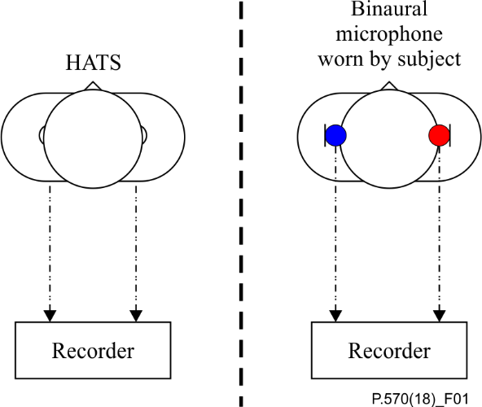

Figure 1 – The different methods of artificial noise field recording addressed in this Recommendation. The methods are head and torso simulator and microphone in real ear

### 7.3.4 Free-field equalization

The free field is equalized for the free-field reference position in an anechoic room. The reference source is placed on the reference axis of the HATS, at a minimum distance of 1.5 m from the HATS lip-ring. When using a binaural microphone, this point corresponds to the lip plane of a human user wearing the binaural microphone. The measured free-field response of the HATS is:

*H*ff(0°, 0°, *f*)

From this the free-field equalization is calculated:

*H*ff-EQ(0°, 0°, *f*) = 1/*H*ff(0°, 0°, *f*)

*H*ff-EQl(0°, 0°, *f*) is the free-field equalization of the left ear, *H*ff-EQr(0°, 0°, *f*) is the free-field equalization of the right ear. The equalization should be correct to within ±0.5 dB in the frequency range from 100 Hz to 10 kHz and to within ±2.0 dB in the frequency range from 10 kHz to 20 kHz measured in one-third-octave bands.

NOTE – The free-field equalization of the HATS requires a very careful set-up of the measurement. Due to the directivity of the HATS, small deviations from the reference position (0°, 0°) may result in incorrect equalized transfer functions.

### 7.3.5 Diffuse-field equalization

The diffuse field is equalized for the diffuse-field reference position in a diffuse sound field. Either an echoic room or an arrangement of multiple loudspeakers each fed by an uncorrelated noise signal and generating a truly diffusive sound field is used. The HATS is positioned at the centre of the diffusive sound field. The measured diffuse-field response of the HATS is:

*H*df(*f*)

From this the diffuse-field equalization is calculated:

*H*df-EQ(*f*) = 1/*H*df(*f*)

*H*df-EQl(*f*) is the diffuse-field equalization of the left ear; *H*df-EQr(*f*) is the diffuse-field equalization of the right ear. The equalization should be correct to within ±0.5 dB in the frequency range from 100 Hz to 10 kHz and to within ±2.0 dB in the frequency range from 10 kHz to 20 kHz measured in one-third-octave bands.

## 7.4 Sound field recording

To present a specific sound field, a series of recording and replay techniques using multichannel mixing technology has been developed over the years. These techniques are based on encoding and decoding sound information on a number of channels – and the techniques are named ambisonics.

The principles of ambisonics define a unified and scalable system that deals with spatial capture and coding of acoustical sound fields, as well as transmission and reproduction using loudspeakers.

The principles can also be applied to synthesize alternative sound capture techniques or encode sources not captured or modelled using ambisonic techniques for subsequent processing and reproduction using ambisonic systems.

Several good overviews (see [b-Malham], [b-Daniel] and [b-Rumsey]) of the principles for spherical harmonic decomposition are available (see [b-Gerzon, 1973] and [b‑Gerzon, 1975]) and this Recommendation only gives an introduction to ambisonics.

Ambisonic theory defines the decomposition of a sound field into an orthogonal set of Laplace spherical harmonic functions that characterize the wave front impacting the centre of a unit sphere. If a plane wave approaches with angles of incidence *θ* for the azimuthand *φ* for the elevation with respect to the pole of a sphere, then its ambisonic components can be represented by four algebraic definitions:

*W* = 1

*X* = cos θ× cos φ

*Y* = sin θ× cos φ

*Z* = sin φ

The "order" defines the degrees of freedom used to define the entire surface of the unit sphere, so the *W* component is the zeroth-order and the *X*, *Y* and *Z* components provide the first-order definitions.

For acoustic encoding purposes, these definitions approximate to *W* being an omni-directional pressure component and *X*, *Y* and *Z* being bi-directional (figure-of-eight) velocity components, all being coincident to each other.

By convention, the *X* component defines the front-back sensitivity, the *Y* component defines the left-right sensitivity and the *Z* component defines the up-down sensitivity. Where all components are used, the resulting definition is termed periphonic as it includes the *Z* height component.

In practice, it is very difficult to achieve coincidence between separate microphone capsules having these responses. A sound field microphone provides a practical realization of such a system by using four capsules with well-matched cardioid (1 + cosθ) or sub-cardioid (2 + cosθ) responses that are positioned in a tetrahedral configuration. An associated preamplifier normalizes for level and applies fixed delay compensation, such that each capsule is virtually coincident, although the accuracy results in some phase differences between channels for frequencies above approximately 12 kHz.

In ambisonic terminology, the four resulting signals from these capsules are called A-format, referenced to their positions, where the vertices of the tetrahedron formed by the centre of each capsule face are coincident with the vertices of a cube. The signals will be directed towards:

LFU = Left/front/up

RFD = Right/front/down

LBD = Left/back/down

RBU = Right/back/up

which can be easily summed within the preamp to produce the equivalent *W*, *X*, *Y* and *Z* signals, called B-format. One important thing to note for B-format is that the *W* signal typically has a higher amplitude than the *X*, *Y* and *Z* signals, so it has been the convention with such sound field microphone systems that the preamp outputs are amplitude weighted to increase the levels of the *X*, *Y* and *Z* channels by 3 dB to get a better signal-to-noise ratio or higher signal delivered to the recorder. This means that the relative intensities of each output channel will be:

*W* = 1

*X* = $\sqrt{2}$ (cos θ× cos φ)

*Y* = $\sqrt{2}$ (sin θ× cos φ)

*Z* = $\sqrt{2}$ (sin φ)

and must be accounted for when decoding. Where the sound field needs only be defined in the horizontal (azimuthal) plane, then the *Z* component and cos φ terms can be omitted and the resulting definition is termed pantophonic.

### 7.4.1 Practical applications and considerations

When using ambisonic techniques to simulate real-world noise environments, there is a number of things that need to be considered when evaluating pros and cons in relation to other sound field capture or reproduction methods.

The scheme requires at least three signals for a pantophonic system or four signals for a periphonic system. Although this seems less efficient than other systems, the number of decoding options to simulate different spatial response patterns is much greater than for individual or pairs of microphones (e.g., mono, stereo [b-Alexander] or binaural).

For capture, a portable system can easily be used either where a HATS cannot easily be set up or when are practical reasons why a person with a MIRE system cannot be present during the recording. Although a portable set-up, including the sound field microphone (with shock-mount and windshield) and battery-powered preamplifier and multichannel recorder, is used very often in audiovisual production, it does attract attention more than, for example, MIRE, which can be an issue when discretion is needed while making recordings.

## 7.5 Multi-point sound field recording

The multi-point sound field recording technique is based on optimization of sound field reproduction at different points in space. The optimization criterion is based on minimization of the reproduction error at each microphone position. Based on this principle, the microphone locations and as a consequence the points in space for which the sound field reproduction is mostly accurate, can be chosen in a wide range. The advantage of the method is that these locations can be adapted to the type of device that is to be tested. For example, if the DUT incorporates a microphone array of the multi-point sound field, recording microphones can be positioned in the area of the microphones of the DUT. If a hands-free device is to be tested, the multi-point sound field recording microphones are positioned in the area of the hands-free device.

The arrangements described in detail in clauses 7.5.1 to 7.5.3 are optimized for the testing of handset or headset terminals using a HATS according to [ITU-T P.58]. The procedure described here can be followed in the same way for other microphone set-ups.

### 7.5.1 Microphone set-up for handset and headset terminals

Figure 2 shows the configuration of microphones located around an artificial head, which is also used for assessment of the system. The locations of the microphones define the sweet spots at which the reproduction of the recorded signals is optimal for all frequencies. In consequence, the majority of these points are selected at relevant positions at which test device microphones are usually located (see Figure 2, top left). The exact positions of the eight recording microphones have been determined by extensive simulations and are given in Figure 2 (bottom). Eight additional positions can be identified by rotation of the microphone array (fine-tuning set in Figure 2, top right, darker spots). The fine-tuning position is defined by a clockwise rotation of 10° of the microphones around the HATS axis of rotation.

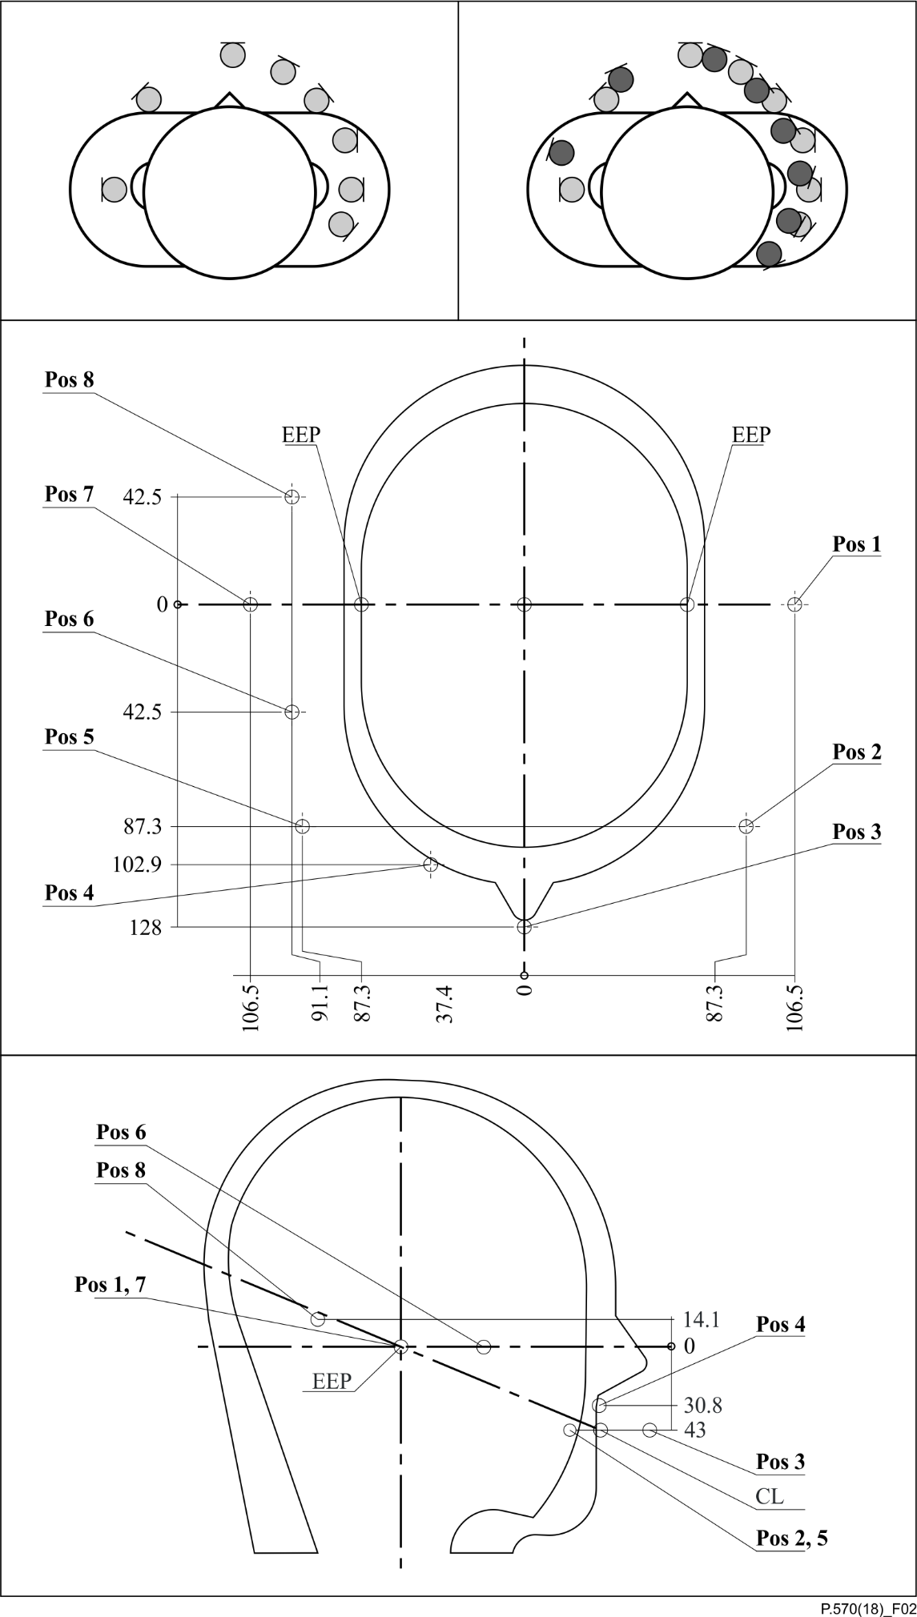

Figure 2 – Positions of the recording microphones. Vertical positions are related  
to the vertical position of the mouth reference point; EEP: ear canal entrance point

### 7.5.2 Calibration of recording instrumentation

As stated before, it is fundamental for this method that at the defined positions in the real sound field and at the corresponding positions in the reproduced sound field the sound pressures over time are identical. Therefore, for every recording, the location, frequency or phase response and the directional sensitivity for each microphone have to be identical. As a consequence, the same microphone set-up is used for both the recording and equalization procedure. Every microphone is calibrated individually.

### 7.5.3 Limitations caused by the selected microphone set-up

If the sound field is reproduced perfectly at two closely located points, the distance between those two points corresponds to an upper critical frequency up to which the sound field in between those two points is also reproduced correctly. This upper critical frequency is comparable to the Nyquist‑criterion and therefore can be estimated as

$f_{lim}=\frac{c}{2d_{max}}$ (7-1)

where $d_{max}$*d*max is the maximum distance between two microphones and *c* is the velocity of sound. For the eight microphones in Figure 2, *f*lim is dependent on position and is about 1.7 kHz in the sparsely spaced microphone region and approximately 3 kHz in that of densely spaced microphones. Note that at the microphone positions themselves, the reproduction quality is optimal across the whole frequency range. In between these positions, accurate spatial reproduction can only be guaranteed up to *f*lim.

## 7.6 Recording format

The recording techniques described in this Recommendation should by default be conducted without any preprocessing and filtering. This implies that the recording should be without equalization and that filtering should only be applied to the extent that this is required by the process of storing the recording in either a digital or analogue representation.

When a digital representation is used to store the recording, a sampling rate of at least 48 kHz should be used to enable the full audio band – 20 Hz to 20 kHz – to be utilized for the applications covered in this Recommendation. Different sampling rates can be used, but note that lower sampling rates reduce the effective frequency range of the recording.

It is anticipated that the majority of recordings relevant to applications of this Recommendation will utilize a digital representation; hence no further description of an analogue representation is given here.

The recording equipment should be able to handle the noise scenarios being recorded without introducing distortion and without adding any recording noise.

The format in which the recording should be preserved is as an uncompressed audio file. Other formats can be used, but the recording should be structured according to the following schema.

– Mono recording: The single microphone signal is stored in a single uncompressed audio file.

– Stereo recording: The two microphone signals are stored in a single uncompressed audio file.

– Binaural recording: The right signal and the left signal are stored in a single uncompressed audio file. It must be guaranteed that recorded real-field sound pressure levels can be reproduced correctly, e.g., by storing calibration data in the file header.

– Ambisonic recording: The B-format should be stored in a single uncompressed audio file. It must be guaranteed that recorded real-field sound pressure levels can be reproduced correctly, e.g., by storing calibration data in the file header.

– Multi-point sound field recording: Eight channels have to be stored with high accuracy, preferably 24 bit or more. It must be guaranteed that recorded real-field sound pressure levels can be reproduced correctly, e.g., by storing calibration data in the file header.

Any calibration recording used must be stored in a separate uncompressed audio file and the format for the associated recording method must be applied.

## 7.7 Calibration of recording instrumentation

Noise environment recording methods described in this Recommendation require the recording instruments to be fully calibrated. When using a measurement microphone, equipment such as a HATS or MIRE only requires that a sensitivity level calibration be performed, typically by using a simple sound level calibrator.

For recording instruments utilizing a sound field microphone, the supplier of such devices should provide information regarding the sensitivity of the individual microphones constituting the sound field microphone, as well as a suitable calibration procedure for the complete sound field microphone for verification purposes.

For all recordings, ensure that the recording system has the same fixed delays and gains applied to each channel. Given the broad dynamic range of noise environments that might be encountered, and the associated instantaneous peak levels, it is preferable to record signals digitally with a resolution of at least 24 bit fixed point accuracy, which should allow a greater variety of environment levels to be recorded without needing to change the gain of the system.

# 8 Environments for reproducing artificial noise fields

A broad categorization of the testing environments in which noise sources or fields can be reproduced, independent of the source material or method of generation, can be defined as follows.

– Reference set-up – acoustic presentation of noise sources utilizing transducers placed about a DUT within a reference physical environment having known acoustic properties (e.g., an anechoic chamber, a listening room, an acoustically treated office, a reverberant room).

– *In-situ* set-up – acoustic presentation of noise sources utilizing transducers placed about or within the physical environment in which a DUT will be utilized (e.g., a motor vehicle cab interior).

– Simulation set-up – "Virtual" presentation of noise sources within a reference modelled test environment (e.g., finite element model, boundary element model, analytical model).

Each of these categories shares some common ways of defining how noise sources are presented for testing or auralization purposes. This is not intended to include loudspeakers producing individual sound events (e.g., competing speech) that are independent of the primary noise field simulation, although such independent sources can be assigned to loudspeakers that are part of the noise field system.

## 8.1 Loudspeaker configurations

For the creation of ANFs, an important part of the system is the actual loudspeaker configuration being used. This Recommendation addresses various loudspeaker set-ups; however, all set-ups require that the influence of the loudspeaker configuration e.g., the individual loudspeaker as well as the test environment, be well controlled and stable with respect to certain acoustical properties.

To be able to establish a well-defined equalization of the loudspeaker configuration is an essential requirement. In the scope of this Recommendation, various equalization procedures are defined each serving different purposes.

## 8.2 Loudspeaker calibration and equalization

In clauses 8.2.1 to 8.2.9, different methods for equalization of loudspeaker configurations are described. For each recording method, a reproduction method and the associated equalization procedure is outlined.

### 8.2.1 Loudspeaker equalization using the HATS method in a reference set-up

The HATS-based equalization method described in this clause is intended for application to reproduction of binaural recordings when the loudspeaker configuration shown in Figure 3 is used. The distance between the centre of the acoustical sound field (the position used for equalization and where the test arrangement is typically placed) should be 2 m. The distance between each loudspeaker and the centre of the simulation set-up should be equal and the distance between two adjacent loudspeakers should be equal. The height of the four loudspeakers should be chosen so that the centre of the acoustical field is of the same height as the loudspeaker positions. The positioning of the subwoofer is mostly uncritical; however, placing the subwoofer exactly in the corner of a room should be avoided.

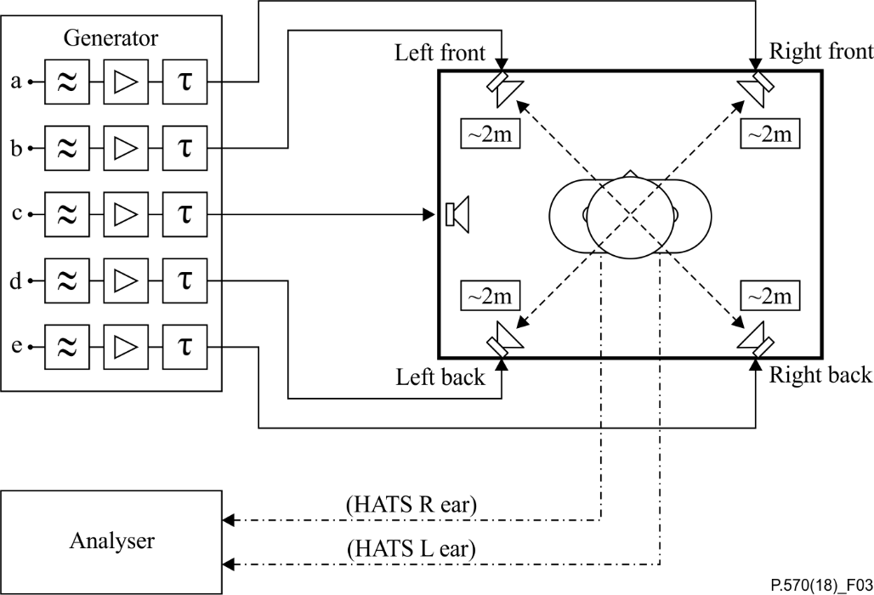

Figure 3 – The set-up for loudspeaker equalization using the HATS method and the physical set-up that is used when conducting the actual test of the device e.g., mobile phone

For the equalization, a HATS according to [ITU-T P.58] is used. The right and the left ear of the HATS should be equalized and the equalization shall correspond to the equalization used for the binaural recording of the sound field (free-field, diffuse-field, see clause 7). The HATS is positioned at the centre of the acoustical sound field (middle of the four loudspeakers, see Figure 3). The equalization is done binaurally e.g., the two left-hand speakers are equalized to the left ear of the HATS and the right-hand loudspeakers are equalized to the right ear of the HATS. In practice, the signal of the left-hand loudspeakers will also reach the right ear of the HATS, which impairs the equalization. The influence of this cross-talk cannot be eliminated, but it may be minimized as described in the equalization procedure.

The equalization is done in several steps:

1) separate equalization for each of the four loudspeakers;

2) separate level adjustment for each loudspeaker;

3) equalization for the two left-hand and the two right-hand loudspeakers;

4) equalization and level adjustment for the subwoofer;

5) delay compensation;

6) equalization for all loudspeakers (verification and reduction of cross-talk).

Each step is described in clauses 8.2.1.1 to 8.2.1.6.

#### 8.2.1.1 Step 1) – Separate equalization for each of the four loudspeakers

For loudspeaker equalization, a pink noise signal is used – the same signal is inserted at a, b, c, d and e in Figure 3. The signal is sequentially applied to the left-front, the left-back, the right-back and the right-front loudspeaker. The pink noise signal applied to the four loudspeakers must cover the frequency range 120 Hz to 20 kHz. The frequency range below is cut off by a high-pass filter providing a roll-off characteristic of at least 18 dB/octave. For specifications of octave-band and fractional-octave-band filters, see [IEC 61260-1].

The filtered pink noise signal is applied at the front-left loudspeaker for at least 2 s. During this period, the output of the HATS left ear as well as the filtered pink noise signals are measured simultaneously. The power density spectrum for the ear signal – *S*LS(*f*) – and for the original signal – *S*pn(*f*) – are determined and the averaged magnitude of the two power density spectra are subtracted as follows:

*H*LS(*f*) = *S*LS(*f*)/*S*pn(*f*) (8-1)

The resulting frequency response – *H*LS(*f*) – shall be flat between 120 Hz and 10 kHz within a tolerance of ±3dB when determined in one-third octave.

To fulfil this condition, a filter needs to be designed that compensates for the frequency response of the loudspeaker in the room. The compensating filter frequency response is calculated from the initially measured loudspeaker frequency response by using the inverse filter function:

*H*EQ(*f*) = 1/*H*LS(*f*) (8-2)

The equalized noise signal is applied at the left-front loudspeaker.

#### 8.2.1.2 Step 2) – Separate level adjustment for each loudspeaker

After each of the loudspeakers is equalized separately, each sound pressure level should be adjusted. To reproduce the original level of any sound source with this arrangement, the level of each of the four loudspeakers should be 6 dB lower than that of the original sound source, due to the fact that the sound source is now reproduced by four loudspeakers. This level adjustment can be achieved by recording and analysing the played back signal for each loudspeaker as described in clause 8.2.1.1 and after that, adjusting the level to one 6 dB below the original.

#### 8.2.1.3 Step 3) – Equalization for the two left-hand and the two right-hand loudspeakers

In this step, the two – separately equalized – left-hand or right-hand loudspeakers are equalized in combination (see Figure 3). Filtered pink noise is used as the test signal. The test signal is synchronously applied to the left-hand loudspeakers (front and back) and – similarly to 8.2.1.1 – measured with the HATS left ear and spectrally analysed in one-third octave. Again, the measured difference in the HATS left ear signal and the original signal should be within the tolerance of ±3 dB when determined in one-third octave. If the measured difference does not comply, the EQ filter for one or both of the left-hand loudspeakers is re-designed to pass the tolerance scheme. The right-hand loudspeakers are equalized by applying the same procedure, but in this situation the HATS right ear is used for the measurement instead of the left.

NOTE – The tolerance scheme for a single loudspeaker might be violated, if the equalization for the combined left loudspeakers passes the tolerance scheme.

#### 8.2.1.4 Step 4) – Equalization and level adjustment for the subwoofer

The subwoofer is equalized for the frequency range between 30 Hz and 120 Hz. The frequency range above is cut off by a low-pass filter providing a roll-off characteristic of at least 18 dB/octave. Pink noise is used as the test signal. Similar to the equalization for the four loudspeakers, the pink noise is applied to the subwoofer and measured at the right ear of the HATS. On the basis of the difference between the measured signal at the HATS ear and the original pink noises spectrum, a filter is designed with which this difference (analysed in one-third octave) is spectrally flat within a tolerance of ±3 dB. The level is adjusted to the level of the original sound source.

#### 8.2.1.5 Step 5) – Delay adjustment

For the four-loudspeaker arrangement, a compensation for the individual loudspeaker delay to the centre of the acoustical field is required in order to keep the correlation of the recorded noise material with respect to the centre of the acoustical field. Incorrect delay adjustment might lead to comb filter effects, which leads to unnatural sounding of the background noise signals. The procedure consists of adding fixed delays to the four loudspeakers (no compensation is needed for the subwoofer) in order to increase the diffusivity of the sound field. Thus, in all types of rooms, the following delays are added to the individual loudspeakers: 0 ms, 11 ms, 17 ms, 29 ms. If not suitable, as room and loudspeaker properties, dimensions and positions are not always the same, these delay values may be replaced by better ones proven to lead to a better overall equalization. No delays higher than 50 ms shall be used. If the resulting overall frequency response is mostly flat (measured at both ears), an appropriate selection of delays can be assumed.

#### 8.2.1.6 Step 6) – Overall equalization for all loudspeakers

The last step is to verify the equalization process, including the delay compensation. Therefore, a stationary, realistic pre-recorded broadband background noise signal covering the entire frequency range, e.g., car noise, is fed to the four-loudspeaker arrangement. With all equalizers, level and delay adjustments active, the signal is played back by all loudspeakers including the subwoofer (see Figure 3). The reproduced sound field is measured at both ears of the HATS. For each ear, the measurement is analysed in one-third octave and referenced to the spectrum of the original signal. The measured frequency response for the left ear and the right ear shall both be within a tolerance of ±3 dB.

NOTE – If the result is outside the tolerance, out of the four, the loudspeaker contributing mostly to the equalization error needs to be checked. A detailed description of this procedure can be found in Appendix V.

### 8.2.2 Loudspeaker equalization using the microphone method in a reference set-up

The microphone-based equalization method described in this clause can be applied for reproduction of monaural recordings for various loudspeaker configurations. However, the following description is based on the same loudspeaker configuration shown in Figure 4.

For equalization, a measurement microphone complying with [IEC 61094-4] is used. The measurement microphone is positioned at the centre of the acoustical sound field in a position equivalent to the centre of the HATS head when the HATS is positioned in the middle of the four loudspeakers – see Figure 4. Each loudspeaker is equalized individually as follows.

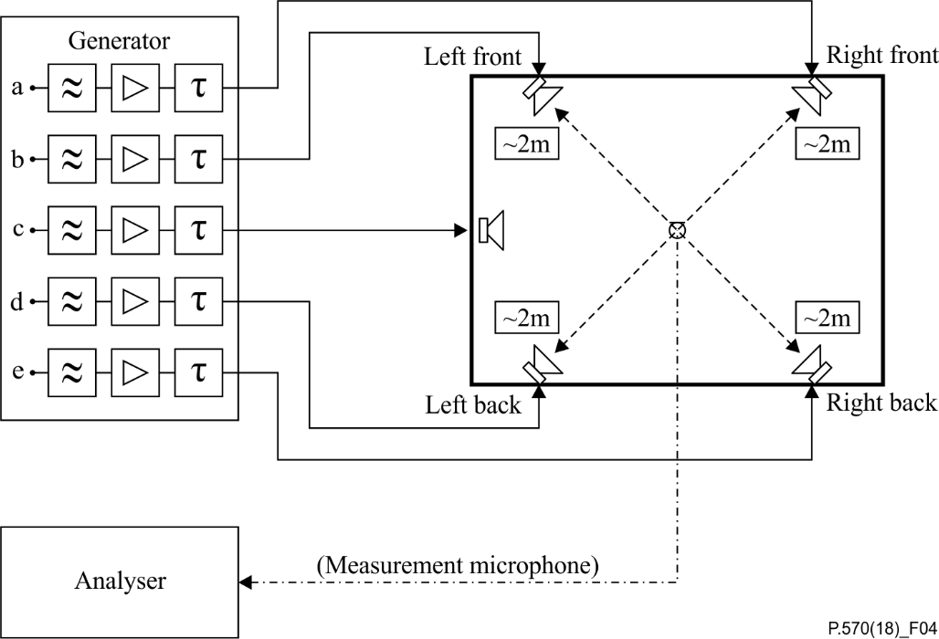

Figure 4 – The set-up for loudspeaker equalization using the microphone method

The equalization is done in several steps:

1) separate equalization for each of the four loudspeakers;

2) separate level adjustment for each loudspeaker;

3) equalization and level adjustment for the subwoofer;

4) delay compensation;

5) equalization for all loudspeakers (verification and reduction of cross-talk).

Each step is described in clauses 8.2.2.1 to 8.2.2.5.

#### 8.2.2.1 Step 1) – Separate equalization for each of the four loudspeakers

For the equalization of the loudspeakers, a pink noise signal is used. The signal is sequentially applied to the left-front, the left-back, the right-back and the right-front loudspeaker. The pink noise signal applied to the four loudspeakers must cover the frequency range 120 Hz to 20 kHz. The frequency range below is cut off by a high-pass filter providing a roll-off characteristic of at least 18 dB/octave.

The filtered pink noise signal is applied at the front-left loudspeaker for at least 2 s. During this period, the output of the measurement microphone as well as the filtered pink noise signal are measured simultaneously. The power density spectrum for the microphone signal – *S*LS(*f*) – and for the original signal – *S*pn(*f*) – are determined and the averaged magnitude of the two power density spectra are subtracted as follows:

*H*LS(*f*) = *S*LS(*f*)/*S*pn(*f*) (8-3)

The resulting frequency response – *H*LS(*f*) – shall be flat between 120 Hz and 10 kHz within a tolerance of ±3 dB when determined in one-third octave.

To fulfil this condition, a filter needs to be designed that compensates for the frequency response of the loudspeaker in the room. The compensating filter frequency response is calculated from the initially measured loudspeaker frequency response by using the inverse filter function:

*H*EQ(*f*) = 1/*H*LS(*f*) (8-4)

The equalized noise signal is applied at the left-front loudspeaker.

#### 8.2.2.2 Step 2) – Separate level adjustment for each loudspeaker

After each of the loudspeakers is equalized separately, each sound pressure level should be adjusted. To reproduce the original level of any sound source with this arrangement, the level of each of the four loudspeakers should be 6 dB lower than that of the original sound source, due to the fact that the sound source is now reproduced by four loudspeakers. This level adjustment can be achieved by recording and analysing the played back signal for each loudspeaker as described in clause 8.2.2.1 and after that, adjusting the level to one 6 dB below the original.

#### 8.2.2.3 Step 3) –Equalization and level adjustment for the subwoofer

The subwoofer is equalized for the frequency range between 30 Hz and 120 Hz. The frequency range above is cut off by a low-pass filter providing a roll-off characteristic of at least 18 dB/octave. Pink noise is used as test signal. Similarly to the equalization for the four loudspeakers, the pink noise is applied to the subwoofer and measured with the measurement microphone at a position equivalent to the centre of the HATS head. On the basis of the difference between the measured signal at the microphone and the original pink noise spectrum, a filter is designed with which this difference (analysed in one-third octave) is spectrally flat within a tolerance of ±3 dB. The level is adjusted to the level of the original sound source.

#### 8.2.2.4 Step 4) – Delay adjustment compensation

For the four-loudspeaker arrangement, a compensation of the individual loudspeaker delay to the centre of the acoustical field is required in order to keep the correlation of the recorded noise material with respect to the centre of the acoustical field. Incorrect delay adjustment might lead to comb filter effects that cause unnatural sounding of the background noise signals. The procedure consists of adding fixed delays to the four loudspeakers (no compensation is needed for the subwoofer) in order to increase the diffusivity of the sound field. Thus, in all types of rooms, the following delays are added to the individual loudspeakers: 0 ms, 11 ms, 17 ms, 29 ms. If not suitable, as room and loudspeakers properties, dimensions and positions are not always the same, these delay values may be replaced by ones proven to lead to a better overall equalization. No delays higher than 50 ms shall be used. If the resulting overall frequency response is mostly flat, an appropriate selection of delays can be assumed.

#### 8.2.2.5 Step 5) – Overall equalization for all loudspeakers

The last step is to verify the equalization process, including the delay compensation. Therefore, the signal that was used in the equalization procedure is fed to the loudspeaker arrangement – including the subwoofer. With all equalizers, level and delay adjustments active, the signal is played back by all loudspeakers including the subwoofer (see Figure 4). The reproduced sound field is measured in one-third octave with the measurement microphone and referenced to the spectrum of the original signal. The measured frequency response for the loudspeakers as well as the subwoofer shall be within a tolerance of ±3 dB.

### 8.2.3 Loudspeaker configuration for a car using one microphone in a reference set-up

Some types of terminals are mostly used in a car environment, e.g., portable hands-free devices or hands-free terminals that are integrated into cars. For portable hands-free devices, the set-up and equalization process is similar to that described for an office except that the HATS is positioned at the driver's seat instead of at the centre of the four loudspeakers. In this Recommendation, the term "portable hands-free devices" refers to handsets as well as headsets.

For hands-free terminals installed in a car, in principle, the same set-up is used for ANF reproduction as in the reference set-up described in clause 9.1. Four loudspeakers and a subwoofer are used. The subwoofer is positioned in the boot of a car. The two rear loudspeakers are positioned in the back of the car between the headrest and the window or the C-pillar. The two front loudspeakers are positioned either above the instrument panel or at the bottom in the foot well (only if the instrument panel position is impossible), depending on the tested car set-up. Figure 5 is a block diagram of the set-up.

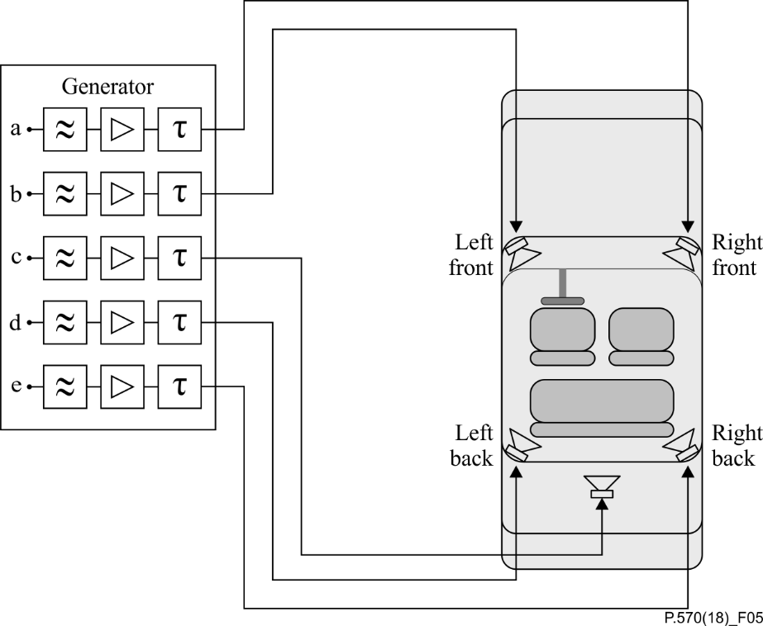

Figure 5 – The loudspeaker configuration for a car

Note that the use of the four loudspeaker arrangement in a car is more sensitive to the positioning of the microphone than the simulation in an office. Due to the smaller dimensions of a car cabin and the surrounding reverberant windows, standing waves and interferences appear.

Therefore, it is highly recommended that the same microphone be used for equalization and terminal testing. This requires that the microphone be separated from the hands-free terminal and used for system equalization, as well as in combination with the hands-free terminal. The microphone shall then be located in the position intended for use after installation. Equalization with the terminal microphone is described in clause 9.2.4.

If the terminal microphone signal is not accessible for equalization and calibration, a pair of cardioid microphones should be used instead. They should be located as close as possible to the expected terminal microphone position to provide a simulated sound field that is as close as possible to the correct position. The equalization with a pair of cardioids microphones is described in clause 9.2.5.

### 8.2.4 Loudspeaker equalization in a car using a HATS

The procedure used for equalization in the reference set-up can be applied. For further details, see clause 8.2.1.

### 8.2.5 Loudspeaker equalization in a car using the microphone of the hands-free terminal

For equalization, the microphone of the hands-free terminal should be located at the position where it will be used e.g., under the ceiling or in or on top of the rear view mirror. The equalization is done in several steps:

1) separate equalization for each of the four loudspeakers;

2) separate level adjustment for each loudspeaker;

3) equalization for the two left-hand and the two right-hand loudspeakers;

4) equalization and level adjustment for the subwoofer;

5) delay adjustment;

6) overall equalization.

Each step is described in clauses 8.2.5.1 to 8.2.5.6.

#### 8.2.5.1 Step 1 – Separate equalization for each of the four loudspeakers

For the equalization of the loudspeakers, a stationary, realistic broadband noise (e.g., broadband car noise recorded under constant driving conditions) covering the frequency range 120 Hz to 20 kHz is used. The realistic broadband noise signal is sequentially applied to the left-front, the left-back, the right-back and the right-front loudspeaker. The frequency range below is cut off by a high-pass filter providing a roll-off characteristic of at least 18 dB/octave.

The filtered signal is applied at the front-left loudspeaker for at least 10 s. During this period, the output of the microphone of the hands-free terminal as well as the filtered realistic broadband noise signal are measured simultaneously. The power density spectrum for the microphone signal – *S*LS(*f*) – and for the original signal – *S*bbn(*f*) – are determined and the averaged magnitude of the two power density spectra are subtracted as follows:

*H*LS(*f*) = *S*LS(*f*)/*S*bbn(*f*) (8-5)

The resulting frequency response – *H*LS(*f*) – shall be flat between 120 Hz and 10 kHz within a tolerance of ±3 dB when determined in one-third octave.

To fulfil this condition, a filter needs to be designed that compensates for the frequency response of the loudspeaker in the car. The compensating filter frequency response is calculated from the initially measured loudspeaker frequency response by using the inverse filter function:

*H*EQ(*f*) = 1/*H*LS(*f*) (8-6)

The equalized noise signal is applied at the left-front loudspeaker.

#### 8.2.5.2 Step 2 – Separate level adjustment for each loudspeaker

After each of the loudspeakers is equalized separately, each sound pressure level should be adjusted. To reproduce the original level of any sound source with this arrangement, the level of each of the four loudspeakers should be 6 dB lower than that of the original sound source, due to the fact that the sound source is now reproduced by four loudspeakers. This level adjustment can be achieved by recording and analysing the played back signal for each loudspeaker as described in clause 8.2.5.1 and after that, adjusting the level to one 6 dB below the original.

NOTE – For microphones with a strong directivity to the back of the car, an improved simulation can be achieved by adjusting the sound pressure level of the rear loudspeakers to a level approximately 5 dB higher and the sound pressure level of the front loudspeakers to a level approximately 3 dB lower. Be aware that the overall sound pressure level is still the same as for the original sound.

#### 8.2.5.3 Step 3 – Equalization for the two front and the two rear loudspeakers

In this step, the two – separately equalized – front or rear loudspeakers are equalized in combination (see Figure 6). A stationary, realistic broadband noise signal is used as the test signal. This test signal is used in order to achieve the same frequency-dependent correlation as for typical binaural recordings and to avoid disturbing influences due to the periodicity of the pink noise. The test signal is synchronously applied to the front loudspeakers and – similar to step 1 – measured with the microphone of the hands-free terminal and analysed in one-third octave. The measured difference in the microphone and original signals should be within the 6 dB tolerance. If the measured difference does not comply, the filter for one or both of the front loudspeakers should be re-designed to pass the tolerance scheme. The equalizations for the rear loudspeakers are performed in a similar manner.

NOTE – The tolerance scheme for a single loudspeaker might be violated if the equalization for the combined front loudspeakers passes the tolerance scheme.

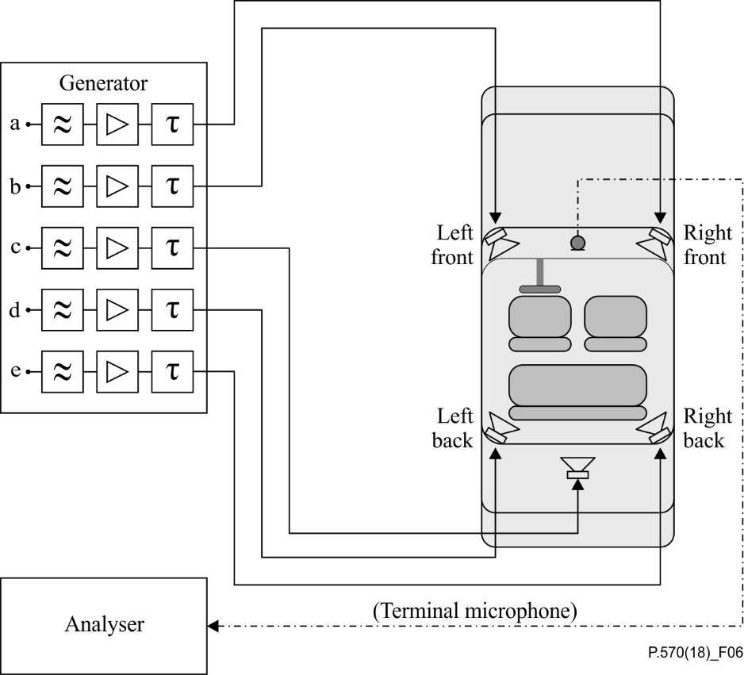

Figure 6 – The loudspeaker configuration for a car when the microphone of the   
hands-free terminal is used during equalization

#### 8.2.5.4 Step 4 – Equalization and level adjustment for the subwoofer

The subwoofer is equalized for the frequency range between 30 Hz and 120 Hz. The frequency range above is cut off by a low-pass filter providing a roll-off characteristic of at least 18 dB/octave. A stationary, realistic broadband noise is used as test signal. Similar to the equalization for the four loudspeakers, the broadband noise is applied to the subwoofer and measured with the microphone of the hands-free terminal. On the basis of the difference between the microphone signal and the original broadband noise spectrum, a filter is designed with which this difference (analysed in one-third octave) should be spectrally flat in a 6 dB tolerance scheme. The level is adjusted to that of the original sound source.

#### 8.2.5.5 Step 5 – Delay adjustment

The delay from each loudspeaker to the position of a hand-free terminal microphone should be measured and adjusted. The delay should not be assigned to one common delay for all loudspeakers, which would produce the highest signal correlation at the position of the microphone. The delays are adjusted to values that will not provide a high correlation at the microphone position, but do provide a mostly diffuse sound field. With this method, the sound directivity is not correctly reproduced; however, equalization with a single microphone is in any case not able to reproduce the sound directivity. The advantage of providing a diffuse sound field at the microphone position is that the spectral equalization matches very well. For the delay adjustment, the following rules should be followed:

– the delay for front loudspeakers should be shorter than that for those at the rear;

– the minimum delay difference should be greater than the length of fast Fourier transform (FFT) used (typically >20 ms);

– the delays, including acoustical delay, should be chosen so that they are not integral multiples of each other.

#### 8.2.5.6 Step 6 – Overall equalization

The last step is to verify the equalization process, including the delay compensation. Therefore, a stationary, realistic broadband background noise signal is fed to the four-loudspeaker arrangement. With all equalizers, level and delay adjustments active, the signal is played back by all loudspeakers including the subwoofer (see Figure 6). The reproduced sound field is measured with the microphone of the hands-free terminal. The measured frequency response at the microphone position should be within a tolerance of ±3 dB. The measured A-weighted signal level should match the original signal level within of tolerance of ±1 dB.

NOTE – If the result is outside the tolerance, it needs to be checked which of the four loudspeakers mostly contributes to the equalization error. A detailed description of this procedure can be found in Appendix V.

### 8.2.6 Loudspeaker equalization using the multi-point method in a reference set-up with a predefined microphone and loudspeaker arrangement

An overview of the benefits and limitations of the method described in this clause can be found in clause 6.

#### 8.2.6.1 Loudspeaker configuration

Figure 7 shows the set-up of the eight loudspeakers in the laboratory. The vertical position of the loudspeakers in general is not so critical. However, in order to achieve the best possible interlaboratory set-up accuracy, the vertical positions are specified as follows. For the first set of loudspeakers, the vertical position is adjusted so that the centre of the loudspeaker membrane is about +15 cm above the vertical position defined by the DRP. The second set of loudspeakers is adjusted to −15 cm below with respect to the DRP. The vertical positions of the loudspeakers alternate. In Figure 8, odd-numbered loudspeakers represent the first set and even numbered the second. The distance between the surface of the artificial head and the loudspeaker fronts should be at least 50 cm. The maximum distance should not extend 2.5 m. The distance between the loudspeakers and the HATS, as well as the horizontal distribution of the loudspeakers, can be selected depending on the room, hence the spacing between the loudspeakers does not have to be exactly equal. The set-up may be a square or a circle around the HATS or a set-up in between, depending on what fits the room best. Note that the maximum distance is also limited by the maximum sound pressure level of the loudspeakers, because for frequencies down to 50 Hz sound fields including levels of up to 105 dBSPL should be reproducible.

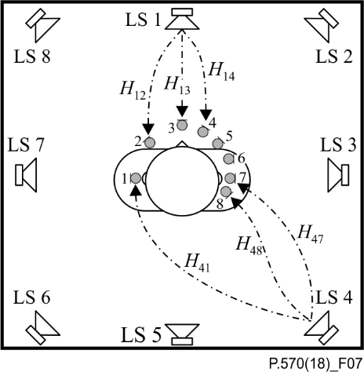

Figure 7 – Loudspeaker set-up and some equalization paths

#### 8.2.6.2 Room requirements

Rooms where the procedure has been verified for range from 1.80 m × 2.40 m × 2.1 m to 8.00 m × 9.00 m × 4.5 m (*d* × *b*× *h*) in size. Rooms may range from anechoic rooms to acoustically treated office-type rooms. The most important criterion a room has to fulfil is the clarity 80 (*C*80). This parameter defines the signal energy of the first 80 ms of the impulse response in relation to the rest of the impulse response expressed in decibels.

Suitable rooms shall have *C*80 > 20dB.

 (8-7)

#### 8.2.6.3 Equalization

The complete equalization procedure consists of the following steps:

1) separate level adjustment for every loudspeaker;

2) system identification;

3) recording using broad-band noise for later equalization check and error compensation;

4) preprocessing of the impulse responses for equalization;

5) calculation of the inversion filters;

6) first test of inversion with recorded noise;

7) adjusting the filter to compensate for inversion errors.

For equalization, the same microphone array set-up and microphone positions should be used as for the recording set-up. Accordingly, the microphone array should be calibrated as described in clause 2.1.2. The equalization itself can then be performed completely automatically, independently of the microphone array set-up. See Figure 8.

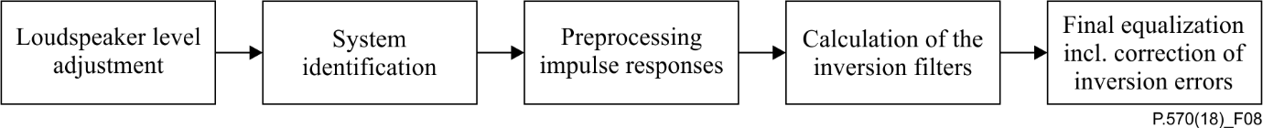

Figure 8 – Blocks of the equalization procedure

Each step is described in clauses 8.2.6.3.1 to 8.2.6.3.7.

##### 8.2.6.3.****1**** Step 1 – ****Separate level adjustment for every loudspeaker****

First of all, the sound pressure level of each loudspeaker is adjusted so that the average sound pressure level across the whole frequency range and across the eight microphones is at least 70 dBSPL. This is needed only in order to ensure a sufficient signal to noise ratio (SNR) for measuring the impulse responses in clause 8.2.6.3.2.

#### 8.2.6.3.****2**** Step 2 – ****System identification****

In this step, the impulse responses between all loudspeakers and all microphones are measured. Figure 7 shows the eight-microphone and eight-loudspeaker set-up. *H*l*i* represents the impulse response (frequency response) from loudspeaker l to microphone *i*.

The impulse response between every loudspeaker and every microphone must then be determined. There exist different possibilities for measuring impulse responses, e.g., using maximum length sequences (MLSs) or using swept-sine (sweeps). The advantage of sweeps is that non-linearities can easily be observed and that the SNR at lower frequencies is higher than with MLS. Using sweeps is therefore recommended for system identification. The sweep, denoted *S*(*f*), may be played back with a loudspeaker and *Y*(*f*) is recorded with a microphone. The frequency response *H*(*f*) can then be calculated from:

$H\left(f\right)=\frac{Y\left(f\right)}{S(f)}$ (8-8)

For sufficient system identification, the frequency range in which the response is calculated should be at least 20 Hz to 20 kHz.

#### 8.2.6.3.3 Step 3 – Recording using broad-band noise for later equalization check and error compensation

In order to generate well-defined material for testing and optimizing the quality of the equalization procedure, a broad-band pink noise is recorded with the calibration set of microphones, as well as with the fine-tuning set. Therefore, a well-defined sound field has to be generated, e.g., by using eight uncorrelated broadband pink noise sources. In contrast to recordings done in real-world situations, both the original noise field and the simulated noise field are then known for exactly the same room. Hence, the reproduction should be perfect at the calibration set microphone positions. Moreover, the accuracy of sound field reproduction can be verified in the fine-tuning positions. Note that these positions are not incorporated into the equalization procedure. The broad-band noise level should be sufficiently high to allow for a good error calculation later on. The frequency range of the noise signal should cover all frequencies for which the system has to be equalized. A range from 20 Hz to 20 kHz is again recommended.

#### 8.2.6.3.4 Step 4 – Preprocessing of the impulse responses for equalization

The motivation for this preprocessing procedure is that, in rooms with a long reverberation time, it is difficult to compensate for this reverberation completely.

In particular, sound fields at frequencies higher than *f*lim, which for the given microphone set-up is in the range between 2 kHz and 3 kHz, cannot be reproduced correctly. Hence, higher frequencies should not influence the quality of inversion.

To cope with that, a low-pass filter with a time-variant cut-off frequency is applied to the measured impulse response.

1) Filter the impulse response in the frequency domain by multiplying a window function which has the value 1 for frequencies smaller than *f*pass and 0 for frequencies greater than *f*stop. Between those two frequencies, the window function has a cosine (Hanning) characteristic.

2) The preprocessed impulse response is calculated in the time-domain as the weighted sum of the original impulse response and the low-pass-filtered impulse response from step (1). The time-variant weighting of the original impulse response is 1 up to *t*min after the start of the impulse response and falls to 0 with a cosine (Hanning) characteristic until *t*max after the start of the impulse response. The time-variant weighting of the low-pass-filtered impulse response from step (1) is 1 minus the weighting of the original impulse response.

The values for these parameters are given in Table 2.

Table 2 – Parameters for preprocessing the impulse responses   
between loudspeakers and microphones

|  |  |  |  |  |
| --- | --- | --- | --- | --- |
| *f*pass | 2 kHz |  | *t*min | 1 ms |
| *f*stop | 4 kHz |  | *t*max | 4 ms |

The result of the above defined filter can be seen in Figure 9, where a measured impulse response can be compared with the corresponding processed impulse response.

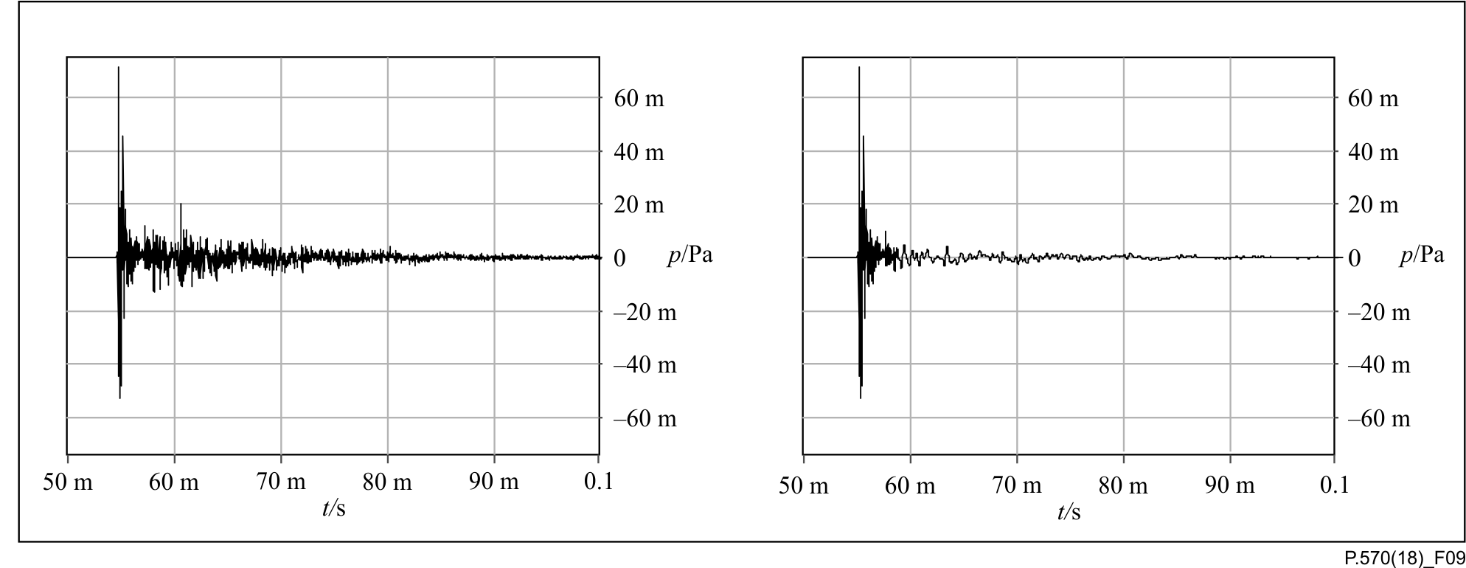

Figure 9 – Left: original (measured) impulse response; right: processed impulse response

This preprocessing introduces an error which is shown in Figure 10. This error should be compensated for in the equalization procedure later on. This will take place in step 7), in which an error compensation filter is calculated and applied to the equalization.

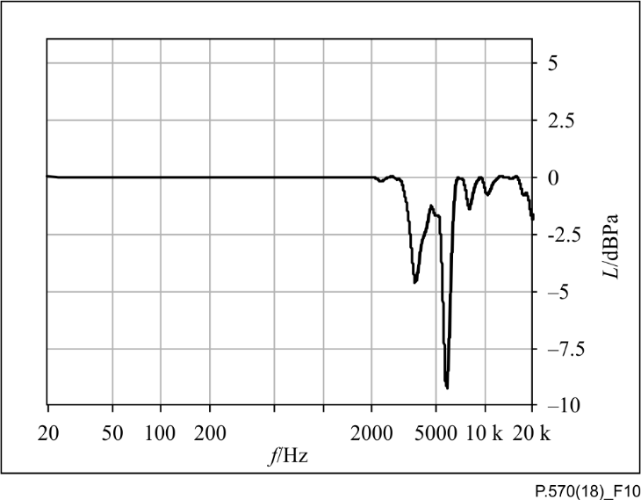

Figure 10 – Error in frequency response introduced by the processing of the impulse response. The curve has been subject to one-twelfth-octave smoothing

#### 8.2.6.3.****5**** Step 5 – ****Calculation of the inversion filters****

The inversion procedure is explained in clauses 8.2.6.3.5.1 and 8.2.6.3.5.2. After the theory has been introduced in clause 8.2.6.3.5.1, theory implementation guidelines appear in clause 8.2.6.3.5.2.

###### 8.2.6.3.5.1 Theoretical explanation of the inversion procedure

The starting point for developing the formulas needed for the inversion procedure is the expression of the signal *Pi*(*f*) arriving at a single microphone *i* as a linear combination of the signals *Xl*(*f*) played back with loudspeaker *l* multiplied by a filter *Hli*(*f*) modelling the acoustic path between microphone and the loudspeaker. This can easily be seen in Figure 8.

$P_{i}\left(f\right)=\sum_{l=1}^{L}{H_{li}\left(f\right)X_{l}\left(f\right)}$ (8-9)

This linear combination can be written as a linear system:

$\underset{H}{\underbrace{\left(\begin{matrix}H_{11} & H_{21} & … & H_{L1} \\ H_{12} & ⋱ & & ⋮ \\ ⋮ & & ⋱ & ⋮ \\ H_{1N} & … & … & H_{LN}\end{matrix}\right)}}\left(\begin{matrix}X_{1} \\ X_{2} \\ ⋮ \\ X_{L}\end{matrix}\right)=\left(\begin{matrix}P_{1} \\ P_{2} \\ ⋮ \\ P_{N}\end{matrix}\right)$ (8-10)

As stated above, the aim of this procedure is to find the signals to be reproduced by the loudspeakers for a given set of spectra *Pi*(*f*) recorded at the microphones. First of all, it can be seen that the number of loudspeakers must be at least as large as the number of microphones, otherwise the linear system is underdetermined.

The goal of the equalization is finding compensating filters *C*. These filters are then used to generate loudspeaker signals that in combination reproduce a given sound pressure at the microphone positions.

$\underset{C}{\underbrace{\left(\begin{matrix}C_{11} & C_{12} & … & C_{1N} \\ C_{21} & ⋱ & & ⋮ \\ ⋮ & & ⋱ & ⋮ \\ C_{L1} & … & … & C_{LN}\end{matrix}\right)}}\left(\begin{matrix}P_{1} \\ P_{2} \\ ⋮ \\ P_{N}\end{matrix}\right)=\left(\begin{matrix}X_{1} \\ X_{2} \\ ⋮ \\ X_{L}\end{matrix}\right)$ (8-11)

A solution of this linear system is given by

$C={\left(H^{*}H\right)}^{-1}H^{*}.$ (8-12)

The direct solution of Equation (8-12) may introduce problems: at lower frequencies, the values of *Hij* are very similar to each other, which means that the matrix becomes ill-conditioned and the value of the condition number,

$κ=\frac{σ_{max}\left(A\right)}{σ_{min}\left(A\right)}$ (8-13)

$\left(A\right)=\frac{σ_{max}\left(A\right)}{σ_{min}\left(A\right)}$ where σmax(A) $σ_{max}\left(A\right)$ and σmin(A) are the maximum and the minimum singular values of A, rises. A large condition number may result in practically unfeasible high gains.

Therefore, the Thikonov-regularization [b-Kirkeby 1998] is used.

$C={\left(H^{*}H+βI\right)}^{-1}H^{*}$ (8-14)

Here a regularization factor βis introduced that reduces poles and improves the condition of the matrix. The regularization factor β is investigated in more detail in clause 8.2.6.3.**5.2.2**.

If a mixture of different types of loudspeakers is used for reproduction, their various characteristics, e.g., their frequency response, can be considered with a weighted version of (8-14):

 (8-15)

The loudspeaker weighting matrix **W** is a frequency-dependent diagonal matrix. It is used as a high‑pass for small loudspeakers which prevents damage to the speakers at low frequencies. **W** shall be 1 for the supported frequency range of the loudspeaker, i.e., above the −3dB point of the frequency response, and fade to 0 with a cosine characteristic within a one-third-octave transition.

###### 8.2.6.3.****5.2**** Implementation of inversion procedure

All impulse responses for all combinations of loudspeakers and microphones are inverted individually. Each impulse response is first segmented into four subbands, as shown in Figure 11. Each subband is processed with a subset of impulse responses according to the microphones used in each subband, as defined in Table 3. The size of the matrix that has to be inverted is given in brackets, e.g., "Subband 1 (3×8)".

After finalizing the regularization process, the resulting inverted impulse responses are combined in the different frequency bands chosen by applying the appropriate frequency weighting (bandpass filtering) shown in the filter blocks, after the inversion blocks in Figure 11 are available.

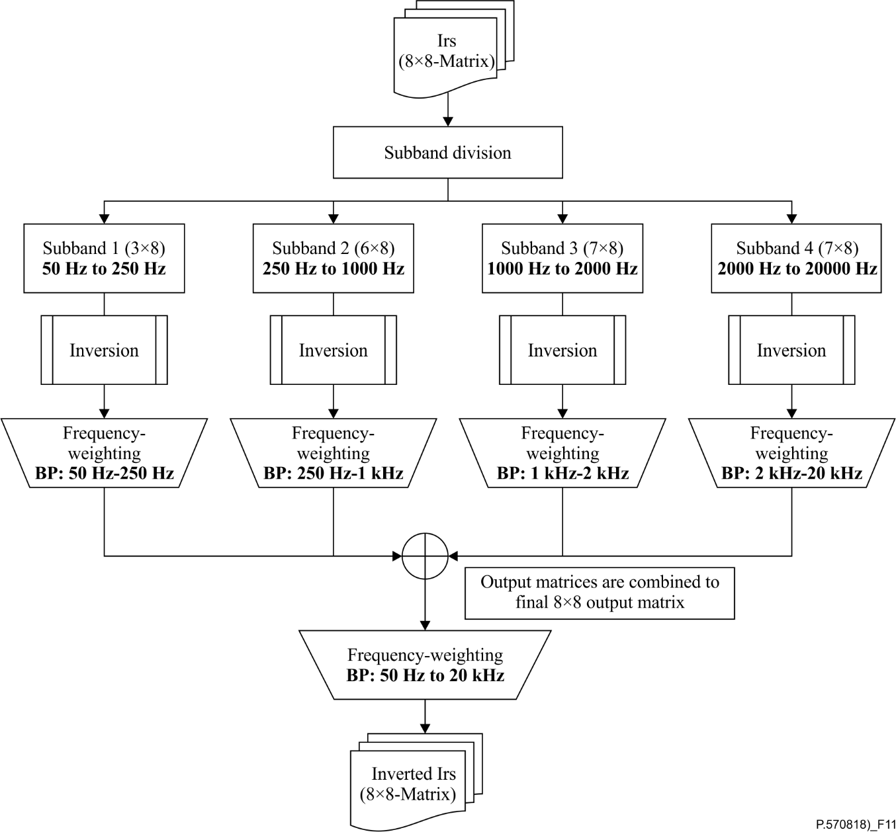

Figure 11 – Block diagram of the inversion procedure

###### 8.2.6.3.****5.2.1**** Different microphones for different frequency bands

Generally, the greater the number of microphones leads, the worse the condition of the matrix to be inverted. For this reason, the number of microphones should be limited. On the other hand, spatial reproduction quality increases with a higher number of microphones. In order to further optimize the inversion quality, different numbers of microphones can be used for various frequency bands. For lower frequencies, the wavelengths are rather long and therefore microphones can be used that are far away from each other. As frequencies become higher, microphones should be used that are nearer to each other.

Measurements have shown that the microphone combinations listed in Table 3 should be used.

Table 3 – Subband definitions and used microphones per subband

|  |  |  |
| --- | --- | --- |
| Subband | Frequency range | Microphone positions |
| 1 | 50 Hz to 250 Hz | 1, 3, 7 |
| 2 | 250 Hz to 1 000 Hz | 1, 2, 3, 5, 7, 8 |
| 3 | 1 000 Hz to 2 000 Hz | 1, 2, 3, 4, 5, 7, 8 |
| 4 | 2 000 Hz to 20 000 Hz | 1, 3, 4, 5, 6, 7, 8 |

###### 8.2.6.3.****5.2.2**** Search for best regularization factor

The lower the regularization factor *β* the more exact is the solution of the equation system. However, if the condition of the equation system is bad, the solution is unstable and may in consequence cause high loudspeaker output levels, possibly destroying the loudspeakers. Therefore, again a compromise has to be found by introducing an iterative process to find the best regularization factor.

First the regularization factor is set to a very low value (e.g., 1−12). With the regularization factor chosen, the compensating filters are calculated. In conjunction with these filters and the knowledge of the maximum volume of signals to be reproduced, the maximum output level of the loudspeakers is calculated. If the loudspeakers reach their performance limit, the regularization factor is increased and the next iteration cycle is performed until an optimal value is found.

###### 8.2.6.3.5.****2.3**** Search for the optimum regularization factor

In order to find the optimum regularization factor, a (basic) iterative procedure is applied in all subbands individually. In the last subband with frequencies above 2 kHz, the wavelengths are shorter and a second iterative procedure refines the result of the first.

8.2.6.3.****5.2.3.1**** Basic methodology to find the optimal regularization factor

The first iterative process used for the calculation of the inversion filters in each block of the equalization procedure (see Figure 8) is shown in Figure 12.

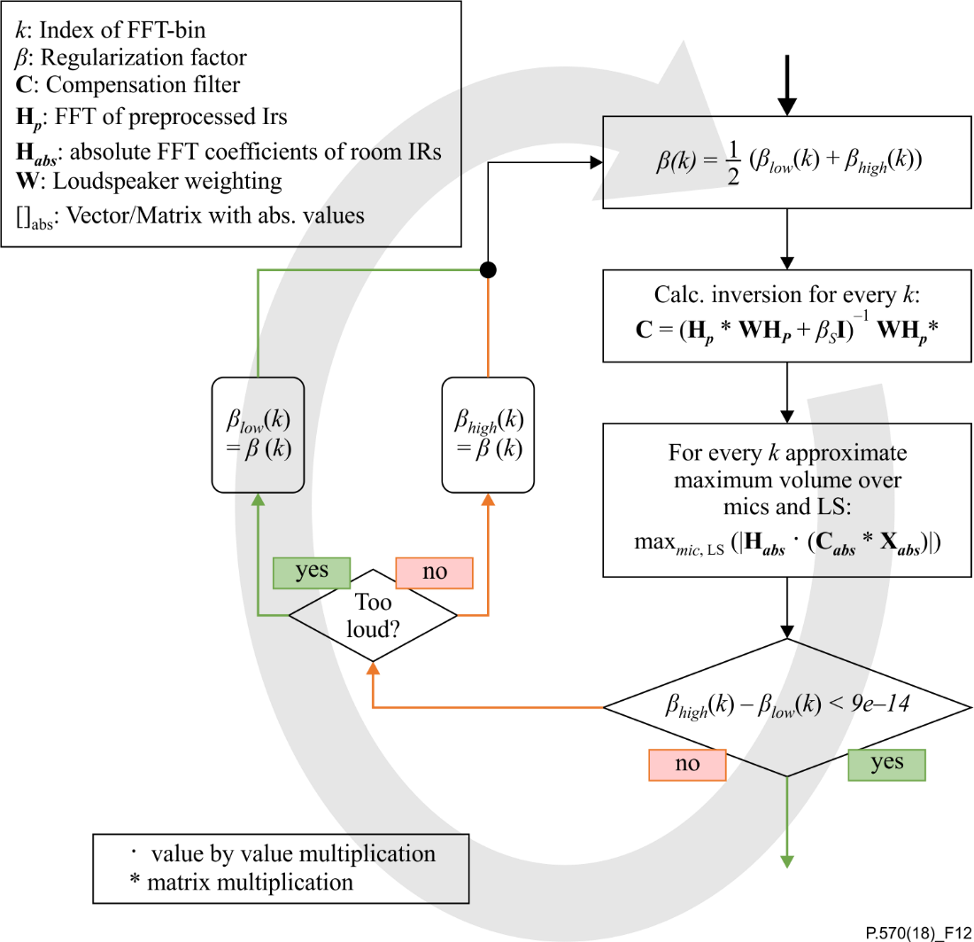

Figure 12 – Basic iterative process for calculating the regularization factors

To find a more exact solution of the equation system, an iterative procedure is used to find the lowest possible regularization factor β. This process is needed to avoid unstable solutions which in consequence may cause high loudspeaker output levels, leading to distortions of loudspeaker signals.

A summary of the search for the best regularization factor, as shown in Figure 9, follows. First, the variables βlow and βhigh are initialized with a very small value for βlow (e.g., 10−12) and a large value for βhigh(e.g., 10). Then, the regularization factor is chosen to be the mean of βlow andβhigh, and the compensating filters are calculated. Using these filters, the maximum output level of the loudspeakers is approximated. This is accomplished by simulating a playback of a typical (loud) sound recording. The spectrum of this recording is represented by **X** or **X**abs denoting its absolute version.

NOTE – In general, different spectra can be used for **X**. As a general rule, a spectrum representative for the maximum level and spectral content to be reproduced by the simulation system should be chosen. This can be achieved for instance by measuring typical noise situations which the system will be used for with a single measurement microphone. After measurement, the spectra of these measurements are averaged. The power spectral density (PSD) should be used for the frequency spectra. This will ensure that the calculated spectra are independent of FFT block size. The "too-loud" condition in Figure 12 is dependent on the loudspeakers. For many loudspeakers, a reasonable value for this condition is 50 dB re. 400 pPa²/Hz.

As **X**abs is an *n*-element vector, the matrix multiplication **C**abs \* **X**absresults in a virtual source signal that is used to simulate a playback by the loudspeakers. As the maximum level recorded at one microphone resulting from one loudspeaker needs to be determined (in contrast to the maximum at one microphone resulting from all loudspeakers playing at the same time), the value is calculated from **H**abs(**C**abs \* **X**abs**)**. The maximum of the resulting matrix is calculated to determine the maximum output level.

If loudspeakers reach their performance limit, i.e., for levels greater than the "too‑loud"-condition defined above, at the microphone positions, the regularization factor is increased and the next iteration cycle is performed until βlow and βhigh converge and an optimal value for β is found.

Figure 13 provides an example of **X** where all eight loudspeakers in the set-up were fed with eight incoherent pink noise channels with the maximum output level of the loudspeakers with a fixed gain. Once the recording is done, the PSD function is calculated for the recordings of all eight microphones. PSD is used to ensure that the level at each frequency line does not change dependent on the frequency resolution in FFT.

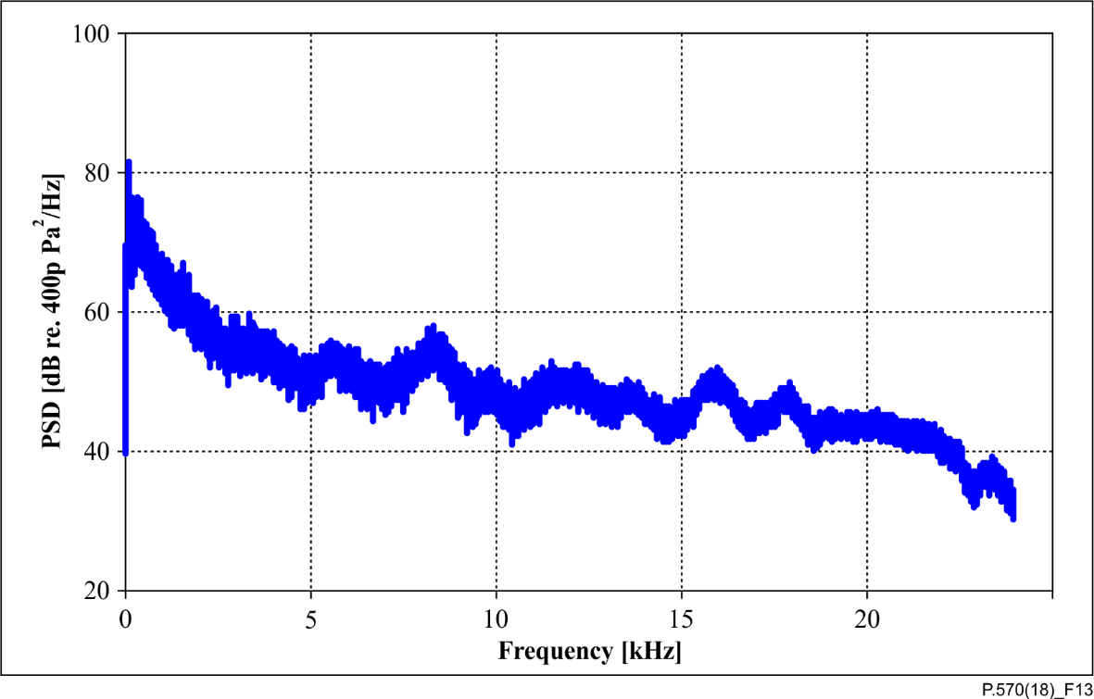

Figure 13 – An example of the maximum power spectral density across eight microphones, i.e., X, using incoherent pink noise individually for each of the eight loudspeakers

As an example, let us assume that the "best" β is 0.5. This means that a β < 0.5 exceeds the maximum volume allowed and a β > 0.5 could be decreased because the "too loud" – condition was not reached. Table 4 shows how the algorithm is used to find the "best" β of 0.5.

Table 4 – Regularization parameter during the optimization process

|  |  |  |  |  |
| --- | --- | --- | --- | --- |
| Step | βhigh | βlow | β |  |
| 1 | 10 | 1−12 | ~5 | Not too loud |
| 2 | 5 | 1−12 | ~2.5 | Not too loud |
| 3 | 2.5 | 1−12 | ~1.25 | Not too loud |
| 4 | 1.25 | 1−12 | ~0.625 | Not too loud |
| 5 | 0.625 | 1−12 | ~0.31 | TOO LOUD! |
| 6 | 0.625 | 0.31 | ~0.46 | TOO LOUD! |
| … | … | … | … | … |

8.2.6.3.****5.2.3.2**** Extended methodology to find the optimum regularization factor for frequencies above 2 kHz

The error at microphones in-between the calibration set positions may become larger for frequencies higher than 2 kHz, since the wavelengths are quite short in this frequency range. This might become a problem if a microphone of the DUT is located at such a position.

To overcome this, the regularization factor can be increased, which on one hand decreases the quality of reproduction at the calibration set positions, but on the other improves the variance of the error over all microphones of the calibration, as well as of the fine-tuning set.

Therefore, a second iterative procedure is used to find the regularization factors with the lowest error variance, starting with the best βvalues found during the first procedure. In each iteration, the βvalues are smoothed over frequency and the filters are calculated. Then a playback is simulated by filtering a previously made reference noise recording with those calculated inverse filters **C** and convolving the result with the original impulse responses **H** before preprocessing for the calibration, as well as the fine-tuning set positions.

For this reference noise recording, a well-defined sound field shall be generated by using eight uncorrelated broadband pink noise sources. The total signal level shall be about 70 dBSPL. This sound field shall then be recorded with microphones positioned in the calibration set and in the fine-tuning set. For hands-free or handset mode, different recordings have to be made. The frequency range of the noise signal shall cover all frequencies for which the system has to be equalized, which is the range from 20 Hz to 20 kHz.

After that, the variance of the error between the reference noise recording and the simulated playback, both at calibration and fine-tuning position, are calculated by determining minimum and maximum deviation and calculating the difference as depicted in Figure 14.

|  |  |  |  |  |
| --- | --- | --- | --- | --- |
| |  |  | | --- | --- | |  |  | |  |  | |

Figure 14 – Example of the calculation of the error variance and its enhancement due to optimization (top left: absolute error before optimization at 16 microphone positions;   
top right: minimum and maximum of error; bottom left: error range  
before optimization (difference between minimum and maximum);   
bottom right: final error range after optimization

In detail, the error range is calculated by the following steps:

1) a playback is simulated using the non-preprocessed IRs and the filters calculated with current regularization factors;

2) the simulated signals from 1 as well as the expected or source signals are smoothed with one-twentyfourth-octave resolution;

3) the differences between expected and simulated spectra are calculated;

4) minimum and maximum over all microphones are determined for every *k*;

5) then the error range is calculated for all *k*: $E\left(k\right)=MAX⁡(k)-\operatorname{MIN}\left(k\right)$

The smoothing which is applied during the iterative process shown in Figure 15 is calculated as follows:

1) calculate one-*n*th-octave representation of the given vector;

2) perform cubic interpolation between the bins of the one-*n*th-octave representation;

3) read values at FFT-bins from the interpolated curve.

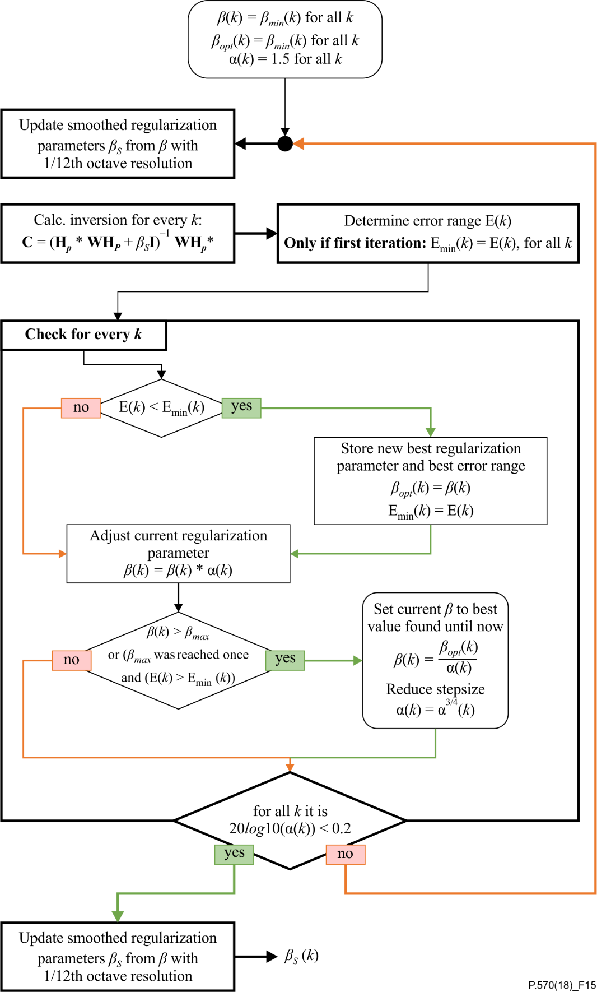

Figure 15 – Extended iterative process for calculating the regularization factor

If the error range decreased, the regularization factor β is stored as the new best value. Then β is increased by a factor α, which is initialized at 1.5. If β exceeds the upper threshold βmax = 1, it is reset to a little less than the best value found and the factor is decreased. It is also reset if the deviation did not decrease and β has already been reset once. The iteration ends if the multiplier becomes very small, i.e., 20log10(α) < 0.2.

#### 8.2.6.3.****6**** Step 6 – ****First test of inversion with recorded noise****

The quality of the equalization is assessed by playing back the noise recording which was made in clause 8.2.6.3.**3**. The reproduced sound field is recorded with the microphones of the calibration as well as with those of the fine-tuning set and compared to the reference noise recordings. The error *E*(*f*) is calculated by first determining the amplitude error for each used microphone in one-ninetysixth-octave bands, finding the minimum and the maximum error over frequency and calculating their mean.

#### 8.2.6.3.****7**** Step 7 – ****Adjusting the filter to compensate for inversion errors****

Several factors that influence the result of the equalization have been presented. First of all, the preprocessing of the impulse responses has a negative impact on inversion quality. In addition, non-linearities and arithmetic uncertainties introduce a deviation from the ideal output. As a last step, a correction filter *D*(*f*) compensates for the impact of the impulse response preprocessing on the inversion quality as well as arithmetic uncertainties (e.g., the regularization factor). The frequency response of this filter is calculated as the reciprocal of the previously calculated mean reproduction error *E*(*f*):

 (8-16)

For all frequencies below 1 800 Hz, the level is compensated for with the average of *D*(*f*) in the frequency range between 50 Hz and 1 800 Hz. Above 1 800 Hz, a minimum phase version of *D*(*f*) is applied to achieve causality and minimum additional delay.

This correction function is applied to all filters in the frequency domain. In the transition from level compensation (for frequencies lower than 1 800 Hz) to minimum phase filter (for frequencies higher than 1 800 Hz), the application of fading with a cosine (Hanning) characteristic to reduce artefacts in the time domain is recommended. The bandwidth of this fading should be one-third octave.

NOTE – Other implementations, e.g., those using a single minimum phase filter rather than having two steps in the procedure, could have negative influences on the phase for frequencies below 1 800 Hz.

#### 8.2.6.4 Accuracy of the equalization

After finalizing the equalization, the following criteria shall be met:

1) *Spectral reproduction accuracy.* The spectrum averaged over the individual microphones and averaged in the frequency bands for which they have been equalized should be flat to within ±3 dB from 50 Hz to 10 kHz measured in one-third octave.

2) *Level accuracy.* The level of the reproduced sound field at each microphone shall be accurate to within ±1 dB.

3) *Complex coherence*. The magnitude of the complex coherence (normalized cross-correlation spectrum, see [b-Carter] and [b-Priestley]) between the original signal and the reproduced signals at the fine-tuning position averaged over the individual microphones and averaged in the frequency bands for which they have been equalized, measured in one-third octave, should be >0.9 from 100 Hz to 1 kHz. The phase of the complex coherence should be accurate within +45° from 100 Hz to 1 kHz measured in one-third octave.

### 8.2.7 Loudspeaker equalization using a generalized multi-point noise simulation method with a flexible loudspeaker and microphone arrangement

An overview of the benefits and limitations of the method described in this clause can be found in clause 6.

This clause presents a generalization of the previously described Multi-point Method which allows the usage of the underlying equalization method for other, more flexible microphone or loudspeaker configurations.

#### 8.2.7.1 Loudspeaker configuration

This generalized multi-point noise simulation method requires at least two, preferably four, loudspeakers or more, which should not be placed close to each other but "as distributed as possible". In no case should the loudspeakers be in the microphone space, i.e., between the microphones.

If the loudspeakers cannot reproduce frequencies down to 50 Hz, i.e., their −3 dB point of the frequency response is much higher than 50 Hz, an additional subwoofer is needed. In this case, the weighted version of the Thikonov-regularization (see Equation 8-14) is used during the inversion procedure, where the diagonal weighting matrix **W** accounts for the different frequency ranges of the loudspeakers. It is suggested that the loudspeakers used be categorized into three groups as described in Table 5.

Table 5 – Definitions of loudspeaker categories

|  |  |
| --- | --- |
| Loudspeaker category | Frequency range |
| Subwoofer | 40 Hz to 120 Hz |
| Large loudspeaker | 50 Hz to 22 000 Hz |
| Small loudspeaker | 120 Hz to 22 000 Hz |

The values for the weighting matrix **W** are then 1 for the given frequency range and faded to 0 with a cosine characteristic within a one-third octave transition.

#### 8.2.7.2 Microphone set-up

No fixed microphone arrangement is required as it has to be arranged individually for every application. Either the output signal of the microphones of the DUT are used directly for equalization or additional measurement microphones are placed near those of the DUT.

In any case, the same microphone arrangement must be used for recording of background noise (see the following) and equalization of the system. Microphone characteristics, like frequency or phase response and directionality, shall be the same for both use cases.

The number of microphones in the calibration set, i.e., those used for the matrix inversion in clause 8.2.6.3.5, must not exceed the number of loudspeakers in the set-up excluding potential subwoofer. In general, it is recommended that there be more full-range loudspeakers in the set-up than microphones in the calibration set, to improve the accuracy of the equalization.

If it is not possible to use the DUT microphones directly, it is recommended that one measurement microphone be placed near to each DUT microphone. If special consideration of the directivity characteristic of the DUT microphone is necessary, at least two measurement microphones should be placed in the DUT microphone surroundings in order to more accurately simulate the sound field characteristics in that area.

Of course, the microphone configuration described in clause 7.5.1 may also be used.

#### 8.2.7.3 Background noise recordings and reference noise

Since the arrangement of the microphones is not fixed, but differs between different applications and (possibly) different DUTs, no default background noise scenarios can be provided. Instead, individual background noise recordings must be made for every application and microphone arrangement.

The equalization step of clause 8.2.6.3 requires a reference noise for the calculation of the inversion filters. One portion of the individual background noise recordings must be selected as reference noise. The selected reference noise should be 5 s to 10 s long and, obviously, representative of the individual background noise recordings, as the selected reference noise will be used to test the equalization, as well as for determining the maximum output volume of the loudspeakers.

#### 8.2.7.4 Adaptation of the equalization method in clause 8.2.6.3

The method described in clause 8.2.6.3 specifies performance of the following steps:

1) \*separate level adjustment for every loudspeaker;

2) \*system identification;

3) (\*)preprocessing of the impulse responses;

4) calculation of the inversion filters:

a. \*inversion procedure,

b. different microphones for different frequency bands,

c. \*search for the optimum regularization factor;

5) \*first test of equalization and filter adjustment for inversion error compensation.

However, this generalization only makes use of the steps marked with an asterisk. If a step needs modification in comparison to clause 8.2.6.3 it is described in the following. The matrix size (used to identify the system and to calculate the matrix inversion for equalization) depends on the number of loudspeakers and microphones chosen for the background noise simulation. The following adaptations are required for this variation:

In clause 8.2.6.3.3, the impulse responses are preprocessed with a low-pass filter with a time‑variant cut-off frequency to avoid a degradation of the quality of the inversion by high-frequency components of the tails of the impulse responses. This step reduces the accuracy of the equalization for higher frequencies. In the variant described in this clause, step 3 is considered as optional: As long as the tails of the impulse responses are short, it is suggested that the step be skipped.

In clause 8.2.6.3.4, different microphones were selected to calculate the inversion filters for each frequency band based on the corresponding wavelength. For the proposed generalized multi-point noise simulation method, the microphone distances are unknown and therefore this type of optimization [i.e., step 4)b in the list in the first paragraph] is not applied. All microphones are used across the whole frequency range to calculate the inversion filters.

In clause 8.2.6.3.4, the optimum regularization factor is searched subject to a limited loudspeaker output level to avoid distortion of the loudspeaker signals. "A spectrum representative for the maximum level and spectral content" (see the Note to clause 8.2.6.3.**5.2.3.1**) can be calculated from the reference noise selected. For this variant [i.e., step 4)c in the list in the first paragraph], the level of the filtered reference noise radiated by each loudspeaker to each microphone position shall not exceed the level which a pink noise of 50 dB re. 400 pPa²/Hz would generate in the same FFT-bin.

The extended methodology that aims to reduce the error at the so-called fine-tuning positions is not applicable, because the locations of the DUT microphones are well known and therefore those for calibration can be located close to them.

In clause 8.2.6.3.7, a correction filter *D*(*f*) is applied to compensate for the arithmetic uncertainties (e.g., the regularization factor) of the inversion. For this generalized multi-point noise simulation method, the microphone distances are unknown and therefore the cut-off frequency is reduced to 50 Hz.

#### 8.2.7.5 Special use case – inside vehicle

Clauses 8.2.7.1 to 8.2.7.4 specify a generalization of the multi-point method, while this clause provides instructions on how to apply the method to loudspeaker equalization inside a car.

##### 8.2.7.5.1 Loudspeaker configuration

As the generalized multi-point noise simulation method is compatible with the loudspeaker arrangement of clause 8.2.3 (four loudspeakers plus subwoofer), it is suggested that the same loudspeaker arrangement be used. As previously described, the required number of loudspeakers depends on the number of microphones. Accordingly, the number of loudspeakers shall be increased if more microphones are used in the calibration set.

##### 8.2.7.5.2 Microphone set-up

The microphones need to be arranged individually for each car interior and for each application.

##### 8.2.7.5.3 Equalization

Since the reverberation time in vehicle interiors is negligible compared to treated offices, the low-pass filtering (step 3) is omitted.

### 8.2.8 Loudspeaker equalization using the generalized multi-point method in a reference set-up

An overview of the benefits and limitations of the method described in this clause can be found in clause 6.

The method described in clause 8.2.6 specifies performance of the following:

1) \*separate level adjustment for every loudspeaker;

2) \*system identification;

3) preprocessing of the impulse responses;

4) calculation of the inversion filters:

a. \*inversion procedure,

b. different microphones for different frequency bands,

c. \*search for the optimum regularization factor;

5) \*first test of equalization and filter adjustment for inversion error compensation.

However, the simple method makes use of the procedure marked with an asterisk. Details of each step are given in clauses 8.2.8.1 to 8.2.8.5.

#### 8.2.8.1 Step 1 – Separate level adjustment for every loudspeaker

The matrix inversion method equalizes the loudspeaker room responses, and the level and frequency response differences among loudspeakers are compensated for. Nevertheless, it may be more reliable if the loudspeakers produce more or less the same sound pressure level with a given input signal. For that, a sine-sweep signal having a maximum value of −0.17 dB relative to full scale in the waveform audio (WAV) file is played through each loudspeaker, and the average sound pressure level across eight microphones is calculated. The loudspeaker gain is adjusted until the average sound pressure level reaches 94 dBSPL. The sound pressure level produced by each loudspeaker can further be increased if the reference (recorded) SPL is higher than the set-up is calibrated for.

#### 8.2.8.2 Step 2 – System identification

The room impulse response (RIR) functions between each loudspeaker and the microphones are measured. The level difference between the peak and noise part of impulse response functions is recommended to be higher than 60 dB to achieve impulse response functions with good SNR. Figure 16 shows an example of an RIR. The SNR, i.e., peak-to-noise-floor ratio, of approximately 90 dB is observed from the measured RIR.

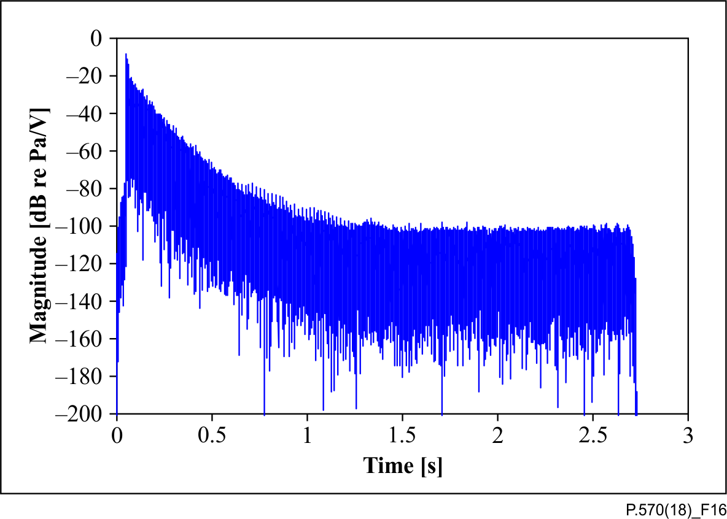

Figure 16 – An example of a room impulse response function RIR displayed in decibels

For RIR measurement, each loudspeaker is excited by a sine sweep signal. Compared to other types of excitation signals, swept sine is able to separate non-linear distortion created by the loudspeakers from the linear part of the impulse response function [b-Müller]. For the sake of convenience, the same notation as used in clause 8.2.6 is used in the following. The deconvolution of input and output signals can be done by dividing the microphone signal *Y*(*f*) by the loudspeaker excitation signal *S*(*f*) in the frequency domain and subsequently taking the inverse FFT of the division. *H*(*f*) denotes the measured room frequency response (RFR) function and *h*(*t*) is the corresponding RIR. The frequency response functions are derived in the frequency range between 20 Hz to 20 kHz.

#### ****8.2.8.3**** Step 4, a – ****Inversion procedure****

A detailed description of the matrix inversion method used by the multi-point method is provided in [b-Kirkeby 1996]. When playing a set of signals through loudspeakers, the resulting signals at microphone positions can be formulated as

$\left(\begin{matrix}w_{1} \\ ⋮ \\ w_{r}\end{matrix}\right)=\left(\begin{matrix}H_{1,1} & ⋯ & H_{1,l} \\ ⋮ & ⋱ & ⋮ \\ H_{r,1} & ⋯ & H_{r,l}\end{matrix}\right)\left(\begin{matrix}v_{1} \\ ⋮ \\ v_{l}\end{matrix}\right)$ (8-17)

where $v$ is the loudspeaker signal, $w$ is the reproduced signal measured at microphones, and $H_{r,l}$ is the RFR between the *l*th loudspeaker and the *r*th microphone. The pseudo inverse of the RFR matrix **H** can be calculated by making use of Thikonov regularization.

$C={\left(H^{*}H+βI\right)}^{-1}H^{*}$ (8-18)

Where **C** is the inverse matrix of the RFR matrix **H**, **I** is the identity matrix, and β is a regularization parameter. The regularization parameter, i.e., β, is introduced to make the matrix inversion more stable. The threshold for the regularization parameter in decibels, i.e., 20log10(1/β), quantifies the amount of regularization. The matrix inversion procedure is applied for each frequency line separately, and the loudspeaker signals are calculated by Equation 8-19.

$\left(\begin{matrix}v_{1} \\ ⋮ \\ v_{r}\end{matrix}\right)=\left(\begin{matrix}C_{1,1} & ⋯ & C_{1,r} \\ ⋮ & ⋱ & ⋮ \\ C_{l,1} & ⋯ & C_{l,r}\end{matrix}\right)\left(\begin{matrix}u_{1} \\ ⋮ \\ u_{r}\end{matrix}\right)$ (8-19)

where $u$ is the reference signal recorded with an array of microphones in a reference sound field.

Instead of performing the matrix multiplication in the frequency domain, the equalization filter *c*(*t*) is calculated by taking the inverse FFT for each element of **C**. Subsequently, the convolution between the reference signals at the microphones and the equalization filters is done in the time domain, and the result of the convolution added to derive the resulting signal for each loudspeaker.

#### 8.2.8.4 Step 4, c – Search for the optimum regularization factor

An optimal regularization parameter can be found for a loudspeaker set-up before running actual device tests. It may be achieved by going through a number of regularization thresholds and checking the magnitude error, as well as coherence. The range of thresholds may be suggested between −20 dB (10) to 40 dB (0.01). A step size of 5 or 10 dB can be selected. The magnitude error and coherence function can be compared across different thresholds in order to select an optimal threshold to be used via visual inspection.

Audible artefacts may be observed when selecting higher thresholds, i.e., lower regularization parameter, even if the resulted errors are relatively small. Therefore, it is recommended that objective results be checked first, i.e., magnitude error and coherence, and for the selected threshold, the presence of audible artefacts should be examined by reproducing or listening to typical background noise under investigation.

#### 8.2.8.5 Step 5 – First test of equalization and filter adjustment for inversion error compensation

The matrix inversion method gives rise to very accurate sound reproduction at target positions where the sound field is optimized. However, the result at validation positions deviates more from the reference sound field, and the amount of deviation is dependent on how far the validation positions are from the target positions as well as the frequency. At low frequencies, the distance between the target and validation positions has less effect compared to high frequencies due to the wavelength corresponding to the frequency of interest. For the validation positions, far from the target positions, it is necessary to compensate for the average magnitude error across all microphones. If a few validation positions are far from the target positions and the rest are close to each other, the maximum and the minimum of magnitude error over frequency may be averaged in order to bring the magnitude error at far distances within the ±3 dB range.

The magnitude error compensation is done once for a reference stimulus using incoherent pink noise, and the same compensation filter is used for other types of stimuli. The average error function across all microphones in one-twelfth-octave bands are linearly interpolated in frequency, and the inverse FFT of the interpolated response is calculated to derive the corresponding impulse response function. The resulting impulse response function is transformed to a minimum phase counterpart in order not to introduce further delays and non-causality in the processing.

### 8.2.9 Loudspeaker equalization using the over-determined multi-point method in a reference set-up

An overview of the benefits and limitations of the method described in this clause can be found in clause 6.

The optimal output of the matrix inversion method may be achieved by positioning the target microphones close to the built-in microphones of a device. When the microphone positions are further away from the device, the coherence between the reference and reproduced recordings may drop significantly at high frequencies, even though the magnitude error can be within a reasonable range. Decrease in coherence eventually means that perception in the reference sound field may not be similar to perception in that reproduced. It has been shown that the over-determined multi‑point method, i.e., the number of loudspeakers higher than the number of calibration microphones, can derive the loudspeaker signals in such a way that the matrix inversion becomes more stable. The reproduction error in the validation microphones seems to decrease when using a higher number of loudspeakers than the number of microphones. For example, even if there are eight loudspeakers installed in the set-up, a couple of target microphone positions can be selected for the optimal sound reproduction.

The procedure for the over-determined multi-point method is exactly the same as that for the generalized multi-point method in clause 8.2.8.

## 8.3 Reproducing artificial noise fields in a simulation set-up

Pre-recorded noises to be used for various background noise scenarios are expected to become available in a future ITU-T Recommendation. Such recordings can be used for validation of various noise reproduction set-ups at various test laboratories.

# 9 Techniques for synthetizing noise fields

While other techniques described in this Recommendation have the goal of reproducing sound fields recorded at a specific time and place, this clause describes how several sources can be superimposed at playback time to create an artificial sound field.

Specifically, it is the intention of this clause to address the following situations.

– A number of non-coherent sources are used to approximate a diffuse sound field of stationary noise (typically pink noise or [b-Hoth] noise signals).

– A number of non-coherent sources is used to approximate a sound field of non-stationary properties, e.g., several loudspeakers play different babble recordings comprising a number of talkers each, simulating being at a restaurant surrounded by a number of guests.

– A special case of the above is a mono recording that is played in all loudspeakers, but with significant delay (several seconds) between the reproduction channels. This decorrelates the signals so that interference effects are minimized (except for periodic signals).

– One of the sound field reproduction methods described in this Recommendation (e.g., mono or binaural recordings reproduced on four loudspeakers) is altered to include significant delays (several seconds) between the reproduction channels. This decorrelates the signals so that interference effects are minimized (except for periodic signals).

– Additional sources are added to one of the sound field reproduction methods described in this Recommendation, e.g., a competing talker at a certain incidence angle is added on top of a background noise.

Advantages of building up an artificial sound field from several sources include:

– the different sources can be adjusted in level, time and space depending on the needs for the specific test, without re-recording the material;

– anechoic recordings reproduced *in situ* (thus including the target acoustics) have a potential to produce natural field properties;

– the signals are easy to capture (e.g., a mono recorder);

– there are no interference effects between channels and thus the robustness to position is high;

– the method is free from some artificial effects in the time domain (echoes, smearing of transients), that might occur for methods using small delays at playback time for partly decorrelating signals;

– the equalization procedure is straightforward.

Considerations include:

– although the final sound field can be representative of a real situation, it is after all artificially created;

– compared to advanced methods that recreate actual field properties (ambisonics etc.), the method described here is limited in the number of simultaneous incidence angles that are represented (to the number of loudspeakers used);

– for non-anechoic reproduction conditions, the reproducibility will be affected by the room characteristics;

– for non-anechoic mono recording conditions, the reverberation is also captured in mono;

– complex distributed sound fields are difficult to reproduce with this set-up.

## 9.1 Equalization procedure

Each loudspeaker is equalized using the single microphone technique outlined in clause 8.2.2, except that the final step (clause 8.2.2.5) is omitted.

## 9.2 Recommended set-ups

For consistency with other methods in this Recommendation, the loudspeaker angles and distances presented in Figures 4 and 6 and Annex A are recommended.

# 10 Techniques for assessing artificial noise fields

## 10.1 Assessment based on spectral content

This is currently not covered in this Recommendation.

## 10.2 Assessment based on spatial coherence

This is currently not covered in this Recommendation.

## 10.3 Assessment of uniformity

This is currently not covered in this Recommendation.

# 11 Documentation of measurements in artificial noise fields

To document an artificial sound field that has been established by one of the methods described in this Recommendation, the following information shall be provided:

– the loudspeaker configuration that has been used to create the sound field shall be documented, preferably with direct reference to Annex A;

– the equalization method that has been used for compensation of the loudspeakers shall be documented and specifically state whether a single measurement microphone, a binaural HATS or a microphone array have been used;

– the environment in which the loudspeaker configuration was located, e.g., an anechoic chamber, a treated office, an ordinary office or a vehicle.

To further quantify the quality of the artificial sound field, the following information shall be provided:

– the type of signal, as well as the level that was used for the equalization;

– the accuracy of the equalization that has been established.

For further characterization of the artificial sound field additional parameters could be provided. Such parameters are:

– the overall level as well as the spectrum of the ambient noise, when no signals are applied to the loudspeaker configuration;

– the reverberation time of the environment in which the loudspeaker configuration is located should be provided.

Annex A  
  
Loudspeaker performance

(This annex forms an integral part of this Recommendation.)

When measured under free-field conditions and using a measurement microphone placed 1 m in front of the loudspeaker, the following specifications must be fulfilled:

– a sound pressure level at 300 Hz of 100 dBSPL must be supported.

– the frequency response of the loudspeaker must be within ±10 dB in the frequency range 100 Hz to 20 kHz.

– the total harmonic distortion of the second and third harmonic must be less than 3% when measured at a constant level of 90 dBSPL over the frequency range 100 Hz to 20 kHz.

– the level measure at ±10° off-axis in the horizontal plan must be lower than 3 dB compared to the on-axis level, when measured in the frequency range 100 Hz to 20 kHz.

When measured under free-field conditions and using a measurement microphone placed 1 m in front of the subwoofer, the following specifications must be fulfilled:

– a sound pressure level at 50 Hz of 110 dBSPL must be supported;

– the frequency response of the loudspeaker must be within ±0 dB in the frequency range 50 Hz to 300 Hz;

– the total harmonic distortion of the second and third harmonic must be less than 10% when measured at a constant level of 90 dBSPL over the frequency range 50 Hz to 300 Hz;

– it is implicit that the directivity of the subwoofer will be acceptable for the application.

Appendix I  
  
Requirements for test environments

(This appendix does not form an integral part of this Recommendation.)

The requirements that should be considered for a typical reference set-up, such as an anechoic chamber, a listening room, an acoustically treated office and a reverberant room, are summarized as follows.

– For an anechoic chamber, no additional requirements should be considered. However, an anechoic chamber should be professionally designed, implying the use of very thick absorbing materials. Furthermore, it is important to realize that a "quiet" room is not necessarily anechoic.

– For a listening room, it will in general be difficult to outline what should be considered. For more specific information see [IEC TR 60268-13], which gives recommendations for establishing, conducting and evaluating listening tests on loudspeakers, as well as general guidelines. With regards to determining the reverberation time, [IEC TR 60268-13] calls for one-third-octave measurements.

– For an acoustically treated office, the following requirements should be considered:

• The floor area should be at least 3.5 m × 3.5 m.

• The room height should be at least 2.5 m.

• No dimension should be an integral multiple of another.

• The floor should be carpeted.

• The ceiling should have acoustical damping.

• The reverberation time should be less than 0.7 s but higher than 0.2 s in the frequency range between 100 Hz and 8 kHz. For the multi-point reproduction technique, the *C*80 criterion (see clause 8.2.6.2) should be applied.

• Strong reflections and standing waves caused by hard surfaces in the room should be avoided. One or two walls should be treated, e.g., with appropriate acoustical damping material.

• Choose loudspeaker and diffuse-field test point (DFTP) carefully and verify the position. The DFTP is at the geometric centre of the loudspeakers, but DFTP should be slightly off-centre, in all dimensions.

– For a reverberant room, no additional requirements should be considered. However, a "reverberant room" does imply that the walls and ceiling are of solid construction. Furthermore, replacing absorbent ceiling panels with 12 mm gypsum board is in many instances insufficient to render a room reverberant.

Additionally, it is recommended that:

– the operator be protected from test sounds that can be up to 90 dBSPL or even higher;

– a larger space be used than 3.5 m × 3.5 m for ease of operator access;

– placing the loudspeakers in the corner of the room be avoided in order to reduce the presence of resonances;

– placing the loudspeakers in a perfect square be avoided;

– positioning the HATS or the measurement microphone in the exact centre of a square be avoided;

– the influence of external noise be reduced by ensuring that the level is less than 30 dBSPL(A):

• separate a test room from operator areas, so that noise from personal computers (PCs) and other equipment, as well as the operator, can be controlled,

• separate an entire test suite from other workers as test sounds up to 90 dBSPL can occur and cause annoyance,

• minimize air-borne noise from ventilation by increasing the length of ventilation pipes and by lining them,

• minimize structure-borne noise from elevators, traffic, etc.,

• seal openings under doors, cable penetrations, etc.,

• sound isolating materials,

• locate a test room on solid ground, if possible,

• install floating floors,

• check for noisy devices that operate only occasionally.

For operator convenience, the following are recommended:

– provision of a clear view of the test space;

• window between control area and test room,

• camera and display screen;

– cable routing that is sensible:

• clear labels (tags or colour-code),

• position cables so tripping is prevented;

– appropriate lighting:

• sufficient light for operator to access equipment,

• low heat generation to ensure consistent measurement conditions;

– an intercom for communication between operator and the test room;

– an outline of a power on/off sequence for complete and reliable switching on/off equipment.

Appendix II  
  
Loudspeaker configurations and decoding of loudspeaker signals

(This appendix does not form an integral part of this Recommendation.)

For the reference test environment category specified in Annex A, some compensation could be necessary to provide better unity between tests performed in, for example, a large anechoic chamber and a listening room conforming to the acoustic requirements of [ITU‑R BS.1116‑3]. For example, the absolute distance of each loudspeaker from the centre of an orthogonal array may be dependent on or restricted by the dimensions of the room.

A simple way of uniquely specifying the orthogonal array without having to describe the required or implemented absolute position of each loudspeaker in relation to the test environment is to specify the Cartesian coordinates (*x*, *y*, *z*) of each source about a unit scale. Examples of this definition for a number of arrays are shown in Figures II.1 to II.4. This positional specification can also be used to report additional loudspeakers used to reproduce signals independent of the simulated noise field (e.g., competing speech).

An assumption here is that each loudspeaker source can provide the full range of frequencies required to accurately simulate a noise field, e.g., including enough low-frequency energy. This may not be feasible or practical to implement and so may require additional low frequency sources, i.e., so‑called subwoofer/s. In this case, it may be possible to either have separate low-frequency extension speakers dedicated to each full-range speaker or, more likely, one or more subwoofers that are assigned the low frequency content of all source signals, depending on the format of the simulated noise recording. For practical purposes, any recommended specification of how the subwoofer is to be placed would be based primarily on the test environment and the system calibration procedure.

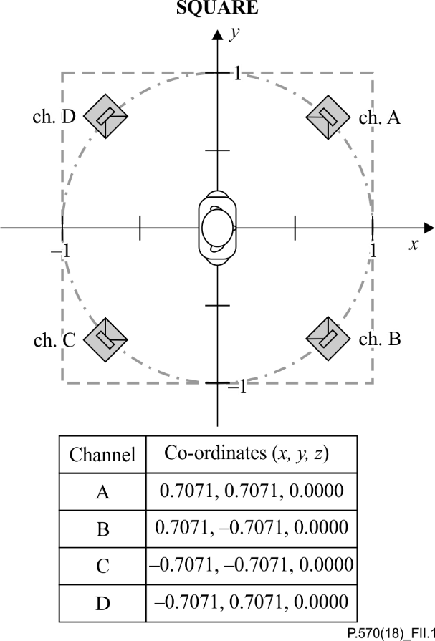

Figure II.1 – Horizontal plane loudspeaker array in a square configuration

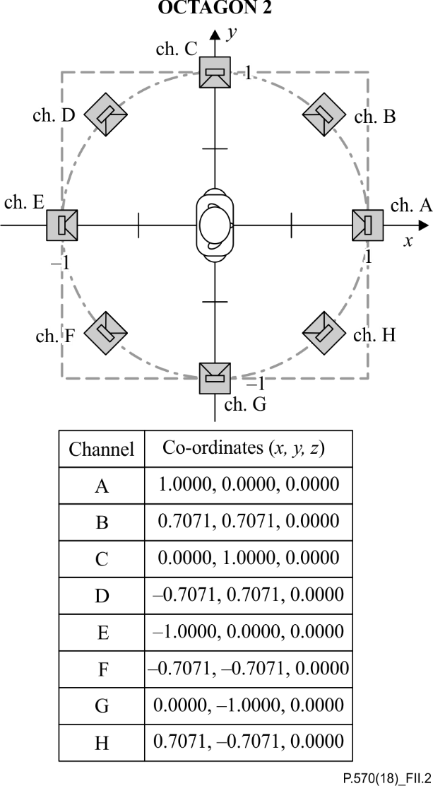

Figure II.2 – Horizontal plane loudspeaker array in an octagonal configuration

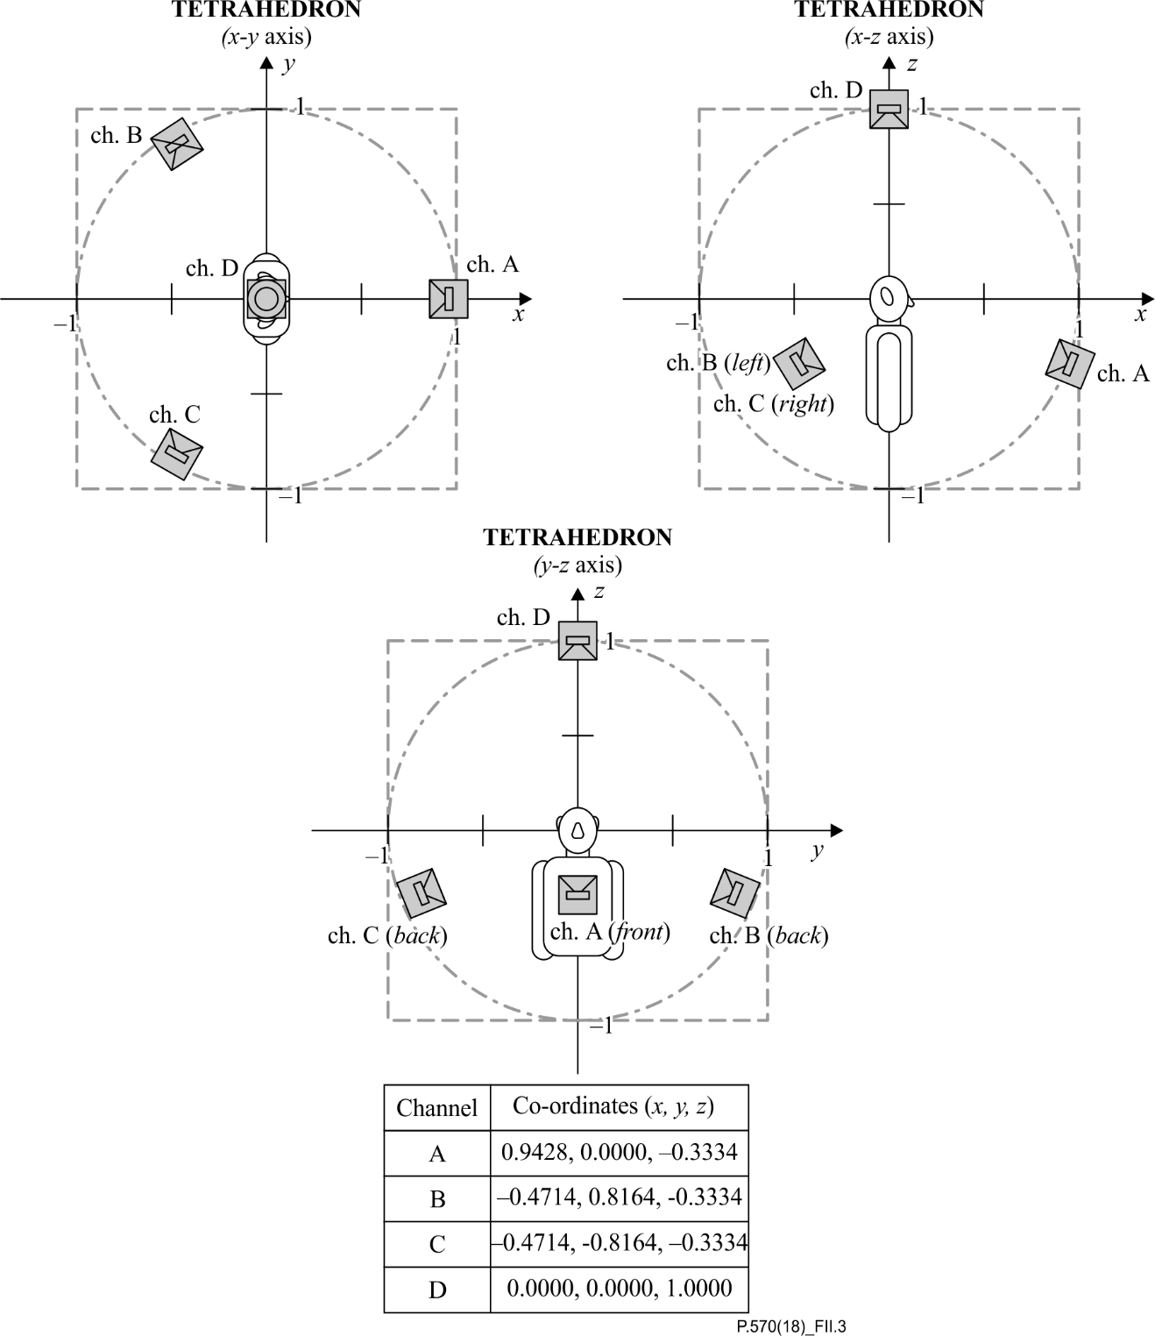

Figure II.3 – Horizontal and vertical plane loudspeaker array in a tetrahedral configuration

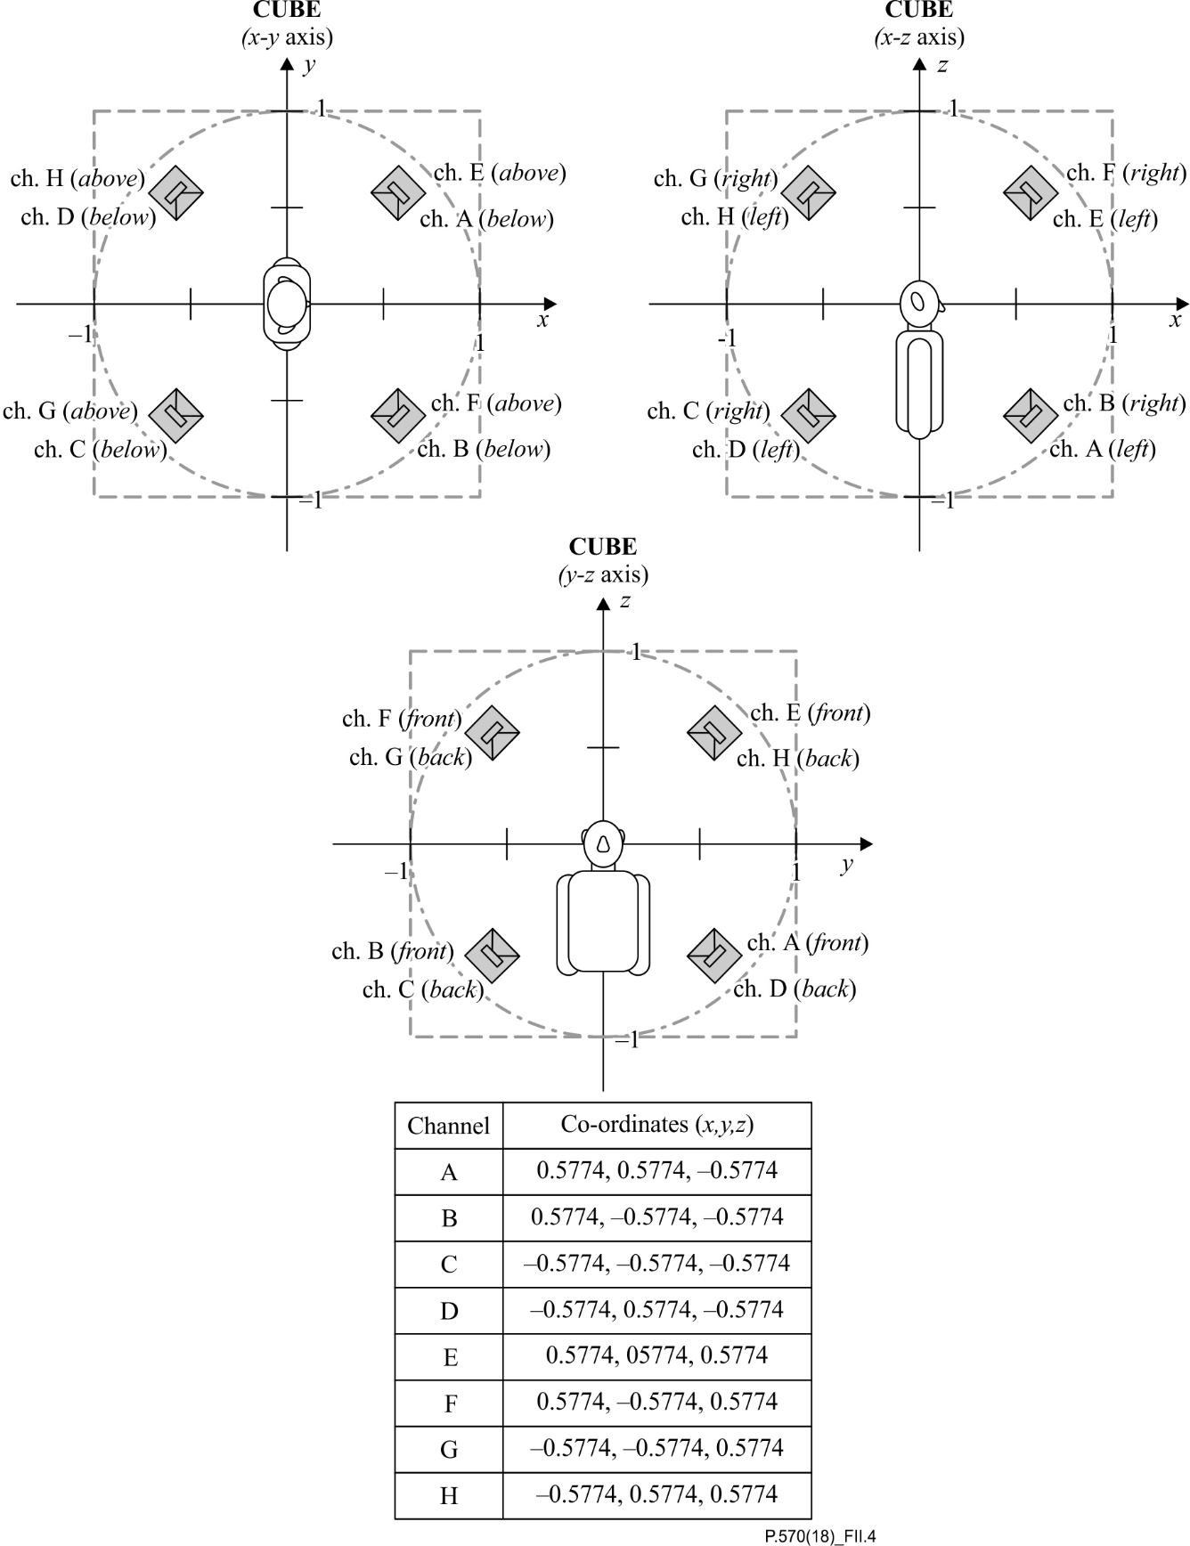

Figure II.4 – Horizontal and vertical plane loudspeaker array in a cubic configuration

The B-format signal can be decoded to represent any number of microphone responses or polar patterns from any direction within the approximated unit sphere (or unit circle if the *Z*-component is omitted) making the B-format very efficient and flexible for simulating coincident mono, stereo or multichannel recording techniques. For sound field reproduction over loudspeakers, it also allows wave front reconstruction, either pantophonic or periphonic, through decoding to orthogonal arrays of loudspeakers each reconstructing the wave field associated with its individual angle of incidence to the centre of the array.

Several different "flavours" of loudspeaker decoding rules for first-order ambisonic signals have been proposed over the years, some taking advantage of psychoacoustic principles to improve spatial or immersive perception. However, the simplest form of decoding from B-format for an orthogonal loudspeaker array I which each loudspeaker is at the same distance from the origin of the array at an azimuth angle *α* and an elevation angle *β* would describe the signal sent to each loudspeaker as:

*S*LS(α,β) = *W* + *X*(cos α× cos β) + *Y*(sin α× cos β) + *Z*(sin β)

where the $\sqrt{2}$*W* term accounts for the weighting in the B-format encoding noted above. Power normalization dependent on the number and configuration of loudspeakers can be achieved by using:

$$S_{LS\left(α,β\right)}=\frac{\sqrt{2}}{N}W+\frac{d}{N}X\left(\cos{α}×\cos{β}\right)+\frac{d}{N}Y\left(\sin{α}×\cos{β}\right)+\frac{d}{N}Z\left(\sin{β}\right)$$

where *N* is the number of speakers in the array and *d* is the number of axes used in the array (e.g., for a square, pantophonic array *d* = 2 but for a cubic, periphonic array *d* = 3).

As examples, Table II.1 shows the unit gains, with signs representing the phase that should be applied to the B-format channels before mixing to create the D-format signal for each loudspeaker in the loudspeaker arrays shown in Annex A. These gains have been calculated using *S*LS(α,β) with the relevant values of *N*, *d*,α and β also provided in Table II.1.

$$S_{LS\left(α,β\right)}=\frac{\sqrt{2}}{N}W+\frac{d}{N}X\left(\cos{α}×\cos{β}\right)+\frac{d}{N}Y\left(\sin{α}×\cos{β}\right)+\frac{d}{N}Z\left(\sin{β}\right)$$

| Table II.1 – Multiplication gains for mixing B-format signals to D-format | | | | | | | | | |
| --- | --- | --- | --- | --- | --- | --- | --- | --- | --- |
| Array | *N* | *d* | LS channel | α | β | *W*gain | *X*gain | *Y*gain | *Z*gain |
| Square | 4 | 2 | A | 45 | 0 | 0.3536 | 0.3536 | 0.3536 | 0 |
| 4 | 2 | B | 315 | 0 | 0.3536 | 0.3536 | −0.3536 | 0 |
| 4 | 2 | C | 225 | 0 | 0.3536 | −0.3536 | −0.3536 | 0 |
| 4 | 2 | D | 135 | 0 | 0.3536 | −0.3536 | 0.3536 | 0 |
| Hexagon | 6 | 2 | A | 0 | 0 | 0.2357 | 0.3333 | 0 | 0 |
| 6 | 2 | B | 60 | 0 | 0.2357 | 0.1667 | 0.2887 | 0 |
| 6 | 2 | C | 120 | 0 | 0.2357 | −0.1667 | 0.2887 | 0 |
| 6 | 2 | D | 180 | 0 | 0.2357 | −0.3333 | 0 | 0 |
| 6 | 2 | E | 240 | 0 | 0.2357 | −0.1667 | −0.2887 | 0 |
| 6 | 2 | F | 300 | 0 | 0.2357 | 0.1667 | −0.2887 | 0 |
| Octagon | 8 | 2 | A | 0 | 0 | 0.1768 | 0.25 | 0 | 0 |
| 8 | 2 | B | 45 | 0 | 0.1768 | 0.1768 | 0.1768 | 0 |
| 8 | 2 | C | 90 | 0 | 0.1768 | 0 | 0.25 | 0 |
| 8 | 2 | D | 135 | 0 | 0.1768 | −0.1768 | 0.1768 | 0 |
| 8 | 2 | E | 180 | 0 | 0.1768 | −0.25 | 0 | 0 |
| 8 | 2 | F | 225 | 0 | 0.1768 | −0.1768 | −0.1768 | 0 |
| 8 | 2 | G | 270 | 0 | 0.1768 | 0 | -0.25 | 0 |
| 8 | 2 | H | 315 | 0 | 0.1768 | 0.1768 | −0.1768 | 0 |
| Cube | 8 | 3 | A | 45 | −35.26 | 0.1768 | 0.2165 | 0.2165 | −0.2165 |
| 8 | 3 | B | 315 | −35.26 | 0.1768 | 0.2165 | −0.2165 | −0.2165 |
| 8 | 3 | C | 225 | −35.26 | 0.1768 | −0.2165 | −0.2165 | −0.2165 |
| 8 | 3 | D | 135 | −35.26 | 0.1768 | −0.2165 | 0.2165 | −0.2165 |
| 8 | 3 | E | 45 | 35.26 | 0.1768 | 0.2165 | 0.2165 | 0.2165 |
| 8 | 3 | F | 315 | 35.26 | 0.1768 | 0.2165 | −0.2165 | 0.2165 |
| 8 | 3 | G | 225 | 35.26 | 0.1768 | −0.2165 | −0.2165 | 0.2165 |
| 8 | 3 | H | 135 | 35.26 | 0.1768 | −0.2165 | 0.2165 | 0.2165 |

Appendix III  
  
Spatial sound field stability

(This appendix does not form an integral part of this Recommendation.)

## III.1 Reproduction of monophonic signals in anechoic conditions

### III.1.1 Introduction

This appendix documents the spatial stability of the reproduced noise field that can be achieved using the microphone method as described in clause 8.2.2. All measurements were performed in an anechoic room.

### III.1.2 Description of the set-up

The loudspeakers were positioned in a square with the microphone at the centre (and in the same plane) as shown schematically in Figure III.1 (around 2 m between the loudspeakers and the microphone); Figure III.2 is a photograph of the actual set-up. Particular attention was paid to not creating a perfect square and to not positioning the microphone at its exact centre. No subwoofer was used in the set-up, thus results are valid from 120 Hz to 20 kHz.

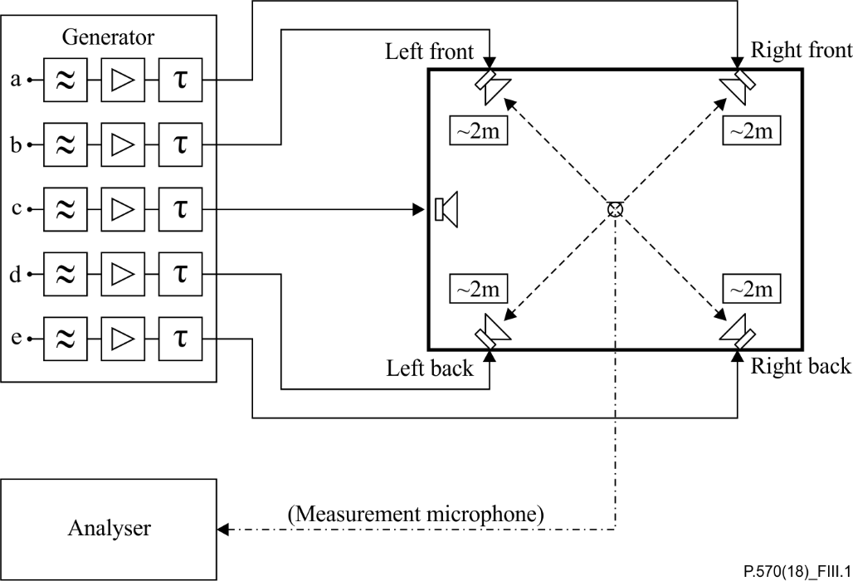

Figure III.1 – The set-up for loudspeaker equalization using the microphone method

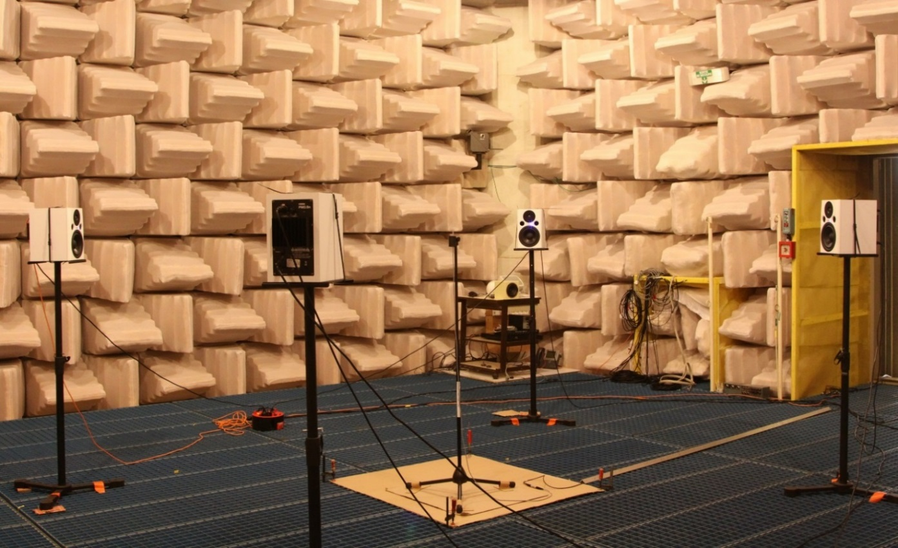

Figure III.2 – Actual set-up using the microphone method in an anechoic room

In order to determine the spatial stability of the reproduced noise field, several measurements around the equalization centre (original position of the microphone for the equalization) were taken. These measurements were done according to Figure III.3.



Figure III.3 – Measurement points (blue circles) for the reproduced noise field

The stability of the sound field in a square of 100 mm × 100 mm around the equalization centre (*X* = 0 mm; *Y* = 0 mm) was measured. Note that the equalization centre corresponds to the original position at which the equalization was realized according to this Recommendation. Measurements were taken every 10 mm on both the *X*- and *Y*-axis (blue circles in Figure III.3) leading to 121 measurements for the full plan.

The test signal that was used for all measurements is pink noise (high-pass filtered as required by this Recommendation) and its level was adjusted in order to get around 75 dBSPL (A) at the equalization centre. The reference used for the calculation of frequency responses is the signal measured at the equalization centre. This signal is used as the reference for the calculation of the frequency responses for all points of the grid defined in Figure III.3.

The results presented in clause III.1.3 are magnitude measured in one-third octave across the full plan.

### III.1.3 Results comparison

Two equalization approaches were tested and their results are compared in this clause. The only difference between these two approaches is the delay adjustment step (see clause 8.2.2.4).

The first approach is slightly different to that described in this Recommendation, since it aims to perfectly synchronize the signals coming from the four loudspeakers at the measurement microphone. The advantage of this method is that it leads to a very good equalization at the measurement microphone (i.e., theequalization centre). This method is referred to as "anechoic room: synchronized delays" in this appendix.

The second approach is that described in this Recommendation where fixed delays (0 ms, 11 ms, 17 ms, 29 ms) are applied to individual loudspeakers in order to increase the diffusivity of the noise field. For the actual examination, different delays were used, i.e.,0 ms, 13 ms, 22 ms, 45 ms, as in that configuration they gave a flatter response than using the recommended delays. This is illustrated in Figure III.4, where the result of equalization is shown in one-third octave for the recommended and modified sets of delays. This retained method is referred to as "anechoic room: fixed delays" in this appendix.

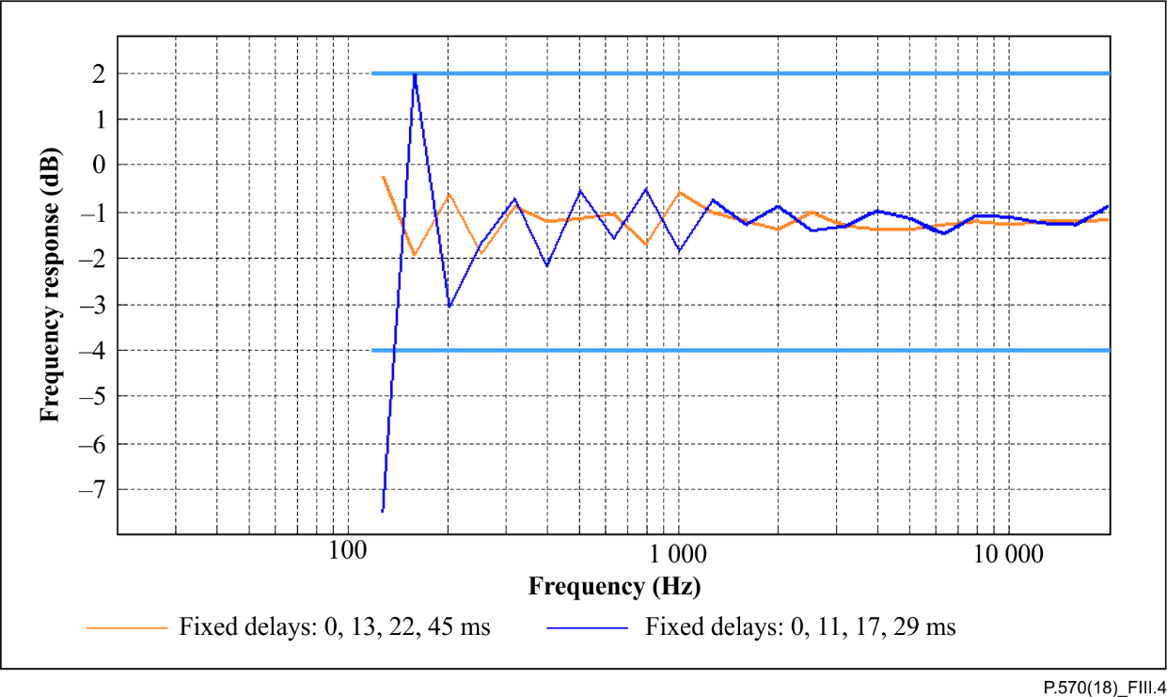

Figure III.4 – Results of equalization in one-third octave for all loudspeakers with fixed delays: for recommended delays, 0 ms, 11 ms, 17 ms, 29 ms (in blue); for the modified set of delays, 0 ms, 13 ms, 22 ms, 45 ms (in orange)

The results for both approaches are shown in Table III.1. Each row corresponds to a one-third octave band. The displayed results start with the one-third octave band centred on 126 Hz and ends with that centred on 19 953 Hz.

Measurements were done every 10 mm on both the *X*- and *Y*-axis; however, in order to get better visual results, images were interpolated with a 1 mm step. Note that the 10 mm step is too large to capture the characteristics at high frequencies.

Table III.1 – Anechoic room results – left: synchronized delays; right: fixed delays

| Anechoic room: Synchronized delays | Anechoic room: Fixed delays |
| --- | --- |
| Spatial stability of noise field at 126 Hz | Spatial stability of noise field at 126 Hz |
| Spatial stability of noise field at 158 Hz | Spatial stability of noise field at 158 Hz |
| Spatial stability of noise field at 200 Hz | Spatial stability of noise field at 200 Hz |
| Spatial stability of noise field at 251 Hz | Spatial stability of noise field at 251 Hz |
| Spatial stability of noise field at 316 Hz | Spatial stability of noise field at 316 Hz |
| Spatial stability of noise field at 398 Hz | Spatial stability of noise field at 398 Hz |
| Spatial stability of noise field at 501 Hz | Spatial stability of noise field at 501 Hz |
| Spatial stability of noise field at 631 Hz | Spatial stability of noise field at 631 Hz |
| Spatial stability of noise field at 794 Hz | Spatial stability of noise field at 794 Hz |
| Spatial stability of noise field at 1000 Hz | Spatial stability of noise field at 1000 Hz |
| Spatial stability of noise field at 1259 Hz | Spatial stability of noise field at 1259 Hz |
| Spatial stability of noise field at 1585 Hz | Spatial stability of noise field at 1585 Hz |
| Spatial stability of noise field at 1995 Hz | Spatial stability of noise field at 1995 Hz |
| Spatial stability of noise field at 2512 Hz | Spatial stability of noise field at 2512 Hz |
| Spatial stability of noise field at 3162 Hz | Spatial stability of noise field at 3162 Hz |
| Spatial stability of noise field at 3981 Hz | Spatial stability of noise field at 3981 Hz |
| Spatial stability of noise field at 5012 Hz | Spatial stability of noise field at 5012 Hz |
| Spatial stability of noise field at 6310 Hz | Spatial stability of noise field at 6310 Hz |
| Spatial stability of noise field at 7943 Hz | Spatial stability of noise field at 7943 Hz |
| Spatial stability of noise field at 10000 Hz | Spatial stability of noise field at 10000 Hz |
| Spatial stability of noise field at 12589 Hz | Spatial stability of noise field at 12589 Hz |
| Spatial stability of noise field at 15849 Hz | Spatial stability of noise field at 15849 Hz |
| Spatial stability of noise field at 19953 Hz | Spatial stability of noise field at 19953 Hz |

Obviously, spatial stability results for these two approaches are very different. For the fixed delays, the noise field is very stable on the measured plan. In one-third octave, a variation of less than 3 dB over the full frequency range (120 Hz to 20 kHz) can be observed.

For the synchronized delays, the noise field is stable (less than 3dB of variation) up to around 1 kHz. For higher frequencies, attenuations occur. These attenuations follow a regular pattern that can be associated with a spatial comb filter. The size of this pattern decreases when frequency increases, i.e.,when wavelength decreases. This behaviour is less desirable from a spatial stability perspective than that obtained using fixed delays, because the resulting noise field is not stable (up to 21 dB of attenuation), which is an issue when testing mobile phone noise reduction, for instance.

So, the noise field stability obtained using fixed delays seems to be very good. It is true when analysed in third octave because signal spectrum is averaged over a large frequency range (increasing with frequency). When using a higher resolution analysis (i.e.,FFT) a degradation of the spectrum can be observed. This phenomenon is illustrated in Figure III.5 where the signals equalized at [*X* = 0 mm; *Y* = 0 mm] for both approaches are displayed on a linear scale. The frequency range is limited to 2 kHz for the sake of clarity. The original pink noise is also displayed (red curve) for comparison. It can be seen that the FFT spectrum obtained using synchronized delays method (green curve) is very close to the original noise spectrum. However, the spectrum obtained using fixed delays: 0 ms, 13 ms, 22 ms, 45 ms (orange curve) is affected by a strong comb effect filter. This comb effect filter is also present with the regular delays (blue curve) proposed in this Recommendation (0 ms, 11 ms, 17 ms, 29 ms).

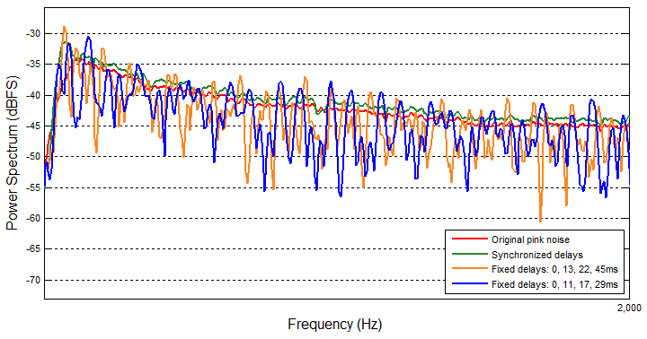

Figure III.5 – Fast Fourier transform spectrum of original high-pass pink noise (red), equalized signal obtained using synchronized delays (green), equalized signal obtained using fixed delays: 0 ms, 13 ms, 22 ms, 45 ms (orange) and equalized signal obtained using  
fixed delays: 0 ms, 11 ms, 17 ms, 29 ms (blue)

Equalization using fixed delays has been tried with several other sets of delays and using other test signals than pink noise, but this comb effect was always there and as strong as illustrated in Figure III.5.

### III.1.4 Summary

This clause documents the spatial stability of a noise field obtained using this Recommendation. As illustrated in clause III.1.3, the delay adjustment has a major impact on the equalized noise field. When using fixed delays, the noise field is very stable on the measured plan which is not the case when using synchronized delays. However, when using fixed delays, the reproduced noise field is subject to a comb effect filter that is noticeable with a frequency resolution higher than one-third octave.

## III.2 Reproduction of monophonic signals in treated rooms

This is currently not covered in this Recommendation.

## III.3 Reproduction of stereophonic signals in anechoic conditions

This is currently not covered in this Recommendation.

## III.4 Reproduction of stereophonic signals in treated rooms

This is currently not covered in this Recommendation.

## III.5 Reproduction of binaural signals in anechoic conditions

This is currently not covered in this Recommendation.

## III.6 Reproduction of binaural signals in treated rooms

This is currently not covered in this Recommendation.

## III.7 Reproduction of sound field signals in anechoic conditions

This is currently not covered in this Recommendation.

## III.8 Reproduction of sound field signals in treated rooms

This is currently not covered in this Recommendation.

## III.9 Reproduction of multi-point signals in anechoic conditions and treated rooms

### III.9.1 Introduction

This clause documents the reproduction accuracy of the reproduced noise field that can be achieved using the multi-point sound field recording and reproduction arrangement as described in clause 8.3.7. The measurements were performed in various types of rooms and for handset terminals as well as for hands-free terminals.

### III.9.2 Results of the equalization of the multi-microphone method

The comparison with the original sound field is an inherent part of the equalization technique. Figures III.6 and III.7 show the results of the equalization process when applied to different types of rooms. The differences in the microphone levels versus frequency were measured, as well as the complex coherence between the recorded sound field and the simulated sound field after equalization at the relevant microphone positions used during calibration (Figure III.6) and used during fine-tuning (Figure III.7) for the four different types of rooms listed in Table III.2:

Table III.2 – Types of rooms in which the validation was performed

|  |  |  |
| --- | --- | --- |
| Name | Reverberation time, 60 dB reduction, RT60 (ms) | *C*80 (dB) |
| Room 1 | 27 | 50.3 |
| Room 2 | 123 | 36.8 |
| Room 3 | 98 | 45.6 |
| Room 4 | 264 | 20.3 |

The room sizes were between 1.8 m × 2.4 m × 2.1 m (smallest) and 8 m × 9 m × 4.5 m (biggest) (*d* × *b*  × *h*). For all rooms, the equalization was performed within the requirements of this Recommendation. The absolute level difference was less than ±1 dB, the spectral accuracy of the simulated sound field was within the range from −3 dB to +3 dB in the frequency range from 50 Hz to 10 kHz, and the magnitude of the complex coherence was higher than 90% in the frequency range from 100 Hz to 1 000 Hz or even up to 2 000 Hz.

NOTE – Channel 1 and 2 are not displayed here since they are on the "shadow side" of the head and only relevant for the equalization process.

|  |  |
| --- | --- |
| Room 1 (RT60: 27ms) | Room 1 |
|  |  |
| Room 2 (RT60: 123ms) | Room 2 |
|  |  |
| Room 3 (RT60: 98ms) | Room 3 |
|  |  |
| Room 4 (RT60: 264ms) | Room 4 |
|  |  |

Figure III.6 – Left: spectral accuracy between the simulated and reference sound fields; right: the complex coherence in magnitude (solid lines) and phase (dashed lines) at the positions of the calibration set. Results are in one-third octave

|  |  |
| --- | --- |
| Room 1 (RT60: 27ms) | Room 1 |
|  |  |
| Room 2 (RT60: 123ms) | Room 2 |
|  |  |
| Room 3 (RT60: 98ms) | Room 3 |
|  |  |
| Room 4 (RT60: 264ms) | Room 4 |
|  |  |

Figure III.7 – Left: spectral accuracy between the simulated and reference sound fields; right: the complex coherence in magnitude (solid lines) and phase (dashed lines) at the positions of the fine-tuning set. Results are in one-third octave

### III.9.3 Terminal performance in original and simulated sound field

#### III.9.3.1 Creation of the reference background noise sound field

A reference sound field was generated by eight loudspeakers located in a reverberant room not used for sound field simulation. The loudspeakers were positioned at different locations to those used later for the sound field simulation. The only adjustment was of level so that all loudspeakers had approximately the same.

Figure III.8 shows an example of a set-up for generating a hands-free reference sound field. As can be seen, the loudspeakers were positioned at different heights to make the sound field more realistic.

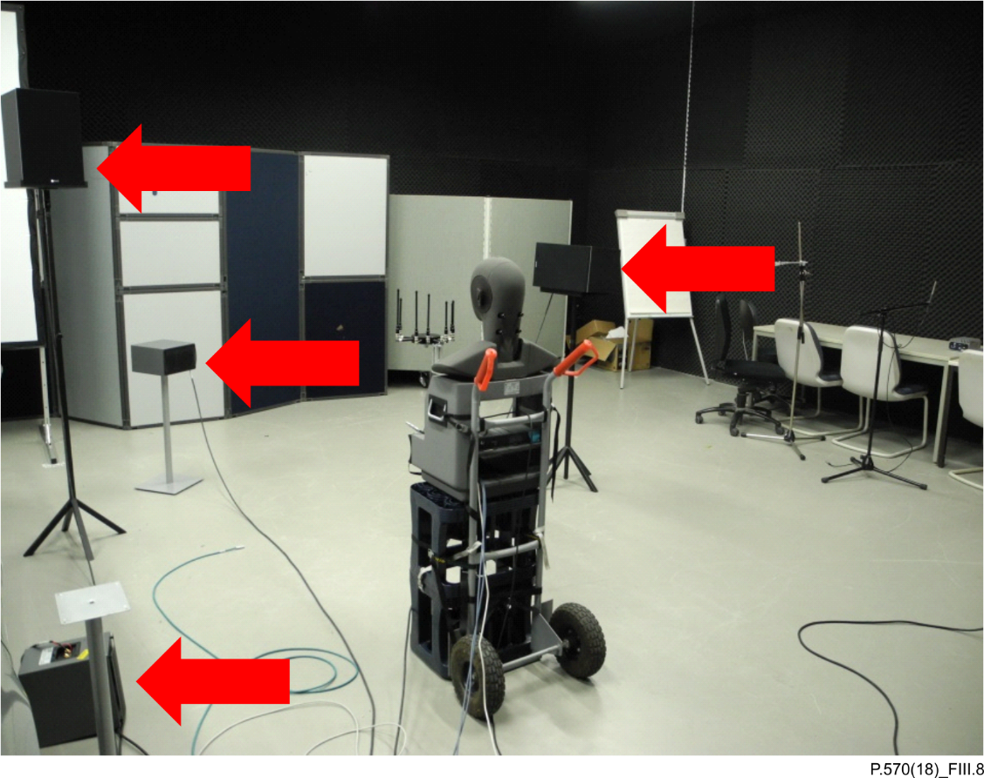

Figure III.8 – The set-up that was used for generating a reference sound field

Two different types of noise were used for sound field generation as follows.

– Eight different car noise recordings were each played back over one loudspeaker. In the following, this recording is referred to as "car noise". The average level was 72.7 dBSPL(A) for handset terminals and 72.2 dBSPL(A) for hands-free terminals.

– A combination of four stationary noises like car noise with four non-stationary noises like cafeteria noise, played simultaneously. In the following this recording is referred to as "mix". The average level was 70.5 dBSPL(A) for handset terminals and 70.1 dBSPL(A) for hands‑free terminals.

Loudspeakers were positioned so as not to occupy the corresponding positions in the reproduction arrangement (see Figure III.9). Those sound fields were recorded using a microphone array as specified in clause 8.2.2.

#### III.9.3.2 Devices used in the validation experiment

Three different mobile phones with different properties were positioned in handset-mode. All phones were recent models employing at least two microphone noise cancellation techniques. All phones were wideband enabled and were evaluated in wideband mode – see Table III.3 for details.

Table III.3 – Different phones used in the experiments

|  |  |  |
| --- | --- | --- |
| Name | Network mode | Size (inch) |
| Phone 1 | 3G | 4.8 |
| Phone 2 | 4G | 5.5 |
| Phone 3 | 3G | 4.3 |
| Phone 4 | 3G | 4.7 |
| Phone 5 | 3G | 4.5 |

#### III.9.3.3 Analysis of background noise transmission

The background noise at the primary microphone position, as well as the background noise transmitted by the different phones, was measured in the reference sound field. These measurements served as the reference for all measurements in the different room where the sound field simulation was set up as specified in this Recommendation.

After those measurements had been carried out, the playback system was equalized in four rooms as described in this Recommendation. In all rooms, the same measurements as in the reference situation were made with the simulated background noise using the microphone array recording employed previously. The results are discussed in the following.

First the different spectra of the transmitted background noise are compared. The test signal consisted of a conditioning sequence of 30 s speech with background noise and 30 s of background noise. The analysis was performed on the background noise sequence only.

When simulating the background noise, the simulated noise was picked up by a measurement microphone at the position of the main microphone of a mobile phone (as was also done in the reference recording). In the following, this signal is called "unprocessed". In addition to that, the sending signal of the mobile phone was also recorded. In the following, this signal is called "processed". The spectra of both signals were compared to those recorded in the original sound field.

In a second step, the speech mean opinion score (S-MOS), noise mean opinion score (N-MOS) and global mean opinion score (G-MOS) values according to [b-ETSI TS 103 106] were calculated.

In Figures III.9 to III.11, the bold solid graph represents the original spectrum whereas the other graphs represent the spectrum of reproduced sound field in different rooms.

#### III.9.3.4 Handset measurements I – spectral comparisons

|  |  |
| --- | --- |
| Car noise – processed  L/dB[V]  -80  -75  -70  -65  -60  -55  -50  f/Hz  50  100  200  2000  5000  10k  Room1 (RT60=27ms)  Room4 (RT60=264ms)  Room2 (RT60=123ms)  Room3 (RT60=98ms)  reference | Car noise – unprocessed  L/dB[Pa]  -70  -60  -50  -40  -30  -20  f/Hz  50  100  200  2000  5000  10k  Room1 (RT60=27ms)  Room4 (RT60=264ms)  Room2 (RT60=123ms)  Room3 (RT60=98ms)  reference |
| Mix – processed  L/dB[V]  -70  -65  -60  -55  -50  -45  -40  f/Hz  50  100  200  2000  5000  10k  Room1 (RT60=27ms)  Room4 (RT60=264ms)  Room2 (RT60=123ms)  Room3 (RT60=98ms)  reference | Mix – unprocessed  L/dB[Pa]  -60  -55  -50  -45  -40  -35  -30  -25  -20  f/Hz  50  100  200  2000  5000  10k  Room1 (RT60=27ms)  Room4 (RT60=264ms)  Room2 (RT60=123ms)  Room3 (RT60=98ms)  reference |

Figure III.9 – Phone 1, handset mode, comparison of one-twelfth-octave spectra for car noise and mix signal in different rooms (left: processed; right: unprocessed)

|  |  |
| --- | --- |
| **Car noise – processed**  L/dB[V]  -80  -75  -70  -65  -60  -55  -50  f/Hz  50  100  200  2000  5000  10k  Room1 (RT60=27ms)  Room2 (RT60=123ms)  Room3 (RT60=98ms)  reference | **Car noise – unprocessed**  L/dB[Pa]  -80  -70  -60  -50  -40  -30  -20  f/Hz  50  100  200  2000  5000  10k  Room1 (RT60=27ms)  Room2 (RT60=123ms)  Room3 (RT60=98ms)  reference |
| **Mix – processed**  L/dB[V]  -80  -75  -70  -65  -60  -55  -50  f/Hz  50  100  200  2000  5000  10k  Room1 (RT60=27ms)  Room2 (RT60=123ms)  Room3 (RT60=98ms)  reference | **Mix – unprocessed**  L/dB[Pa]  -80  -70  -60  -50  -40  -30  -20  f/Hz  50  100  200  2000  5000  10k  Room1 (RT60=27ms)  Room2 (RT60=123ms)  Room3 (RT60=98ms)  reference |

Figure III.10 – Phone 2, handset mode, comparison of one-twelfth-octave spectra for car noise and mix signal in different rooms (left: processed; right: unprocessed)

|  |  |
| --- | --- |
| **Car noise - processed**  L/dB[V]  -60  -55  -50  -45  -40  -35  -30  f/Hz  50  100  200  2000  5000  10k  Room4 (RT60=264ms)  Room3 (RT60=98ms)  reference  Room1 (RT60=27ms)  Room2 (RT60=123ms) | **Car noise - unprocessed**  L/dB[Pa]  -70  -60  -50  -40  -30  -20  f/Hz  50  100  200  2000  5000  10k  Room4 (RT60=264ms)  Room3 (RT60=98ms)  reference  Room1 (RT60=27ms)  Room2 (RT60=123ms) |
| **Mix - processed**  L/dB[V]  -60  -55  -50  -45  -40  -35  -30  f/Hz  50  100  200  2000  5000  10k  Room4 (RT60=264ms)  Room3 (RT60=98ms)  reference  Room1 (RT60=27ms)  Room2 (RT60=123ms) | **Mix - unprocessed**  L/dB[Pa]  -70  -60  -50  -40  -30  -20  f/Hz  50  100  200  2000  5000  10k  Room4 (RT60=264ms)  Room3 (RT60=98ms)  reference  Room1 (RT60=27ms)  Room2 (RT60=123ms) |
|  | |

Figure III.11 – Phone 3, handset mode, comparison of one-twelfth-octave spectra for car noise and mix signal in different rooms (left: processed; right: unprocessed)

A further validation of the accuracy of the reproduction system when applied to a modern mobile phone is shown in Figures III.12, III.13 and III.14. The spectrograms of the same device tested in different rooms show a high degree of correlation, not only in the frequency domain, but also in the time domain. The different transient sounds, being part of the mix background noise, are well reproduced independently of the test room used. Note that the phone incorporates certain time-variant processing techniques, which in general may lead to small deviations in the result between tests.

|  |  |
| --- | --- |
| Reference | Room 1 (27 ms) |
| Room 2 (123 ms) | Room 4 (264 ms) |

Figure III.12 – Spectrum versus time analysis of the mix signal for three rooms   
for phone 1; reference recording at top left

|  |  |
| --- | --- |
| Reference | Room 1 (27 ms) |
| Room 2 (123 ms) | Room 3 (98 ms) |

Figure III.13 – Spectrum versus time analysis of the mix signal for three rooms   
for phone 2; reference recording at top left

|  |  |  |  |  |
| --- | --- | --- | --- | --- |
| |  |  | | --- | --- | | Reference | Room 1 (27 ms) | | Room 2 (123 ms) | Room 4 (264 ms) | |

Figure III.14 – Spectrum versus time analysis of the mix signal for three rooms   
for phone 3; reference recording at top left

#### III.9.3.5 Handset measurements I – MOS comparison

Figure III.15 shows the mean opinion score (MOS) values measured in the simulation in relation to the MOS values measured in the original sound field for the handset case. High correlation between values determined in the reproduced sound field and original sound field can be observed. The correlation factors are given in Table III.4.



Figure III.15 – Results of the S-MOS, N-MOS and G-MOS measurements for different phones, located in the handset position, in different rooms

Table III.4 – Correlation of mean opinion score values for different phones in different rooms

|  |  |  |  |
| --- | --- | --- | --- |
| Name | G-MOS (%) | N-MOS (%) | S-MOS (%) |
| Room 1 | 98.9 | 90.4 | 98.9 |
| Room 2 | 99.6 | 93.3 | 99.7 |
| Room 3 | 99.2 | 90.3 | 99.5 |
| Room 4 | 99.5 | 97.4 | 99.7 |

#### III.9.3.6 Handset measurements II – spectral comparison

Further experiments especially concentrating on the hands-free-mode were conducted in a second set of tests. For this purpose, two phones, numbered 4 and 5, both providing wideband transmission in hands-free mode, were used in addition to phone 1. Also, an additional new background noise was introduced. In the reference set-up, a cafeteria noise was played back by a loudspeaker located on the left side behind the HATS. This background noise is called "single speaker" in the following. This additional simulation was done in order to cover the situation of only one interfering sound source considered to be the most demanding for the simulation set-up. The average levels of this single speaker signal were 57.3 dBSPL(A) for the handset position and 58.1 dBSPL(A) for the hands-free position. Figure III.16 shows an example set-up for a handset measurement in room 2 (RT60: 123 ms).

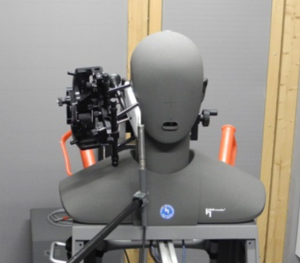

Figure III.16 – Example set-up for a handset measurement in room 2 (RT60: 123 ms)

The results of these measurements are shown in Figures III.17 to III.19. In this experiment, only rooms 1, 2 and 4 were used for setting up the background noise field simulation.

|  |  |
| --- | --- |
| Car noise – processed | Car noise – unprocessed |
| **Mix - processed** | **Mix - unprocessed** |
| **Single speaker – processed** | **Single speaker – unprocessed** |
|  | |

Figure III.17 – Phone 1, handset mode, comparison of one-twelfth-octave spectra  
(left: processed; right: unprocessed)

|  |  |
| --- | --- |
| **Car noise - processed** | **Car noise - unprocessed** |
| **Mix - processed** | **Mix - unprocessed** |
| **Single speaker – processed** | **Single speaker – unprocessed** |
|  | |

Figure III.18 – Phone 5, handset mode, comparison of one-twelfth-octave spectra  
(left: processed; right: unprocessed)

|  |  |
| --- | --- |
| **Car noise - processed** | **Car noise - unprocessed** |
| **Mix - processed** | **Mix - unprocessed** |
| **Single speaker – processed** | **Single speaker – unprocessed** |
|  | |

Figure III.19 – Phone 4, handset mode, comparison of one-twelfth-octave spectra  
(left: processed; right: unprocessed)

As seen already in experiment I, a good correlation between reference and reproduced sound field can be observed. As expected, a somewhat higher deviation can be observed for the sound field consisting just of a single speaker, but the transmitted spectra of the noise when using the reproduction arrangement is quite similar to the original. It needs to be taken into account that all terminals are using highly sophisticated, non-linear and time variant signal processing unknown to the laboratory. Therefore, it can be assumed that some of the time variant behaviour can be attributed to the terminals.

#### III.9.3.7 Handset measurements II – Mean opinion score comparison

As already shown in Experiment I, the correlation of the S-MOS, N-MOS and G-MOS prediction compared to the real background noise situation is very high using the sound field simulation technique in the different rooms. See Table III.5.

Table III.5 – Correlation of mean opinion score values for different phones in different rooms

|  |  |  |  |
| --- | --- | --- | --- |
| Name | G-MOS (%) | N-MOS (%) | S-MOS (%) |
| Room 1 | 97.5 | 99.3 | 95.4 |
| Room 2 | 98.0 | 99.4 | 98.8 |
| Room 4 | 99.2 | 99.3 | 97.9 |



Figure III.20 – Results of S-MOS, N-MOS and G-MOS measurements for different phones, located in the handset position, in different rooms

#### III.9.3.8 Hands-free measurements – spectral comparison

As described for the handset tests, an original sound field was created. However, instead of recording the sound field with the microphone array at the HATS position, the sound field was recorded at the hands-free position. This position was also used for sound field equalization in the different rooms. The experiment was conducted in three different rooms (numbered 1, 2 and 4). The three different background noises described previously were used. The sound field at the main hands-free microphone position, as well as the sending signal of the mobile phone in hands-free mode, were analysed. The results of the tests are shown in Figures III.22, III.23 and III.24.

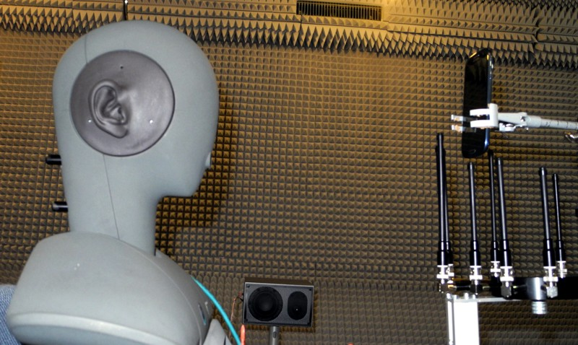

Figure III.21 – Example of a hand-held hands-free set-measurement (the array is only shown to illustrate the set-up, it is not present during hands-free testing)

|  |  |
| --- | --- |
| **Car noise - processed**  -70  -65  -60  -55  -50  -45  -40  -35  -30  f/Hz  50  100  200  2000  5000  10k  Room1 (RT60=27ms)  reference  Room4 (RT60=264ms)  Room2 (RT60=123ms) | **Car noise - unprocessed** |
| **Mix - processed** | **Mix - unprocessed** |
| **Single speaker – processed** | **Single speaker – unprocessed** |
|  | |

Figure III.22 – Phone 1, hands-free mode, comparison of one-twelfth-octave spectra  
(left: processed; right: unprocessed)

|  |  |
| --- | --- |
| **Car noise - processed** | **Car noise - unprocessed** |
| **Mix - processed** | **Mix - unprocessed** |
| **Single speaker – processed** | **Single speaker – unprocessed** |
|  | |

Figure III.23 – Phone 5, hands-free mode, comparison of one-twelfth-octave spectra  
(left: processed; right: unprocessed)

|  |  |
| --- | --- |
| **Car noise - processed** | **Car noise - unprocessed** |
| **Mix - processed**  -60  -55  -50  -45  -40  -35  -30  f/Hz  50  100  200  2000  5000  10k  Room1 (RT60=27ms)  reference  Room4 (RT60=264ms)  Room2 (RT60=123ms) | **Mix - unprocessed**  L/dB[Pa]  -60  -55  -50  -45  -40  -35  -30  -25  -20  f/Hz  50  100  200  2000  5000  10k  Room1 (RT60=27ms)  reference  Room4 (RT60=264ms)  Room2 (RT60=123ms) |
| **Single speaker – processed**  L/dB[V]  -70  -65  -60  -55  -50  -45  -40  f/Hz  50  100  200  2000  5000  10k  Room1 (RT60=27ms)  reference  Room4 (RT60=264ms)  Room2 (RT60=123ms) | **Single speaker – unprocessed**  L/dB[Pa]  -70  -65  -60  -55  -50  -45  -40  -35  -30  f/Hz  50  100  200  2000  5000  10k  Room1 (RT60=27ms)  reference  Room4 (RT60=264ms)  Room2 (RT60=123ms) |

Figure III.24 – Phone 4, hands-free mode, comparison of one-twelfth-octave spectra  
(left: processed. right: unprocessed)

By comparing the different spectra of the transmitted background noise, determined for the two situations – when the hands-free device is exposed to the original sound field and the reproduced sound field – it can be see that the spectra are very similar. As expected, the deviations observed for the single speaker (considered the worst-case scenario) are somewhat higher, but still very comparable to the recorded original sound field.

#### III.9.3.9 Hands-free measurements – mean opinion score comparison

As already shown in the handset experiments, the correlation of the S-MOS, N-MOS and G-MOS prediction compared to the real background noise situation is very high using the sound field simulation technique in the different rooms for the hands-free situation. See Table III.6 and Figure III.25.

Table III.6 – Correlation of mean opinion score values for different phones in hands-free mode

|  |  |  |  |
| --- | --- | --- | --- |
| Name | G-MOS (%) | N-MOS (%) | S-MOS (%) |
| Room 1 | 98.2 | 99.7 | 98.2 |
| Room 2 | 99.1 | 99.1 | 98.7 |
| Room 4 | 97.7 | 99.3 | 96.5 |



Figure III.25 – Results of the S-MOS, N-MOS AND G-MOS measurements for different phones located in the hands-free position, in different rooms

### III.9.4 Summary

The results provided in this appendix show a high accuracy of the sound field reproduction technique described in this Recommendation for both, handset and hands-free reproduction set-ups using sophisticated modern mobile terminals employing the latest state of the art processing techniques.

Appendix IV  
  
Spatial reproduction stability

(This appendix does not form an integral part of this Recommendation.)

## IV.1 Spatial reproduction accuracy of monophonic signals under anechoic conditions

This is currently not covered in this Recommendation.

## IV.2 Spatial reproduction accuracy of monophonic signals in treated rooms

### IV.2.1 Introduction

This clause investigates the spatial stability of the reproduced noise field achieved using the microphone method (clause 8.3.2) in an acoustically treated room, whose dimensions were 3.5 m × 5.0 m × 2.7 m. The room had been fitted with sound-absorbing materials to control the reverberation time, as well as standing waves, in the room.

### IV.2.2 Description of the experiment

The loudspeakers were positioned in a square with a microphone at the centre (and in the same plane) as depicted in Figure IV.1 (around 2 m between the loudspeakers and the microphone). In this experiment, the subwoofer was not part of the set-up, thus results are valid from 120 Hz to 20 kHz.

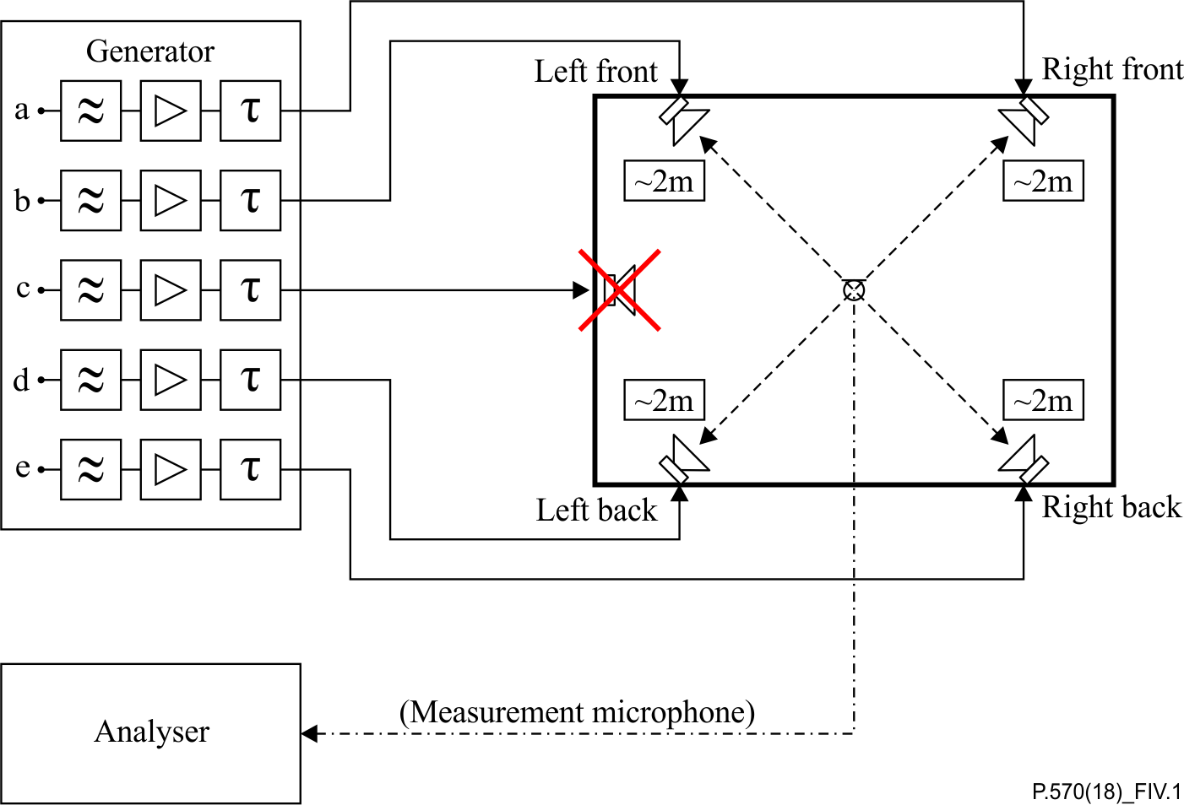

Figure IV.1 – Set-up for loudspeaker equalization using the microphone method

In order to determine the spatial stability of the reproduced noise field, in a first step, several measurements were taken around the equalization centre (original position of the microphone for the equalization) without the HATS. These measurements (blue circles) were taken according to Figure IV.2. The points later occupied by the HATS were omitted.



Figure IV.2 – Measurement points (blue circles) for the reproduced noise field, withoutHATS; the measurement taken at the equalization centre is marked in red

In a second step, the microphone was replaced by the HATS and several measurements were taken around it. These measurements were taken according to Figure IV.3.



Figure IV.3 – Measurement points (blue circles) for the reproduced   
noise field, with the HATS

In both cases, the stability of the sound field in a rectangle of 325 mm × 300 mm around the equalization centre (*X* = 0 mm; *Y* = 0 mm), which is also the HRP, was checked. The equalization centre corresponds to the original position where the equalization was performed; in Figure IV.2 this position is marked by a red circle. More measurements were taken in front of the HATS, because this area is usually of more interest than the area behind the HATS. Measurements were done every 25 mm on the *X*- and *Y*-axis (blue circles in Figures IV.2 and IV.3) where possible, leading to 149 measurements for each configuration. Note that no measurement could be done at position (*X* = −75 mm; *Y* = −50 mm), because the handset positioner was set up on the left side of the HATS.

The results presented in clause IV.2.3 are spatial frequency responses in one-third octave bands. The test signal that was used for all measurements was pink noise (high-pass filtered as required by this Recommendation) and its level was adjusted in order to get around 75 dBPa(A) at the equalization centre. The reference used for the calculation of frequency responses was the signal measured at the equalization centre [(*X* = 0 mm; *Y* = 0 mm) see Figure IV.2]. This signal was the reference for the calculation of the frequency responses for all grid points shown in Figures IV.2 and IV.3.

### IV.2.3 Results

Clause 8.3.2 recommends adding fixed delays (0 ms, 11 ms, 17 ms, 29 ms) to individual loudspeakers in order to increase the diffusivity of the noise field. However different delays, i.e.,0 ms, 13 ms, 22 ms, 45 ms were applied, as, in this specific configuration (room and loudspeaker set-up), they gave better results than those recommended.

The spatial noise field stability results for both cases (with and without HATS) are shown in Table IV.1 Each row corresponds to a one-third octave band. The results displayed start with the one‑third octave band centred on 126 Hz and end with that centred on 19 953 Hz.

The difference between these two configurations (centre minus left column results) is given in the right column. These additional results allow easier verification of the impact of placing the HATS in the noise field.

Measurements were done every 25 mm on *X*- and *Y*-axis; however, in order to get better visual results, images were interpolated with a 1 mm step.

Table IV.1 – Spatial noise field stability results – left: without HATS; centre: with HATS; right: their differences

| Without HATS | With HATS | Difference, with and without HATS |
| --- | --- | --- |
| Spatial stability of noise field at 126 Hz | Spatial stability of noise field at 126 Hz | Spatial stability difference, with and without HATS, at 126 Hz |
| Spatial stability of noise field at 158 Hz | Spatial stability of noise field at 158 Hz | Spatial stability difference, with and without HATS, at 158 Hz |
| Spatial stability of noise field at 200 Hz | Spatial stability of noise field at 200 Hz | Spatial stability difference, with and without HATS, at 200 Hz |
| Spatial stability of noise field at 251 Hz | Spatial stability of noise field at 251 Hz | Spatial stability difference, with and without HATS, at 251 Hz |
| Spatial stability of noise field at 316 Hz | Spatial stability of noise field at 316 Hz | Spatial stability difference, with and without HATS, at 316 Hz |
| Spatial stability of noise field at 398 Hz | Spatial stability of noise field at 398 Hz | Spatial stability difference, with and without HATS, at 398 Hz |
| Spatial stability of noise field at 501 Hz | Spatial stability of noise field at 501 Hz | Spatial stability difference, with and without HATS, at 501 Hz |
| Spatial stability of noise field at 631 Hz | Spatial stability of noise field at 631 Hz | Spatial stability difference, with and without HATS, at 631 Hz |
| Spatial stability of noise field at 794 Hz | Spatial stability of noise field at 794 Hz | Spatial stability difference, with and without HATS, at 794 Hz |
| Spatial stability of noise field at 1000 Hz | Spatial stability of noise field at 1000 Hz | Spatial stability difference, with and without HATS, at 1000 Hz |
| Spatial stability of noise field at 1259 Hz | Spatial stability of noise field at 1259 Hz | Spatial stability difference, with and without HATS, at 1259 Hz |
| Spatial stability of noise field at 1585 Hz | Spatial stability of noise field at 1585 Hz | Spatial stability difference, with and without HATS, at 1585 Hz |
| Spatial stability of noise field at 1995 Hz | Spatial stability of noise field at 1995 Hz | Spatial stability difference, with and without HATS, at 1995 Hz |
| Spatial stability of noise field at 2512 Hz | Spatial stability of noise field at 2512 Hz | Spatial stability difference, with and without HATS, at 2512 Hz |
| Spatial stability of noise field at 3162 Hz | Spatial stability of noise field at 3162 Hz | Spatial stability difference, with and without HATS, at 3162 Hz |
| Spatial stability of noise field at 3981 Hz | Spatial stability of noise field at 3981 Hz | Spatial stability difference, with and without HATS, at 3981 Hz |
| Spatial stability of noise field at 5012 Hz | Spatial stability of noise field at 5012 Hz | Spatial stability difference, with and without HATS, at 5012 Hz |
| Spatial stability of noise field at 6310 Hz | Spatial stability of noise field at 6310 Hz | Spatial stability difference, with and without HATS, at 6310 Hz |
| Spatial stability of noise field at 7943 Hz | Spatial stability of noise field at 7943 Hz | Spatial stability difference, with and without HATS, at 7943 Hz |
| Spatial stability of noise field at 10000 Hz | Spatial stability of noise field at 10000 Hz | Spatial stability difference, with and without HATS, at 10000 Hz |
| Spatial stability of noise field at 12589 Hz | Spatial stability of noise field at 12589 Hz | Spatial stability difference, with and without HATS, at 12589 Hz |
| Spatial stability of noise field at 15849 Hz | Spatial stability of noise field at 15849 Hz | Spatial stability difference, with and without HATS, at 15849 Hz |
| Spatial stability of noise field at 19953 Hz | Spatial stability of noise field at 19953 Hz | Spatial stability difference, with and without HATS, at 19953 Hz |

For the full frequency range (120 Hz to 20 kHz) similar level variations were observed with and without HATS. The variation was around 9 dB (from −3 dB to 6 dB) for the case without HATS and around 11 dB (from −4 dB to 7 dB) for the case with HATS.

Without the HATS, the noise field is generally stable but still exhibits some variations. See Table IV.2. With the HATS present, results are similar up to 501 Hz but start to diverge for higher frequencies. This can be explained by the presence of the HATS in the noise field which creates some perturbations. However, results from right column indicate that these perturbations remain limited as the range of the difference (with HATS minus without HATS) is contained in [−4 dB; 5 dB].

Table IV.2 – Sound field uniformity without and with HATS

|  |  |  |  |
| --- | --- | --- | --- |
| Frequency range | Microphone method (without HATS) | Microphone method (with HATS) | Likely cause |
| Low (120 Hz-400 Hz) | −2 dB to 6 dB | −3 dB to 7 dB | Room modes |
| Mid (500 Hz-3 kHz) | −3 dB to 5 dB | −4 dB to 7 dB | Reflections from HATS |
| High (4 kHz-20 kHz) | 0 dB to 5 dB | −2 dB to 6 dB | Reflections from HATS |

Furthermore, no influence of the HATS positioner (located on the left side) on the noise field, was observed because the results rather symmetrical (relative to the *X*-axis).

## IV.3 Spatial Reproduction Accuracy of stereophonic signals in anechoic conditions

This is currently not covered in this Recommendation.

## IV.4 Spatial Reproduction Accuracy of stereophonic signals in treated rooms

This is currently not covered in this Recommendation.

## IV.5 Spatial Reproduction Accuracy of binaural signals in anechoic conditions

This is currently not covered in this Recommendation.

## IV.6 Spatial Reproduction Accuracy of binaural signals in treated rooms

### IV.6.1 Introduction

This clause investigates the spatial stability of the reproduced noise field achieved using the HATS method in clause 8.3.1 in an acoustically treated room. The room dimension was 3.5 m × 5.0 m × 2.7 m and had been equipped with sound absorbing materials to control the reverberation time as well as standing waves in the room.

### IV.6.2 Description of the experiment

The positioning of the loudspeakers was a square and HATS at the centre as described in Figure IV.4 (around 2 m between the loudspeakers and the HRP). In this experiment, the subwoofer was not part of the set-up, thus results are valid from 120 Hz to 20 kHz.

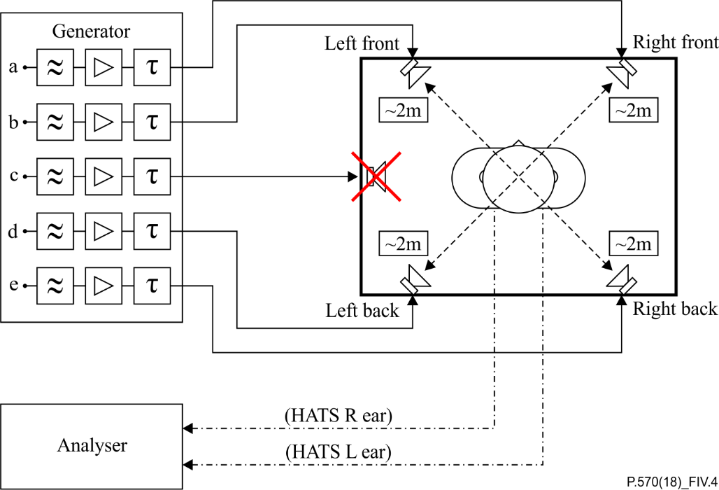

Figure IV.4 – Set-up for loudspeaker equalization using the HATS method

In order to determine the spatial stability of the reproduced noise field, several measurements around the head of the HATS were realized. These measurements (blue circles) were done in the plane of the mouth according to Figure IV.5.



Figure IV.5 – Measurement points (blue circles) for the reproduced noise field,  
in the plane of the HATS mouth

The stability of the sound field in a rectangle of 325 mm × 300 mm around the HRP (*X* = 0 mm; *Y* = 0 mm) was checked. More measurements were taken in front of the HATS because this area is usually of more interest than the area behind the HATS. Measurements were done every 25 mm on the *X*- and *Y*-axis (blue circles in Figure IV.5) where possible, leading to 149 measurements for the full plane. It can be noticed that no measurement could be done at position (*X* = −75 mm; *Y* = −50 mm) because the handset positioner was set up on the left side of the HATS.

The results presented in clause IV.6.3 are spatial frequency responses in one-third octave bands. The test signal that was used for all measurements was binaural pub noise (Pub\_Noise\_binaural\_V2 described in clause 8.1 of [ETSI ES 202 396-1] and high-pass filtered as required by this Recommendation). The reference used for the calculation of frequency responses was the signal measured at the position (*X* = 125 mm; *Y* = 0 mm) Figure IV.5. This signal was the reference for the calculation of the frequency responses for all points of the grid defined in Figure IV.5.

### IV.6.3 Results

Clause 8.3.1 recommends adding fixed delays (0 ms, 11 ms, 17 ms, 29 ms) to individual loudspeakers in order to increase the diffusivity of the noise field. However different delays, i.e.,0 ms, 13 ms, 22 ms, 45 ms were applied, as, in this specific configuration (room and loudspeaker set-up), they gave better results than those recommended.

The spatial noise field results are listed in Table IV.3. Each cell corresponds to a one-third octave band. The results displayed start with the one-third octave band centred on 126 Hz and end with that centred on 19 953 Hz.

Measurements were done every 25 mm on the *X*- and *Y*-axis; however, in order to get better visual results, images were interpolated with a 1 mm step.

Table IV.3 – Sound field uniformity with a head and torso simulator

| HATS method |  |
| --- | --- |
| Spatial stability of noise field at 126 Hz | Spatial stability of noise field at 158 Hz |
| Spatial stability of noise field at 200 Hz | Spatial stability of noise field at 251 Hz |
| Spatial stability of noise field at 316 Hz | Spatial stability of noise field at 398 Hz |
| Spatial stability of noise field at 501 Hz | Spatial stability of noise field at 631 Hz |
| Spatial stability of noise field at 794 Hz | Spatial stability of noise field at 1000 Hz |
| Spatial stability of noise field at 1259 Hz | Spatial stability of noise field at 1585 Hz |
| Spatial stability of noise field at 1995 Hz | Spatial stability of noise field at 2512 Hz |
| Spatial stability of noise field at 3162 Hz | Spatial stability of noise field at 3981 Hz |
| Spatial stability of noise field at 5012 Hz | Spatial stability of noise field at 6310 Hz |
| Spatial stability of noise field at 7943 Hz | Spatial stability of noise field at 10000 Hz |
| Spatial stability of noise field at 12589 Hz | Spatial stability of noise field at 15849 Hz |
| Spatial stability of noise field at 19953 Hz |  |

For the full frequency range (120 Hz to 20 kHz) a level variation of around 15 dB (from −8 dB to 7 dB) was observed.

The noise field is quite stable for frequencies up to 1 000 Hz and then starts to get less stable for higher frequencies. This can be explained by the presence of the HATS in the noise field, which creates some perturbations. See Table IV.4

Table IV.4 – Sound field uniformity with a head and torso simulator

|  |  |  |
| --- | --- | --- |
| Frequency range | HATS method | Likely cause |
| Low (120 Hz-400 Hz) | −5 dB to 3 dB | Room modes |
| Mid (500 Hz-3 kHz) | −5 dB to 6 dB | Reflections from HATS |
| High (4 kHz-20 kHz) | −8 dB to 7 dB | Reflections from HATS |

Note that for frequencies higher than 6 310 Hz the noise field is not symmetrical (relative to the *X*‑axis), which could be explained by the presence of the HATS positioned on the left side.

## IV.7 Spatial reproduction accuracy sound field signals in anechoic conditions

This is currently not covered in this Recommendation.

## IV.8 Spatial reproduction accuracy of sound field signals in treated rooms

This is currently not covered in this Recommendation.

## IV.9 Spatial reproduction accuracy of multi-point reproduction

To verify that the multi-point equalization procedure works for different rooms, it was applied to two different types:

– a semi-anechoic room with an RT60 of about 140 ms;

– a room without special acoustical treatment, with an RT60 of 310 ms.

In Figure IV.6, the differences in the microphones levels between the simulated and the real sound fields at the fine-tuning microphone positions are shown after equalization was done. This equalization was successful because in both rooms, the error, especially the mean error, is within ±3 dB.

If the error is outside tolerance, it is associated with a microphone not equalized for level in this frequency range.

|  |  |
| --- | --- |
| **Semi-anechoic room** | **Reverberant room** |
|  |  |

Figure IV.6 – Differences between real and simulated sound field after equalization at fine tuning microphone positions. The wider curve represents the mean error.  
The violation of the tolerance at 1 250 Hz is caused by a microphone   
that is not equalized in this frequency range

As another analysis, the coherence between the microphone signals in the real sound field and in the reproduced sound field was calculated. Again, the microphone positions at the fine-tuning positions were compared.

The results show that there is a strong correlation between both sound fields up to 3 kHz. Magnitude and phase show a good correspondence. See Figure IV.7.

|  |  |
| --- | --- |
| **Semi-anechoic room** | **Reverberant room** |
|  |  |
|  | |

Figure IV.7 – Coherence between microphone signals at the fine-tuning set microphone positions – solid line: magnitude; dashed line: phase

The final evaluation was done with a comparison criterion based on spherical correlation. A spherical microphone array was used to compare a real sound field to a simulated sound field in the spherical harmonics domain. The results are shown in Figure IV.8.

|  |  |
| --- | --- |
|  |  |

Figure IV.8 – Spherical correlation of original and recorded fields

First of all, it can be seen from the results of the error and coherence analyses that both rooms exhibit approximately the same performance. A first view suggests that the limiting frequency is around 500 Hz, which would be rather low. However, bear in mind that the spherical microphone array used had a diameter of 25 cm with an even microphone distribution. In contrast, the microphone array used for equalization had a non-equal microphone distribution with a higher number of microphones on the right hand of the HATS where the handset terminal is placed. As a consequence, the result of the spherical correlation analysis leads to a limiting frequency in a sphere of 25 cm diameter around the microphone array with the HATS of about 500 Hz. However, the accuracy of the sound field reproduction on the right side of the HATS in the area where the handset is located is much higher, as seen in the coherence analysis shown in Figure IV.8 In addition to the correct sound field reproduction in this area, the sound pressure at the different microphones is correct up to 20 kHz, which cannot be guaranteed with ambisonics.

Appendix V  
  
Detailed description of the overall equalization procedure for a HATS

(This appendix does not form an integral part of this Recommendation.)

If the result of the equalization is outside tolerance, it needs to be checked whether one or more loudspeakers contribute to the violation. In general, some experimental work is required to do some root cause analysis.

Some examples of how to perform this are as follows.

– Check the individual contribution of each loudspeaker to the overall response. The need to introduce high equalization gain, to have many equalizers and to have a high Q-factor in parametric equalizers are typically indications of poorly positioned loudspeakers.

– Reposition the loudspeakers to attempt to find a spot where less equalization is needed.

– Change the delays introduced into the loudspeaker-paths to find an optimum.

Bibliography

[b-ITU-T P.10] Recommendation ITU-T P.10/G.100 (2017), *Vocabulary for performance and quality of service*.

[b-ETSI TS 103 106] ETSI TS 103 106, V1.5.1 (2018), *Speech and multimedia transmission quality (STQ); Speech quality performance in the presence of background noise: Background noise transmission for mobile terminals-objective test methods*.

[b-Alexander] Alexander, R.C. (1999). *The inventor of stereo: The life and works of Alan Dower Blumlein*. Boston, MA:Focal Press. 421 pp.

[b-Carter] Carter, C.G. (1987). Coherence and time-delay estimation. *Proc. IEEE* **75**(6), pp. 236-255.

[b-Daniel] Daniel, J. (2000), [Représentation de champs acoustiques, application à la transmission et à la reproduction de scènes sonores complexes dans un contexte multimédia](https://www.researchgate.net/publication/242669363_Representation_de_champs_acoustiques_application_a_la_transmission_et_a_la_reproduction_de_scenes_sonores_complexes_dans_un_contexte_multimedia)[Representation of acoustic fields, application to the transmission and reproduction of complex sound scenes in a multimedia context],PhD thesis, 1996-2000 Université Paris 6. <https://www.researchgate.net/publication/242669363_Representation_de_champs_acoustiques_application_a_la_transmission_et_a_la_reproduction_de_scenes_sonores_complexes_dans_un_contexte_multimedia>

[b-Gerzon, 1973] Gerzon, M.A. (1973). Periphony: With-height sound reproduction. *J. Audio Eng. Soc.*, **21**(1), pp.2-10.

[b-Gerzon, 1975] Gerzon, M.A. (1975). The design of precisely coincident microphone arrays for stereo and surround sound. Paper L-20presented at the *50th AES Convention*, London.

[b-Hoth] Hoth, D.F. (1941). Room noise spectra at subscribers’ telephone locations. *J.Acoust.Soc.Am*., **12**, pp. 99-504

[b-Kirkeby, 1996] Kirkeby,O., Nelson, P. A., Orduna-Bustamante, F., Hamada, H. (1996).Local sound field reproduction using digital signal processing. *J. Acoust. Soc. Am.* **100**(3), pp.1584-1593.

[b-Kirkeby, 1998] Kirkeby,O., Nelson, P. A., Hamada, H., Orduna-Bustamante, F. (1998), Fast deconvolution of multichannel systems using regularization. *IEEE Transactions on speech and audio processing*, **6**(2), pp.189-194.

[b-Malham] Malham, D.G. (1998). [*Spatial hearing mechanisms and sound reproduction*](https://www.york.ac.uk/inst/mustech/3d_audio/ambis2.htm)*,* Technical report, University of York. https://www.york.ac.uk/inst/mustech/3d\_audio/ambis2.htm

[b-Müller] Müller, S; Massarani, P. (2001). Transfer function measurement with sweeps. *J. Audio Eng. Soc*., **49**(6), pp. 443-471.

[b-Priestley] Priestley, M.B., (1981). *Spectral analysis and time series*,. 2 vols. London: Academic Press. 890 pp.

[b-Rumsey] Rumsey, F. (2001). *Spatial audio*. Oxford: Focal. 240 pp.

|  |  |
| --- | --- |
| **SERIES OF ITU-T RECOMMENDATIONS** | |
| Series A | Organization of the work of ITU-T |
| Series D | Tariff and accounting principles and international telecommunication/ICT economic and policy issues |
| Series E | Overall network operation, telephone service, service operation and human factors |
| Series F | Non-telephone telecommunication services |
| Series G | Transmission systems and media, digital systems and networks |
| Series H | Audiovisual and multimedia systems |
| Series I | Integrated services digital network |
| Series J | Cable networks and transmission of television, sound programme and other multimedia signals |
| Series K | Protection against interference |
| Series L | Environment and ICTs, climate change, e-waste, energy efficiency; construction, installation and protection of cables and other elements of outside plant |
| Series M | Telecommunication management, including TMN and network maintenance |
| Series N | Maintenance: international sound programme and television transmission circuits |
| Series O | Specifications of measuring equipment |
| **Series P** | **Telephone transmission quality, telephone installations, local line networks** |
| Series Q | Switching and signalling, and associated measurements and tests |
| Series R | Telegraph transmission |
| Series S | Telegraph services terminal equipment |
| Series T | Terminals for telematic services |
| Series U | Telegraph switching |
| Series V | Data communication over the telephone network |
| Series X | Data networks, open system communications and security |
| Series Y | Global information infrastructure, Internet protocol aspects, next-generation networks, Internet of Things and smart cities |
| Series Z | Languages and general software aspects for telecommunication systems |
|  |  |

1. \* To access the Recommendation, type the URL http://handle.itu.int/ in the address field of your web browser, followed by the Recommendation's unique ID. For example, <http://handle.itu.int/11.1002/1000/11830-en>. [↑](#footnote-ref-1)